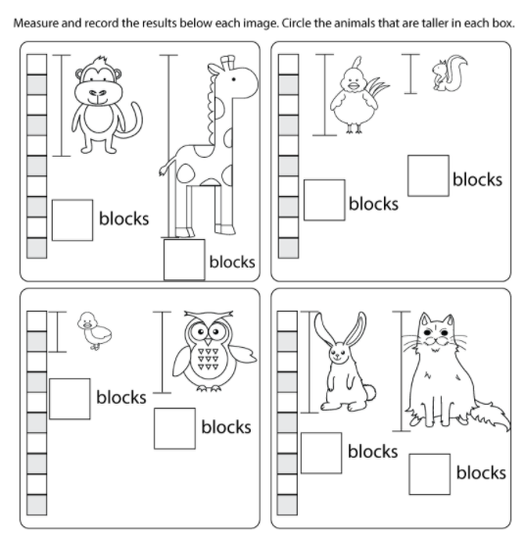
Extention: can you measure the height of objects in your house? You could measure using blocks, lego or your hands!

