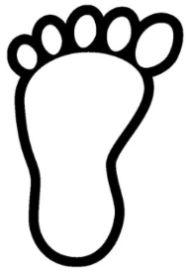
Comparing length scavenger hunt!
Find 2 objects that are longer than your foot and 2 objects that are shorter than your foot.
Draw and label your picture
Longer Shorter

