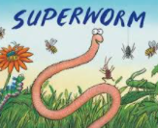
Lesson 1- Superworm challenge

Use playdough to make Superworm and his friends. Make sure they are of different lengths.. You can use spaghetti string, wool or wool if you don’t have playdough.
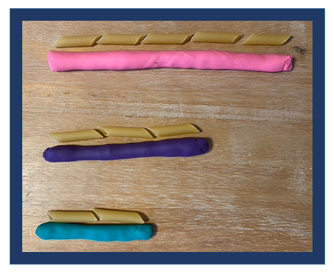
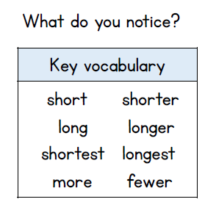

Can you arrange your worms in order from shortest to longest?
You can line them up or use household objects to compare the lengths

