Area of Learning | Monday | Tuesday | Wednesday | Thursday | Friday
Phonics | Listen to the tricky word flashcards on tapestry - four new ones!  Valentines Day Card - Can you use your tricky words inside a beautiful valentines day card?  Miss Barrett’s card:  To FS2  You are all WONDERFUL!  Lots of love,  Miss Barrett  You could maybe try writing:  To xx  I love you because...  Love from  xx  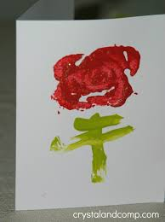 | Today’s sound - oo short sound like u  Recording on tapestry  Jolly Phonics song: https://youtu.be/opQ7gMO9ysc  Complete oo pages in phonics book 4 or practise blending the oo words from the video then write one in a sentence.  look, cook, book, foot, wood, wool, hook, took, hood, | Today’s sound - oo long sound like oo  Recording on tapestry  Jolly Phonics song:  https://youtu.be/opQ7gMO9ysc  Children to pretend to climb onto the moon and walk across the sounds of long ‘oo’ words to blend them – too, zoo, boot, boom, zoom, balloon, doom, gloom, rooftop,  and or  Complete oo pages in phonics book 4 or practise blending the oo words from the video then write one in a sentence. | Today’s sound - ar  Intro and story on tapestry.  Today’s story is Shark in the park. Can you make the ‘ar’’ sound?  Sing the jolly phonics song:  https://youtu.be/qJ_UHR3-pDg  Children go on a hunt with their own telescope like Timothy Pope to find the ‘ar’ words around the house. Blend the words and collect them.  Model the digraph ‘ar’ on the line. Then choose some to write. Adults explain their meaning and put them in sentences: car, bar, jar, star, hard, start, card, smart, start, market, spark, starlight.  Can you write an ‘ar’ word sentence? maybe you could make a rhyme? like shark in the park.  OR ‘ar’ page in phonics book 4. | Today’s sound - or  Intro and story on tapestry.  Today’s story is Cinderella! Can you make the ‘or’ sound? Her clothes were w-or-n and t-or-n.  Sing the jolly phonics song:  https://youtu.be/0_TiU-5dHpo  Regal River game: Children have a selection of ‘or’ words on the carpet in front of them: fork, cork, cord, sort, born, worn, fort, torn, short, north, cornet.  They choose one and ask you as Cinderella or the Prince if they can cross the river… ‘Cinderella can I cross your magic river?’  Cinderella says you may cross if you have … sound talk a ‘or’ word either that they have or a different one. The children blend their word and see if they can cross!  Once across they write the word on the fairy Godmothers whiteboard...they can have as many wishes as the words they write. Start the game again.
Maths | This week we are learning about comparing and measuring length & height. The maths lesson PowerPoint is not needed this week. The number of the week will continue after half term.
 | Starting with a story- Superworm  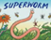  Recording on Tapestry  Practical activity- WB 8.2.21 Maths lesson 1- activity sheet.  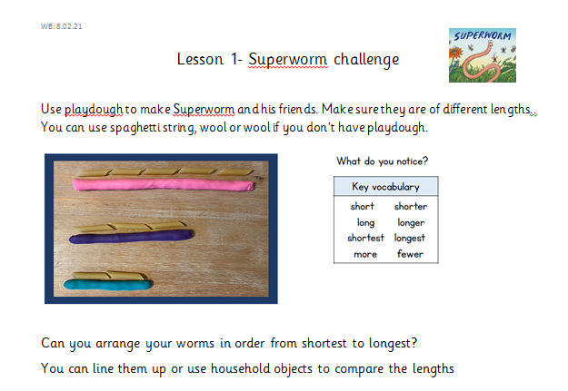  Resources to make worms: playdough/spaghetti/wool/string. There is a sheet uploaded with 5 worms if you would prefer to print. | Lesson 2- Comparing length- scavenger hunt  Recording on Tapestry  Activity- WB 1.2.21 Maths lesson 2- activity sheet.  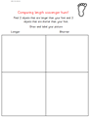  Resources: paper to draw around your foot, household objects | Lesson 3- measuring length- welly throwing.  Recording on Tapestry- introducing activity  Recording Activity- WB 1.2.21 Maths lesson 3  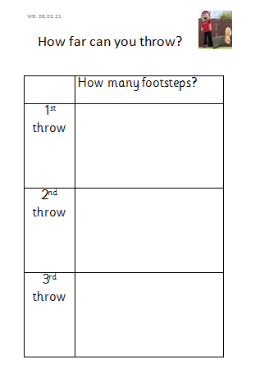Resources: something to throw e.g., welly boot or socks/ball. You will need a big enough space to throw your object safely. | Lesson 4- comparing height  Today we are following White Rose Home Learning- Session 1  https://whiterosemaths.com/homelearning/early-years/growing-6-7-8-week-3/  Practical Actvity- WB 8.2.21 Maths lesson 4- comparing height activity sheet.  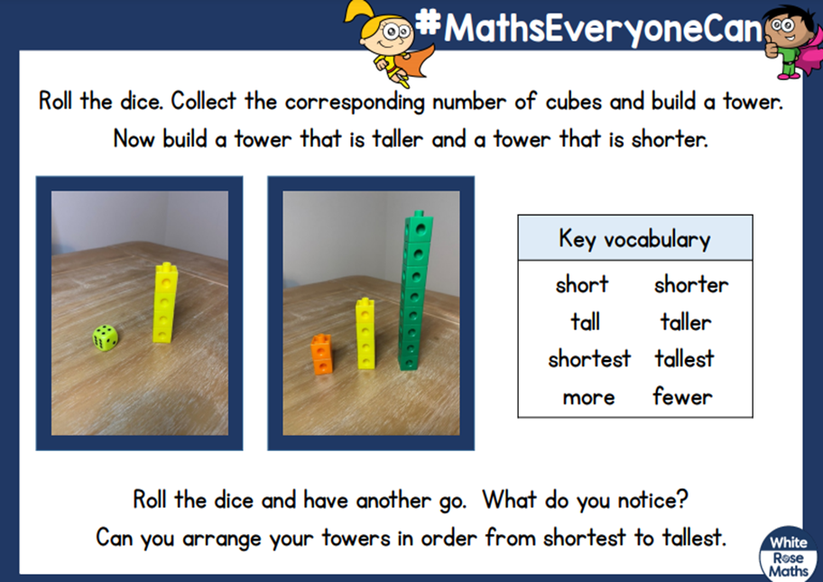  Resources: dice/cubes or lego | Lesson 5- measuring height  Today we are following White Rose Home Learning-Session 4  https://whiterosemaths.com/homelearning/early-years/growing-6-7-8-week-3/  Activity- WB 8.2.21 Maths lesson 5- measuring height
Reading | Share your reading book together discussing the character, settings and what happens next. | Share your reading book together discussing the character, settings and what happens next. | Share your reading book together discussing the character, settings and what happens next. | Share your reading book together discussing the character, settings and what happens next. | Share your reading book together discussing the character, settings and what happens next.
Other | RE: The Miracles of Jesus  Listen and sing- https://youtu.be/moqygKoIWY4  Talk time – Miracles of Jesus – powerpoint  Talk about the miracles and see which one your child likes and why.  Let us pray- ‘Lord Jesus, help us to stay calm when we are feeling scared and remember that you are always there looking over us’  Activity – Draw your favourite miracle  OR  Role play your favourite miracle using small world people. | Safer Internet Day 2021  ‘Together for a better internet’  Start today’s talking time with the first film: https://www.saferinternet.org.uk/safer-internet-day/safer-internet-day-2021/i-am-educator/safer-internet-day-films/films-5-11-year  What can we trust or not trust? How do we know?  Use the document: ‘Safer Internet day - Key Questions’ to further the conversation.  Use the document: ‘Safer Internet Day - activity and story information’ to introduce the story for today.  https://www.childnet.com/resources/digiduck-stories/detective-digiduck  Then make a poster as suggested.  Follow this with the other story about a little Penguin learning how to use the internet: https://www.childnet.com/resources/smartie-the-penguin  Make an online agreement together: ‘Safer Internet Day - Family Online Agreement’ | NON SCREEN TIME IDEAS  PE  Skipping Challenges - This is a core skill we were developing with the children in school so we will leave this one on for the next few weeks.  Knee Boxing  High Jump | NON SCREEN TIME IDEAS  Science Experiment - Melting Chocolate! yummy and interesting :)  Document attached: Changing State - Chocolate Experiment  Children melt one piece of chocolate in their hand and discuss.  Talk / Key Questions:  What is happening to the chocolate? Once it melts can we change it back? Is it a solid or a liquid? I wonder what it reminds you of?  Continue this experiment by melting the whole bar and change the shape by putting the melted chocolate into an ice cube mould and resetting in the fridge.  Resources: You will need a bar of chocolate, an ice cube mould, two bowls, a spoon and hot water (adult supervision), | Chinese New Year - The Year of the OX  Chinese New Year is the festival that celebrates the beginning of a new year on the traditional Chinese calendar.  Watch the video to find out how the animals of the Chinese Zodiac decided who would have which year names after them. Which Zodiac animal are you?  Chinese Zodiac https://www.bbc.co.uk/cbeebies/watch/chinese-new-year  Activities  Listen to the story ‘The Great Race’-  https://www.youtube.com/watch?v=P4WlzNrpUCs  Create: Choose your favourite Zodiac animal from ‘The Great Race story’ and make a mask- see Home Leaarning Timetable for mask templates. Maybe you could have a ‘Great Race’ at home with your family!
Extra | Cosmic Kids Yoga  https://www.youtube.com/user/CosmicKidsYoga | Finger Gym  https://youtu.be/3VpARNgbb8c | Boot Camp  https://www.youtube.com/channel/UC1uISIOKNnnGALw17v9naPg | Music  Please follow the link for YolnaDa’s Band jam – Bass Face (supporting document uploaded) https://www.bbc.co.uk/teach/bring-the-noise/primary-music-yolanda-brown-bass-face/zd4vt39

