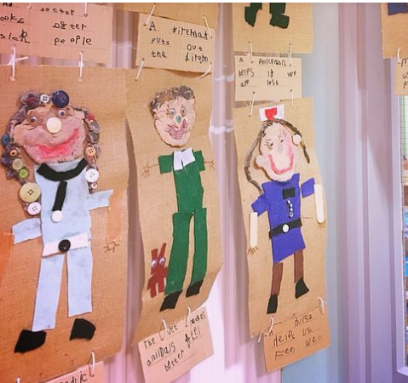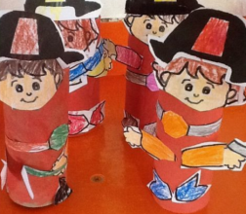

Create your own town with buildings for the people who help us. Or choose the one you really love and just make that ☺

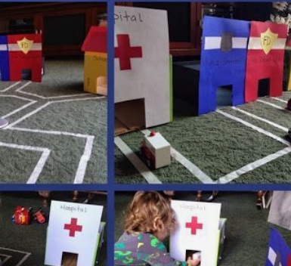

Create your own toilet tube figures , painting or junk pictures for the town. Firefighters, Police Officers…a vet?

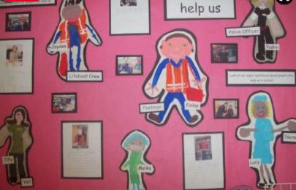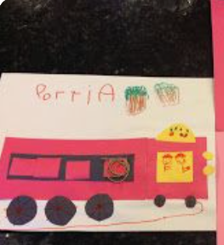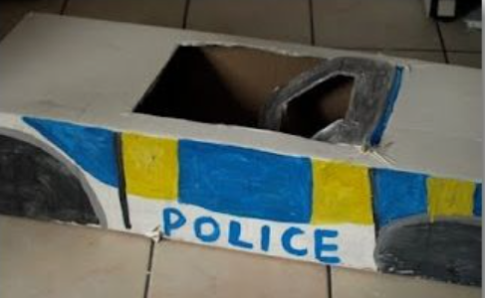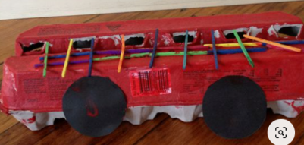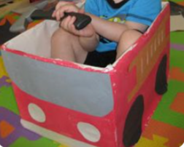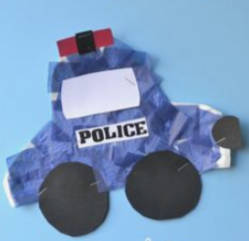

Create your own emergency vehicle. Think about its features - sirens, hosepipes and ladders, bright colours. You could make your vehicles out of old boxes, bottle tops and cardboard tubes.