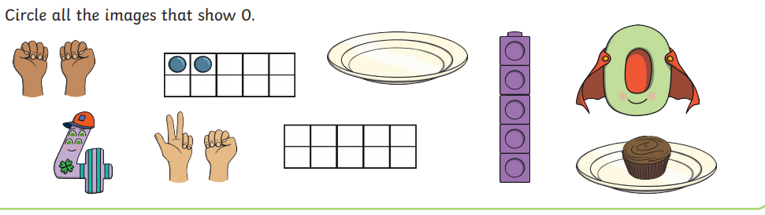
WB: 4.1.20 I D Zero Superhero Quest!

