LO: Fix it sentences.
SC: Add capital letters and full stops.

a man and wife lived in a little cottage
the man and wife desperately wanted a baby
next door to their house was a witch who had a beautiful garden filled with flowers and herbs
one day the wife became gravely ill
her husband knew the only thing to make her better was herbs but they were in the witches garden
he broke in so he could get the herbs but the witch caught him
she demanded his first born child as payment for the herb
a few years later rapunzel was born so the witch came and took her away
the witch imprisoned rapunzel in a tall tower where nobody could see her
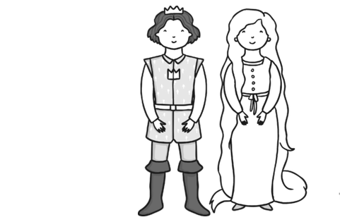
the only way into the tower was to climb rapunzel’s long, golden hair and climb through the window

