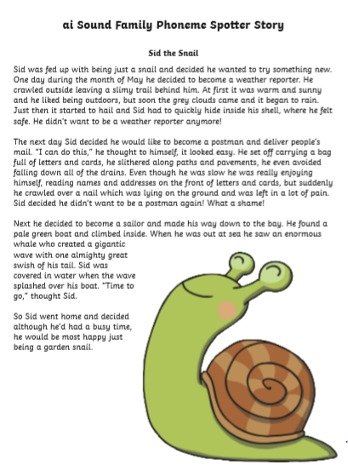

Task: Find and highlight the ai sound family in this phoneme story.