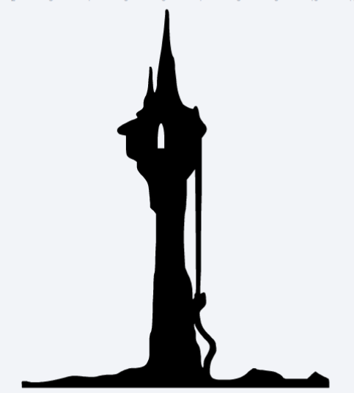  
  
  
  
  
  
  
  
  
  
  
  
  
  
  
  
  
  
  
  
  
  
  
  
  
  
  
  
  
  
  
  
  
  
  
  
  
  
  
  
  
  
  
  
  
  
  
  
  
  
  
  
  
  
  
  
  
  
  
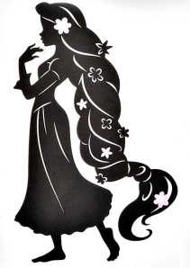  
  
  
  
  
  
  
  
  
  
  
  
  
  
  
  
  
  
  
  
  
  
  
  
  
  
  
  
  
  
  
  
  
  
  
  
  
  
  
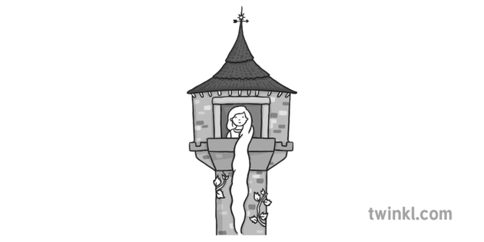

He lost his ball

To get a herb

It was a magic spell

He wanted to look around.

Rapunzel

Fact Retrieval: These questions aren’t too tricky. All you have to do is read the questions carefully, then go back to the text and find the piece of information you have been asked for.

1. Why did the man go into the witches’ garden?
2. What did the witch do when she found the man?  
   ______________________________________________________  
     
   ______________________________________________________  
     
   ______________________________________________________
3. Where did Rapunzel live?  
     
   ______________________________________________________  
     
   ______________________________________________________
4. How did the prince notice Rapunzel?  
     
   ______________________________________________________  
     
   ______________________________________________________

Rapunzel

Inference questions:  
There’s no getting away from these INFERENCE questions. Remember, you can always work out an answer. So don’t despair, if you get stuck keep looking at the story.

1. Was the man right to promise the witch his first baby? What could have happened if he didn’t?  
   I think the witch was _____________ because ___________________  
     
   _______________________________________________________  
     
   _______________________________________________________
2. Do you think the witch was kind or mean? Explain why?  
   I think the witch was _____________ because ___________________  
     
   _______________________________________________________  
     
   _______________________________________________________
3. If you were stuck in the tower, would you let the witch up?

_______________________________________________________  
  
_______________________________________________________

1. What messages can we take from the story?  
   ______________________________________________________  
     
   ______________________________________________________  
     
   ______________________________________________________

Rapunzel

1. Match up the feelings to the parts of the story. (the first one is done for you).  
     
   The man went into the witches’ garden. Excited  
     
     
   They gave their baby to the witch. Sad   
     
      
      
   Rapunzel meets a prince she wants to marry. Scared  
     
      
     
   Rapunzel is sent to the woods to live alone.  
    Lonely

1. What did the witch do to Rapunzel’s hair when she realised what she had been doing?  
     
     
   ______________________________________________________  
     
   ______________________________________________________

Rapunzel  
Word meaning question: Questions to test your vocabulary. You’ll be given the sentence the word is in, so even if you are not 100% sure what it means you can usually work it out.

1. What does the word ‘crept’ tell us about the way the man went into the garden?

______________________________________________________  
  
______________________________________________________

1. In this sentence what word tells us that Rapunzel doesn’t really want to drop her hair for the witch?   
   ‘She would call up to the beautiful, young girl, “Let down your golden hair," where she would reluctantly do so.’  
     
   ______________________________________________________  
     
   ______________________________________________________
2. What does the word ‘golden’ tell us about the colour of Rapunzel’s hair? What colour is gold similar too?
3. ______________________________________________________  
     
   ______________________________________________________
4. Choose word from the following that most closely related to the word ‘**forest’**
5. What was the name of the plant that scratched the prince’s eyes?  
     
   ______________________________________________________  
     
   ______________________________________________________

wood

T

town

city

unpleasant