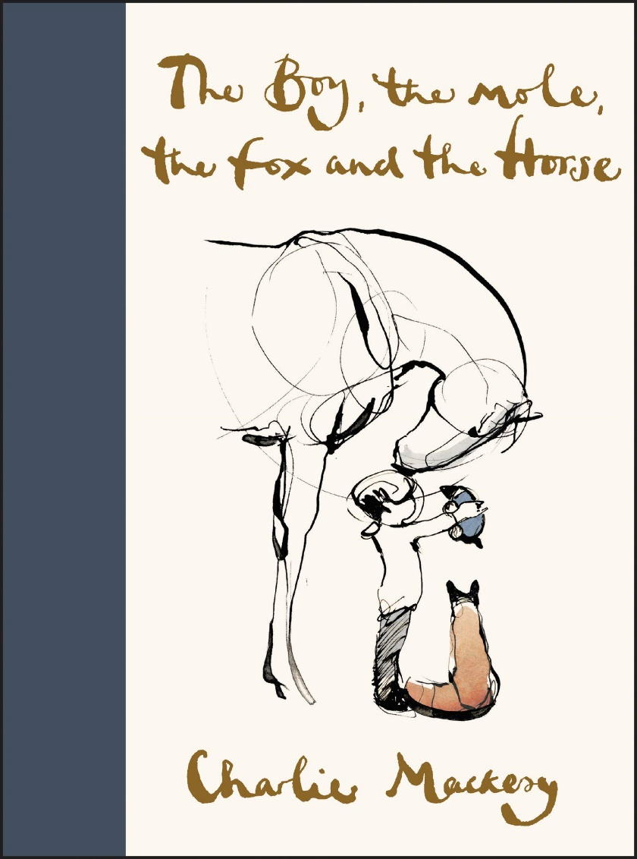

LO: I can write a prediction about a story from looking at the front cover

* Think about the picture and title; what characters might be in the story?
* Where might the story be set? When might the story have been set? What might the story be about?

|  |
| --- |
|  |
|  |
|  |
|  |
|  |
|  |
|  |
|  |
|  |
|  |