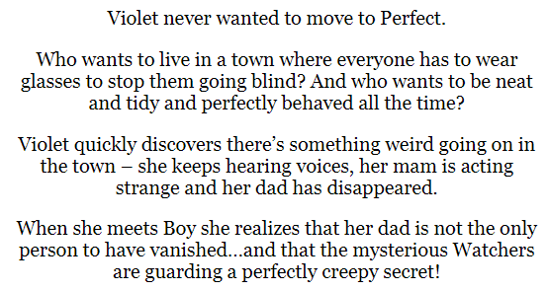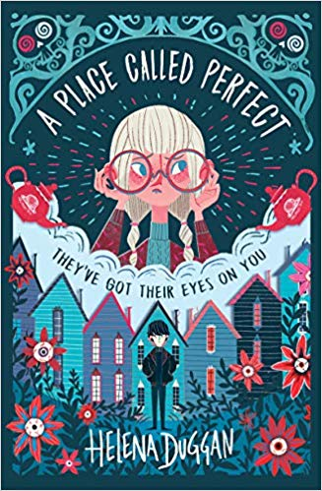

**Day one**

1. Look at the front cover: make a prediction about the story by using the title and the images on the front of the book.

___________________________________________________________________________________________________________________________________________________________________________________________________________________________________________________**(2 marks)**

1. Read the blurb. Why do you think everyone goes blind in Perfect?

**___________________________________ (1 mark)**

1. Do you think that the place called Perfect is perfect? Explain your answer.

________________________________________________________________________________________________________________________________________________________________________________________________________________________________________________________________________________________________________________________________________________________________________**(3 marks**)

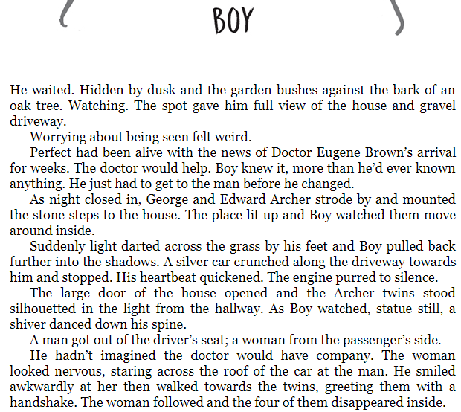

Read the extract of chapter one, **‘Boy’.**

4) Clarify what the phrase, ‘Perfect had been alive with the news…’ means.

__________________________________________________________________________________________________________________________(1 mark)

5) What do you think the Doctor will help with?

__________________________________________________________________________________________________________________________(1 mark)

6) Find a word in the text which is similar in meaning to a risky manoeuvre.

_____________________ (1 mark)

7) Why do you think the girl could be frightened?

__________________________________________________________________________________________________________________________(1 mark)

**Grammar focus**

**8) Find an example of an adverbial phrase in the text. _______________________________________________ (1 mark)**

**9) Find an adverb in the text. __________________(1 mark)**

**10) Find an example of parenthesis in the text.**

**_______________________________________________________(1 mark)**

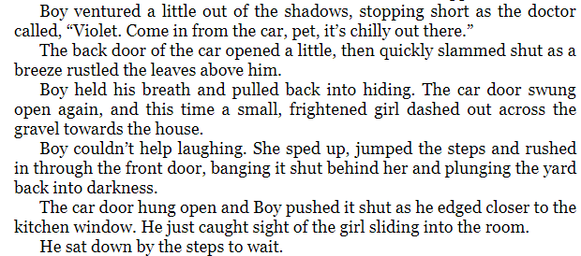

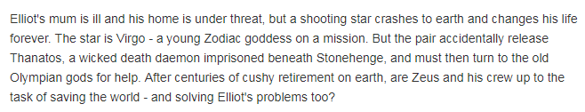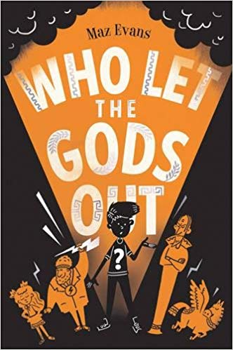

**Day two**

1) Look at the front cover: make a prediction about the story by using the title and the images on the front of the book.

__________________________________________________________________________________________________________________________________________________________________________________________________________________________________________ **(2 marks)**

2) Read the blurb. Clarify what a ***cushy retirement*** is.

**___________________________________ (1 mark)**

3) What do you think Elliot’s problems are?

______________________________________________________________________________________________________________________________________________________________________________________________________________________________________________________________________________________________________________________________________________________________ **(2 marks**)

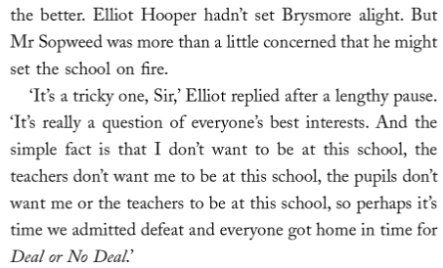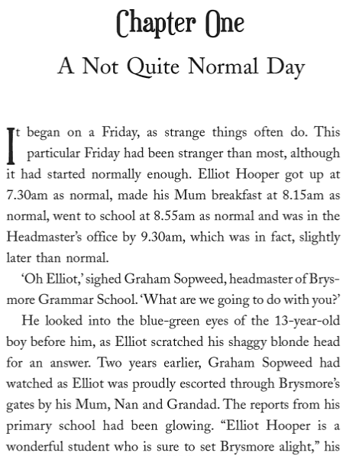

Read the extract of chapter one, **‘A Not Quite Normal Day.’**

4) Why has the author repeated the word ‘normal’ in the first paragraph?

______________________________________________________________________________(1 mark)

5) Find a word that is a synonym for guided.

______________________________(1 mark)

6) What is Mr Sopweed worried that Elliot might do to the school?

________________________________________________________________________________ (1 mark)

7) Find evidence that Elliot doesn’t want to stay at school.

_________________________________________________________________________________(1 mark)

**Grammar focus**

**8) Find an example of an apostrophe for contraction. ___________________ (1 mark)**

**9) Find 3 adjectives from the text. __________________(1 mark)**

**10) Find a hyphenated word in the text. _______________________________ (1 mark)**

**_______________________________________________________(1 mark)**

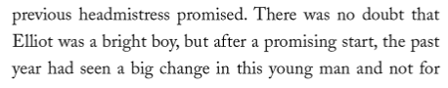

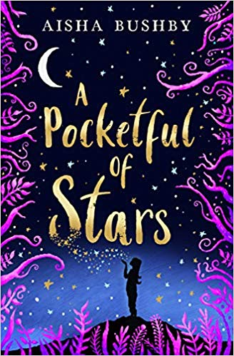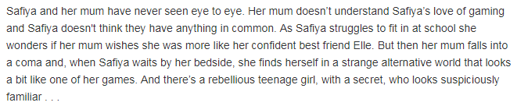

**Day three**

1) Look at the front cover: make a prediction about the story by using the title and the images on the front of the book.

__________________________________________________________________________________________________________________________________________________________________________________________________________________________________________ **(2 marks)**

2) Read the blurb. What does, ‘**had never seen eye to eye’** mean?

**____________________________________________________________________________ (1 mark)**

3) What does it mean to **fall in to a coma?**

______________________________________________________________________________ **(1 mark**)

4) What impression do you get of the character Safiya?

_______________________________________________________________________________**(1 mark)**

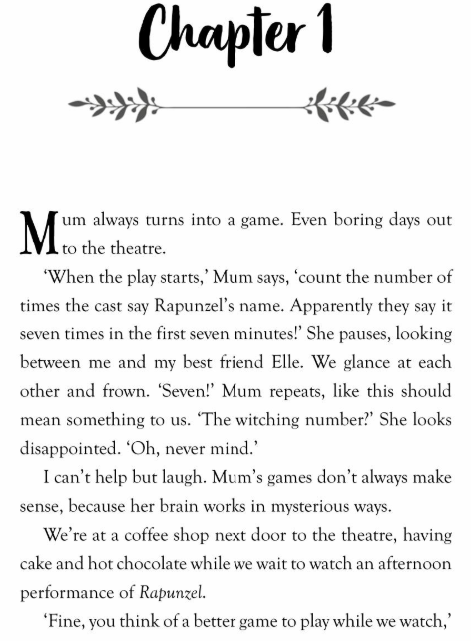

Read the extract of chapter one, **‘Chapter 1.’**

4) What impression do you get of the character, ‘Mum?’

__________________________________________________________________________________________________________________________(1 mark)

5) What does mum think the number 7 means?

__________________________________________________________________________________________________________________________(1 mark)

6) Find the word which means to pull a miserable face.

_____________________ (1 mark)

7) Find the synonym for look.

_________________________________ (1 mark)

**Grammar focus**

**8) Expand the noun phrase, ‘a coffee shop.’ _______________________________________________ (1 mark)**

**9) Find and copy an example of a subordinate clause. _______________________________________________________(1 mark)**

**10) Expand the contraction ‘we’re.’**

**_______________________________________________________(1 mark)**

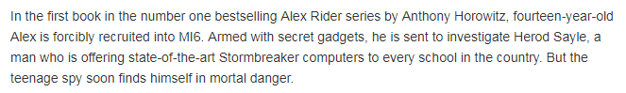

**Day four**

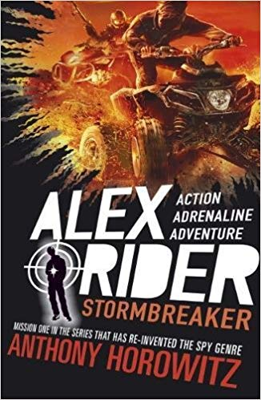

1) Look at the front cover: make a prediction about the story by using the title and the images on the front of the book.

__________________________________________________________________________________________________________________________________________________________________________________________________________________________________________ **(2 marks)**

2) Read the blurb. What does ‘**forcibly recruited’** mean?

**____________________________________________________________________________ (1 mark)**

3) What ‘mortal danger’ do you think Alex Ride could be in**?**

______________________________________________________________________________ **(1 mark**)

4) According to the text, what is Alex Rider’s first mission?

_______________________________________________________________________________**(1 mark)**

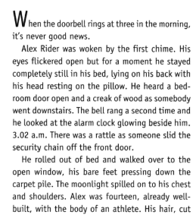

Read the extract of chapter one, **‘Funeral voices’.**

4) How do you think the first line is effective?

____________________________________________________________________________________________________________________________________________________________________(1 mark)

5) How do you think Alex feels when he looks out of the window?

____________________________________________________________________________________________________________________________________________________________________(1 mark)

6) Why do you think Alex didn’t go downstairs immediately?

____________________________________________________________________________ (1 mark)

7) What does Alex ‘already know’ at the end of the extract?

__________________________________________________________________________________________________________________________(1 mark)

**Grammar focus**

**8) Find an example of a subordinate clause. _______________________________________________ (1 mark)**

**9) Find an expanded noun phrase in the text**

**_______________________________________________(1 mark)**

**10) Add a relative clause to this sentence:**

**Alex Rider, ______________________________, was woken by the first chime.**

**(1 mark)**

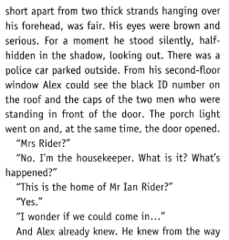

**Day five**

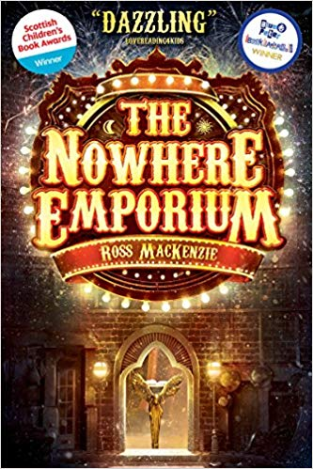

When the mysterious Nowhere Emporium arrives in Glasgow, orphan Daniel Holmes stumbles upon it quite by accident. Before long, the 'shop from nowhere' -- and its owner, Mr Silver -- draw Daniel into a breath-taking world of magic and enchantment. Recruited as Mr Silver's apprentice, Daniel learns the secrets of the Emporium's vast labyrinth of passageways and rooms -- rooms that contain wonders beyond anything Daniel has ever imagined. But when Mr Silver disappears, and a shadow from the past threatens everything, the Emporium and all its wonders begin to crumble. Can Daniel save his home, and his new friends, before the Nowhere Emporium is destroyed forever?

1) Look at the front cover: make a prediction about the story by using the title and the images on the front of the book.

__________________________________________________________________________________________________________________________________________________________________________________________________________________________________________ **(2 marks)**

2) Read the blurb. What does ‘**orphan’** mean?

**____________________________________________________________________________ (1 mark)**

3) Clarify what it would mean to be an apprentice.

______________________________________________________________________________ **(1 mark**)

4) What is one effect of Mr Silver’s disappearance?

_______________________________________________________________________________**(1 mark)**

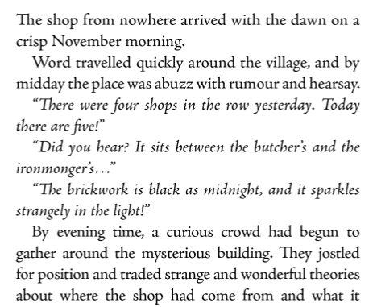

Read the extract of chapter one, **‘Prologue.**

4) What does **‘abuzz with rumour and hearsay’** suggest about the place?

__________________________________________________________________________________________________________________________________________________________________(1 mark)

5) Why has the author use italics for the speech in the first part of the extract?

________________________________________________________________________________________________________________________________________________________________ (1 mark)

6) Find a word similar to conspiracies.

_________________________________________________________________________ (1 mark)

7) What does **intricate** mean?

__________________________________________________________________________(1 mark)

**Grammar focus**

**8) Write a question you have about The Nowhere Emporium that has appeared on the street. Remember to punctuate accurately.**

**_________________________________________________________ (1 mark)**

**9) Find and copy an adverbial phrase.**

**_______________________________________________(1 mark)**

**10) Improve, ‘the shop’ by expanding this noun phrase.**

**________________________________________________________ (1 mark)**

**(1 mark)**

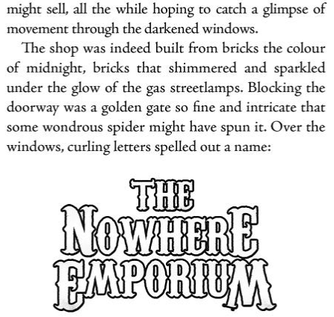

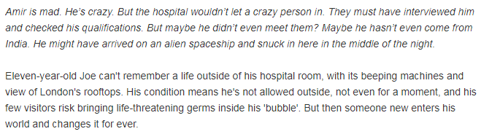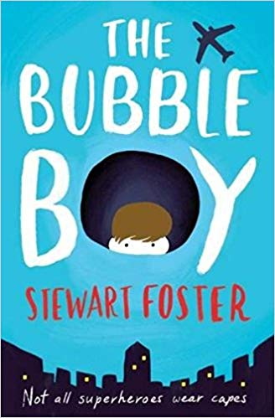

**Day six**

1) Look at the front cover: make a prediction about the story by using the title and the images on the front of the book.

__________________________________________________________________________________________________________________________________________________________________________________________________________________________________________ **(2 marks)**

2) Read the blurb. What does Joe’s condition mean he can’t do?

**____________________________________________________________________________ (1 mark)**

3) Why do you think that this book is titled, ‘The Bubble Boy?’

______________________________________________________________________________ **(1 mark**)

4) How do you think Amir relates to this story?

_______________________________________________________________________________**(1 mark)**

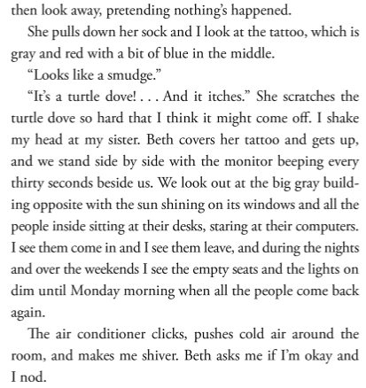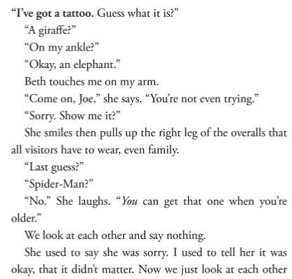

**Answer the following questions:**

4) Why do you think visitors have to wear overalls? (1 mark)

5) Why do they, ‘look at each other and say nothing?’ (1 mark)

6) Find evidence that the narrator of the story doesn’t leave the room. (1 mark)

**7) List four different pieces of punctuation that are used in this extract. (1 mark)**

**8) Find and copy an adverbial phrase.**

**9) Why does the word, ‘nothing’s’ have an apostrophe?**

**10) Improve, ‘the shop’ by expanding this noun phrase.**

**________________________________________________________ (1 mark)**

**(1 mark)**

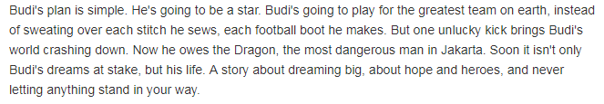

**Day seven**

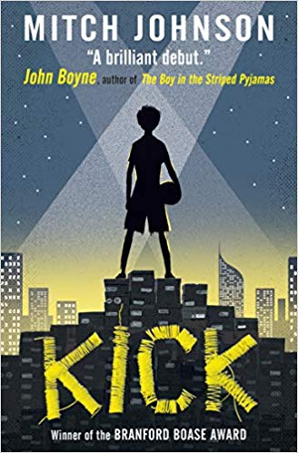

1) Look at the front cover: make a prediction about the story by using the title and the images on the front of the book.

__________________________________________________________________________________________________________________________________________________________________________________________________________________________________________ **(2 marks)**

2) Read the blurb. What is Budi’s plan?

**____________________________________________________________________________ (1 mark)**

3) What could have happened to make Budi owe the dragon?

______________________________________________________________________________ **(1 mark**)

4) Why is the front cover effective when comparing it to the final line of the blurb?

_________________________________________________________________________________________________________________________________________________________________________ **(2 marks)**

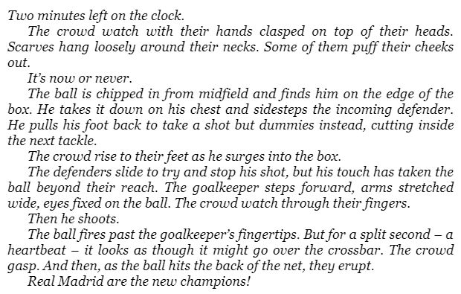

Read the extract of chapter one, **‘It’s now or never.’**

4) What does the word, ‘**surges’** mean**?**

_____________________________________________________(1 mark)

5) Why has the author use italics for the first part of this chapter?

____________________________________________________________________________________________________________________ (1 mark)

6) Why does Budi have blood trickling down his leg?

_____________________________________________________ (1 mark)

7) What does, ‘**the crumbling apartment blocks rise up like a stadium on every side’** suggest about where Budi and Uston are playing football?

____________________________________________________ (1 mark)

**Grammar focus**

**8) Find and highlight an example of parenthesis in the text.**

**9) Find and copy two verbs from the text.**

**_______________________________________________(1 mark)**

**10) Improve, ‘the crowd’ by expanding this noun phrase.**

**__________________________________________________ (1 mark)**

**(1 mark)**

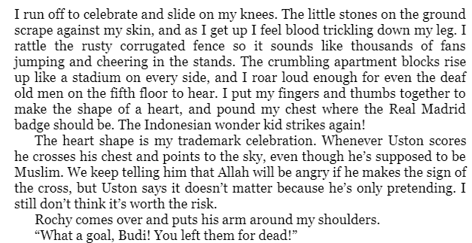

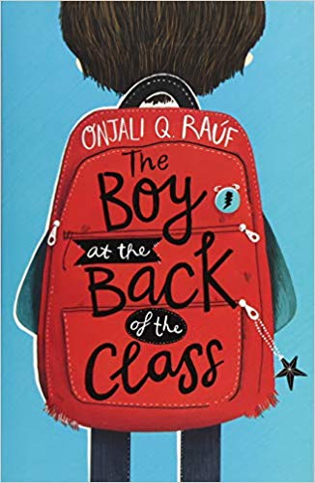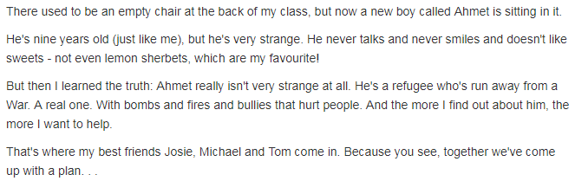

**Day eight**

1) Look at the front cover: make a prediction about the story by using the title and the images on the front of the book.

__________________________________________________________________________________________________________________________________________________________________________________________________________________________________________ **(2 marks)**

2) Read the blurb. Clarify what a refugee is.

**____________________________________________________________________________ (1 mark)**

3) What impression do you get of the character Ahmet from the blurb?

______________________________________________________________________________ **(1 mark**)

4) What do you think the plan could be that they have come up with?

_________________________________________________________________________________________________________________________________________________________________________(**2 marks)**

Read the extract of chapter one, **‘The empty chair.’**

4) What do you think the most exciting thing that could ever happen was**?**

________________________________________________________________(1 mark)

5) Why would the narrator get extra pocket money at the start of a brand new term?

________________________________________________________________ (1 mark)

6) What impression do you get of the character who is telling the story?

________________________________________________________________________________________________________________________________________ (2 marks)

**Grammar focus**

**7) Why has the author used a dash in the final part of the extract? _________________________________________________________________________________________________________________________________________(1 mark)**

**8) Find and copy a subordinate conjunction in the text.**

**_______________________________________________(1 mark)**

**9) Find an adverb in the text.**

**__________________________________________________ (1 mark)**

**(1 mark)**

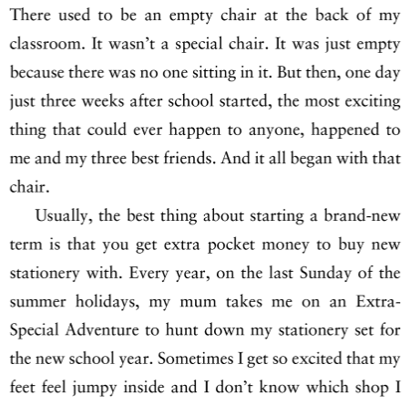

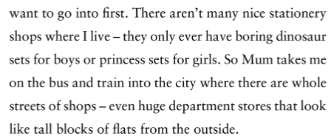

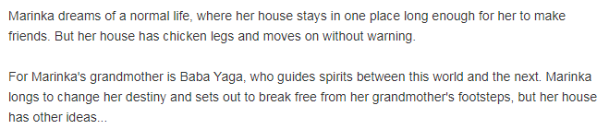

**Day nine**

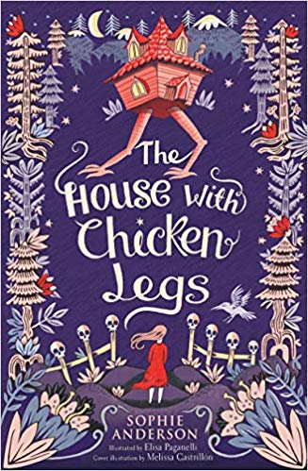

1) Look at the front cover: make a prediction about the story by using the title and the images on the front of the book.

__________________________________________________________________________________________________________________________________________________________________________________________________________________________________________ **(2 marks)**

2) Why does Marinka struggle to make friends?

**____________________________________________________________________________ (1 mark)**

3) Clarify what Marinka’s grandmother does.

______________________________________________________________________________ **(1 mark**)

4) What does it mean to break free from someone’s footsteps?

_________________________________________________________________________________________________________________________________________________________________________(**1 marks)**

Read the extract of chapter one, **‘Prologue.’**

4) Explain what the narrator’s house does a few times a year.

________________________________________________________________(1 mark)

5) What is the same about where the house ends up?

________________________________________________________________ (1 mark)

6) Infer how the character might feel when their house moves again. Explain your answer.

________________________________________________________________________________________________________________________________________ (2 marks)

7) Find evidence that the narrator is desperate to have company.

______________________________________________________________________________________________________________________________________(2 marks)

**Grammar focus**

**8) Find and copy a modal verb in the text. ________________________________________ (1 mark)**

**9) Find and copy the word which is close in meaning to the word ‘bleak’.**

**_______________________________________________(1 mark)**

**10) Find an adverbial phrase in the text.**

**__________________________________________________ (1 mark)**

