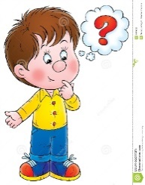

1. Where is Hamilton Square?
2. When was Hamilton Square built?
3. Who is James Gillespie Graham?
4. Hamilton Square is made up of lots of buildings that are Grade I listed buildings. Find out

how many.

1. What does it mean if a building is ‘listed’?
2. What is the main Grade II building over- looking the Square in Hamilton Square?
3. Name the monuments located in Hamilton Square.
4. When was Hamilton Square train station built?
5. What were the buildings in Hamilton Square used for in the 1800’s?
6. What are the buildings in Hamilton Square used for now?
7. Key information you have learned about Hamilton Square:

I can find out about the history of Hamilton Square