JUST VISITING
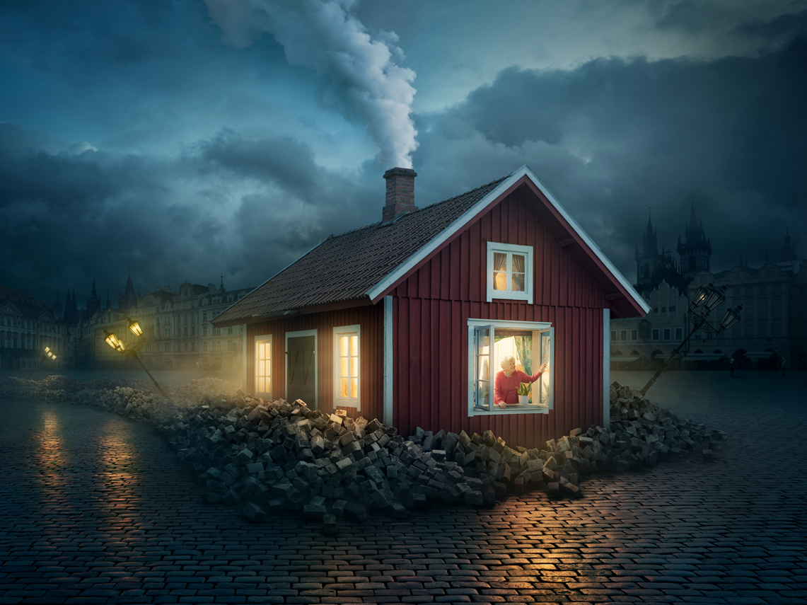

- What can you see? What do you think has happened/is happening/will happen? What do you wonder? See think wonder
- Where did the house come from?
- How do you think it got here? (Which direction did it come from? How fast was it travelling?) Why is it surrounded by all of the bricks? What happened to the lampposts?
- Who is the woman inside the house? Was she bothered by the ‘landing’? Give evidence to support your opinion.
- Why is she looking out of the window? What might she be thinking?
- Do you think she’ll stay here for long? Why/why not?
- Do you think anyone else is in the house with her?
- Why do you think she came to this place? Where is this?
- If your house could travel, where would you like to go? Have a look at maps/travel brochures/best places to visit lists. Make a travel itinerary for you and your house. Are there any costs involved? How much spending money would you take? Which currencies would you need? Which languages would you need to be able to speak? What sights would you see?
Write a short story (no more than a page) about what would have happened here.

