How to Access Seesaw for the First Time
STEP 1:
Go to the Seesaw website at http://app.seesaw.me or install the iOS or Android Seesaw app.
STEP 2:
Select “I am a student”:
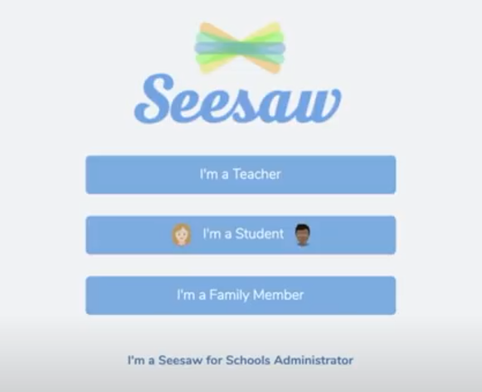
STEP 3:
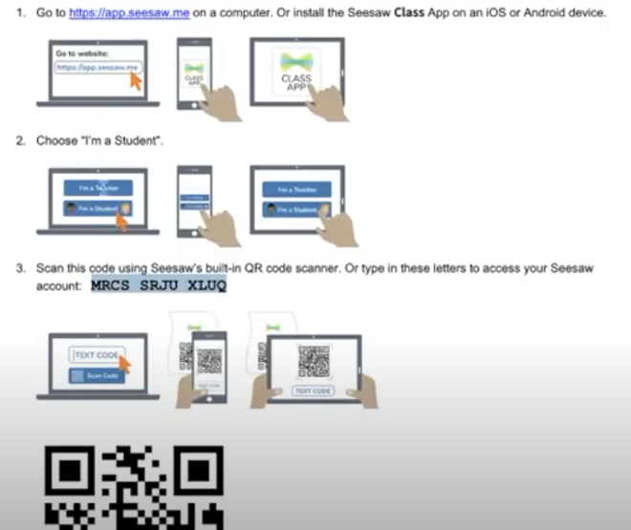
Either enter the code on your welcome letter or using your device, scan the QR code:
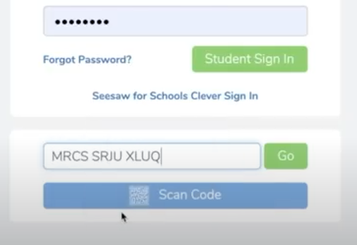

The Login Page of Seesaw
Your Welcome Letter

For a full video guide produced by Seesaw, please visit: https://www.youtube.com/watch?v=g5jG9VoROFs

