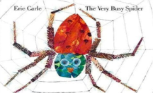
Summer term- week 4 Maths activity board – The Very Busy Spider
Webs everywhere!  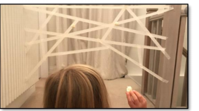  Unleash your inner Spiderman by making your own web. You could use tape or string to make it a 3-D web. How will you connect it? How long did it take you?  Taking it further  If you have made a sticky web with tape, see who can get the most flies to stick to it! (You could use rolled up tape.) Roll 10 or 20 “flies” and see how many go into your web or are outside your web. You can do this on the floor like the picture with tape or just chalk. What else will you catch in your web?  Please see separate pictures for enlarged images of the webs.  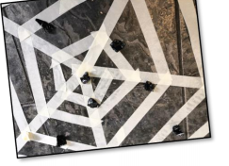  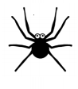  Number Bond Incy!  Can you remember the Rhyme Incy wincy spider?  Try the Number Bond Incy Nursery rhyme!  10 wincy spiders climbed up the water spout. Down came the rain and washed 5 spiders out. Out came the sunshine and dried up all the rain. So 5 wincy spiders won’t climb the spout again!  Repeat with different numbers!  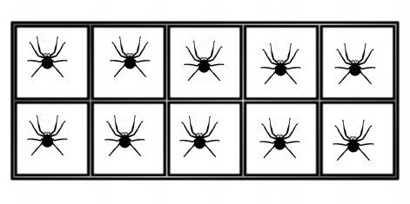  Use a ten frame to help you count. You can cross out the spiders as you count (I have uploaded a ten frame template or you could draw your own). You could also use objects to represent your spiders and place them on a blank ten frame. Physically take your spiders away. How many are left?  Ten Frame | 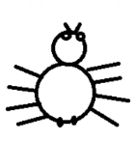  Spider Drive  Have you ever played the game beetle drive? This is the same but with the parts of a spider. All you need is a dice and a paper and pencil!  No dice? No problem!  I have uploaded a picture of a dice net. You could make one from a tissue cube or cardboard. There is also a roll dice app.  Spider Drive instructions  -Roll the dice  -Look at which part of the spider you can draw.  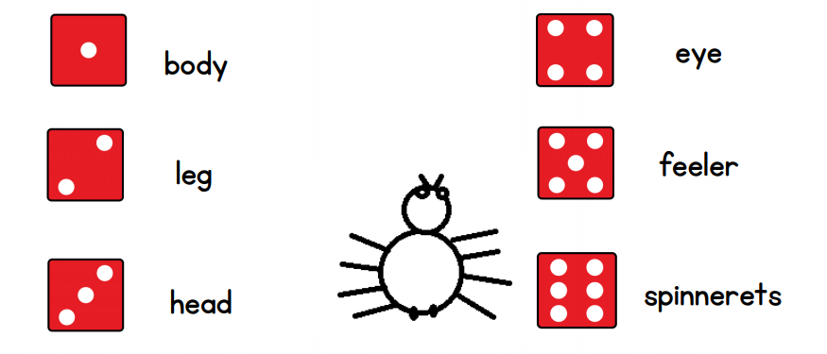  The winner is the first to draw a complete spider.  Please see separate picture for enlarged image.  Doubles or not doubles?  As we know spiders have 8 legs, 4 on each side. Can you sort spiders into doubles and not doubles?  Some of our spiders have been losing their legs!  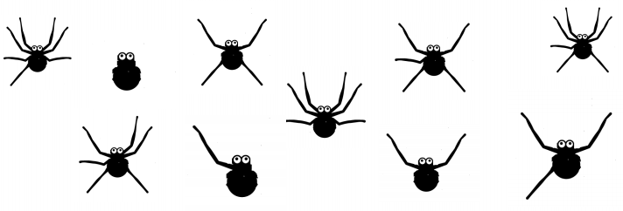  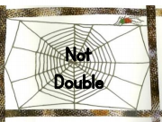  Decide which spider is a double and which web it should live in!  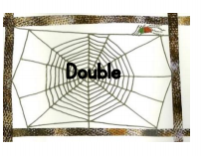  Please see separate photo for the enlarged version of Double or Not Doubles.

