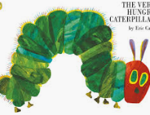
Summer term- week 3 Maths Activity Board – The Hungry Caterpillar

Picnic Time- Halving and sharing  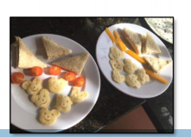  Have a look and see if you have any of the food the hungry caterpillar has to eat and make a picnic! Think about what you will need and how many people are going to come. (Psst… it could be a picnic in the living room!)  Enjoy getting your things out for your picnic how are you going to share your food? To halve things we need to share into 2 equal groups. Have a look here. Have these 2 children each got the same? Look closer. If there are more people at the picnic, let’s say 3, how many sandwiches could they have each? How will you share things for your picnic?  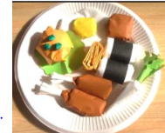  Talk about how much of each thing you would have. You draw your picnic on a paper plate or a circle of paper or find the food in magazines  Taking it further  You could or make your own 3-D models. | Finger Painting- one more, one less and doubles  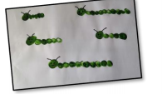  Dip a finger in the paint and make your prints close together to look like caterpillars (or just draw.) How many body parts has he got? Count together and then talk about how many there would be if there was one more. Look at adding more, explore adding different amounts. How big is he now? For example, if we use the language of first, then, now. First he had 8 body pieces, then we added 2 more, now he’s got 10!  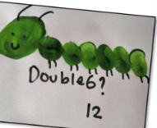  Take another look at your little creatures. How many body parts would there be one less? Can you make a caterpillar that is 3 less? Paint or draw yourself some more caterpillars  Taking this further -Doubling  Have a look at the caterpillar. On quite a few of his body parts he has 2 little legs. Can you create some doubles with your caterpillars? You could draw on his legs! Count how many body parts and double it to get the legs!  Please see separate pictures for examples.

From Caterpillar to Butterfly –symmetry  Have a go at making your own symmetrical butterfly. Fold paper in half so you can see the line down the middle. Squeeze different colours of paint into the middle and fold over. Gently squidge the paint to the edges of the paper with flat hands.  Open up and see your fantastic butterfly! Or use felt tips and ensure you draw the same pattern on each side – you could use a mirror to help you! If you don’t want to draw you can still look at matching patterns by using Lego!  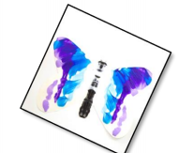  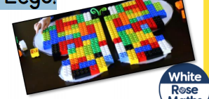 | Fruit Bowl-grouping, adding and taking away  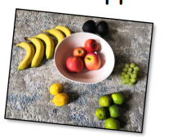  Explore your fruit bowl and look at what's in it! How we can sort it? What groups have you got in there? How can you combine these to make some maths problems?  How many of each fruit have you got in there? Can you look at different ways of combining amounts? For example what number do you get when you combine apples and bananas? Lemons and limes? How many bananas would I have if I had one less? Make some fruity patterns! What will be my next fruit?  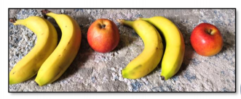  Taking it further  Make a list of your favourite fruits. What will be number 1? Could you work out which fruit is the most popular in your house? Which fruit will be the winner? Is all your fruit in the bowl? I hope there isn’t any evil fruit in the freezer!

