Using Online Bug Club Reading Books
Hello!
We’ve noticed that some children have been opening their assigned reading books but perhaps not answering all of the questions by clicking on the bug faces. Their teacher will only be able to see if they have completed the book once all of the bug faces have been answered. Here’s a picture guide to what you will see when you log on and how to know if you have done all of the questions. Happy reading!
‘My Stuff’ shows assigned work
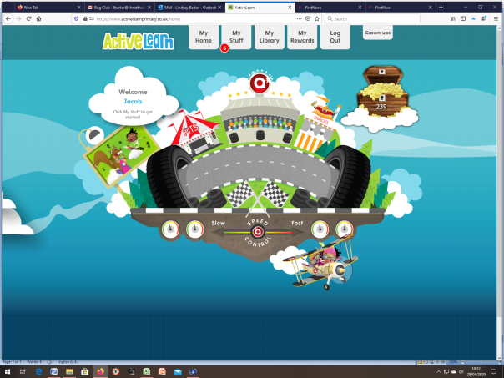

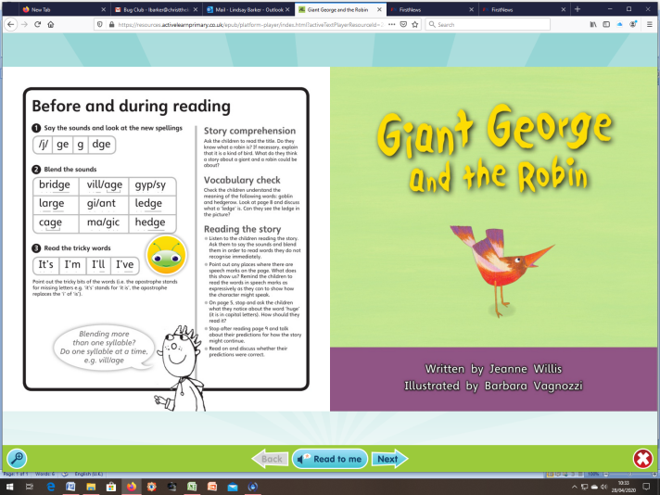
Watch out for the bug faces. You need to click on these to answer questions. There is an option to have the question read aloud. If the eyes are open, the question has not been answered yet.
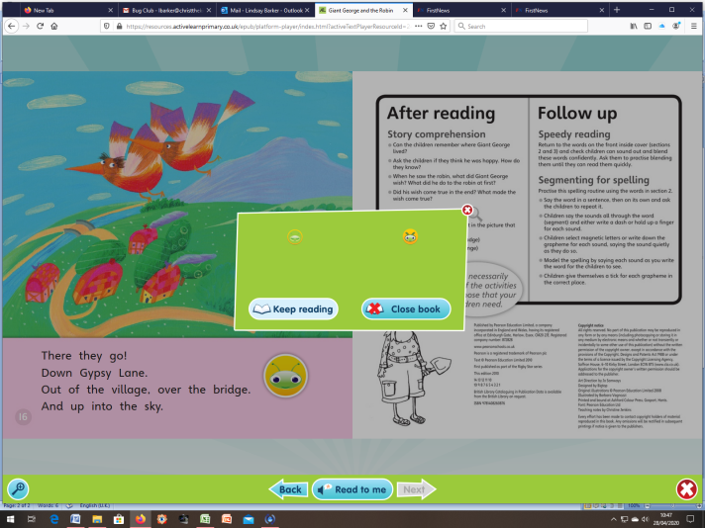
This last box will show you if you have missed out any questions. Click on ‘Keep reading’ to go back and find where you missed one out.
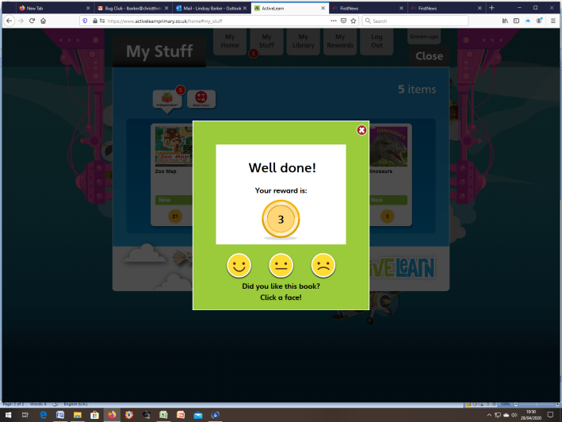
Points are awarded when books are finished. Your child should also record their enjoyment level of the book.

