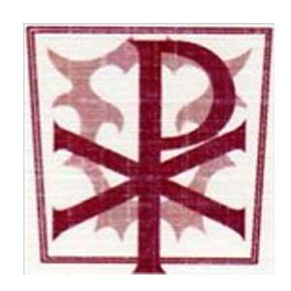
Year 4 Home Learning Tasks – Summer Term 1 2020
Children should complete at least one task from each box per week.
Design and make  - Design and make your own poster or model of the water cycle  - Make a time capsule or memory box for lockdown 2020. You could include a photograph of you and your family now, a personal letter explaining what life is like at the moment, pictures or cards you have made, newspaper articles.  - A stop animation story. Create a story board for the characters and plot, and then ask an adult to help you record the story as a stop animation film. There are lots of apps you can download to help you.  - Design and decorate pebbles with different textured decorations. What materials have you got in your garden or around your house that you could use to create texture? Put them outside your house to cheer up passers-by.  - Design and create your own museum in a room in your house. Use your own art that you create from Picasso self-portraits or print out the works of Picasso and create your own frames. Then, think of a title and explanation to stick next to each picture. | Write  - A knowledge organiser for our Science topic ‘States of matter’. Include pictures of the water cycle, definitions and examples of solids, liquids and gases, key vocabulary.  - A postcard to send to a child in another country. Explain what life is like here for you are the moment and think about what questions you would ask them?  - A script for a news report for a news channel reporting what like is like for school children at the moment in this country.  - Write a story about life in lockdown. You could be the main character. Write in 1st person and try to include speech, remember; new line new speaker, inverted commas and reporting clause e.g. whispered.  - Write a prayer for someone at this time. Remember the different ways you can start your prayers; Heavenly Father, Lord hear us, Let us pray, We ask God…
Find out  - All about the water cycle.  - Research the artist Picasso and self-portraits.  - Research the world’s highest mountains and largest rivers.  - What happens when you freeze different liquids? For example; water, salty water, water with food colouring, fizzy water. Make a prediction and then evaluate this after you experiment.  - Find out all about water: Can water be found anywhere else in the universe apart from planet Earth? How much of a human is made of water? Can water be freezing but still a liquid? | Do  - Read for pleasure  - Using a mirror draw a self-portrait  - Watch your favourite film and write a play script for your favourite scene  - Create an activity circuit with stations in your garden. At each station a different movement or activity e.g. station 1: 10 star jumps, Station 2: how many times can you throw the ball in the bucket in 1 minute.  - Create a dance to your favourite song. Think about movements for 8 counts, could you repeat moves? Do your movements fit with the pace of the music?  - Create your own movements to represent a solid, liquid and gas.  - Collect items from around your house and label them; solid, liquid and gas.

