First News Log On (Y3-6)
https://ihub.firstnews.co.uk/
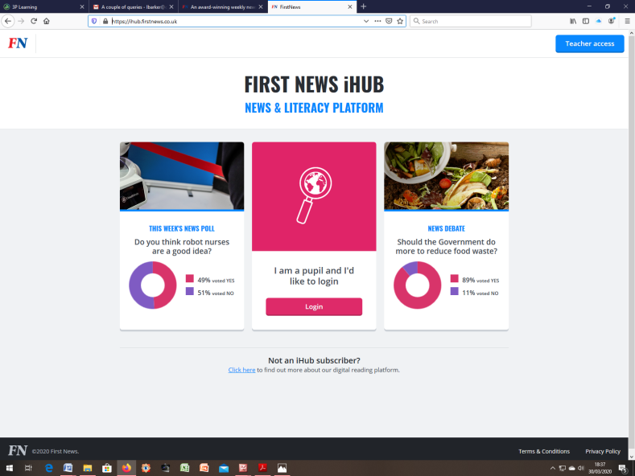
Click log on button
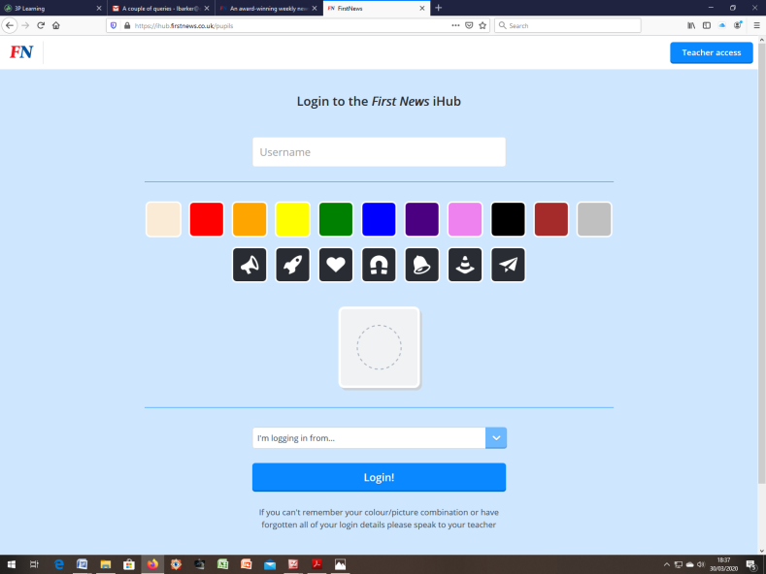
Type in username and click colour and symbol of password then choose:
I’m logging on ‘from home’
Then click log in.

