KS2 Reading/Accelerated Reader

Accelerated Reader now allow quizzing from home. You can only access this on:
https://ukhosted77.renlearn.co.uk/2244400/

MyOn has lots of free ebooks until the end of June that are levelled by Accelerated Reader levels.
https://readon.myon.co.uk/library/browse.html
Although these are levelled in American terms (and likely have American spellings in them) they still provide reading content when we can’t access libraries and school books. The higher the ‘Lexile level’ and ‘Guided reading’ letter, the harder the book. However, there are a number of genres and you can listen to them too.
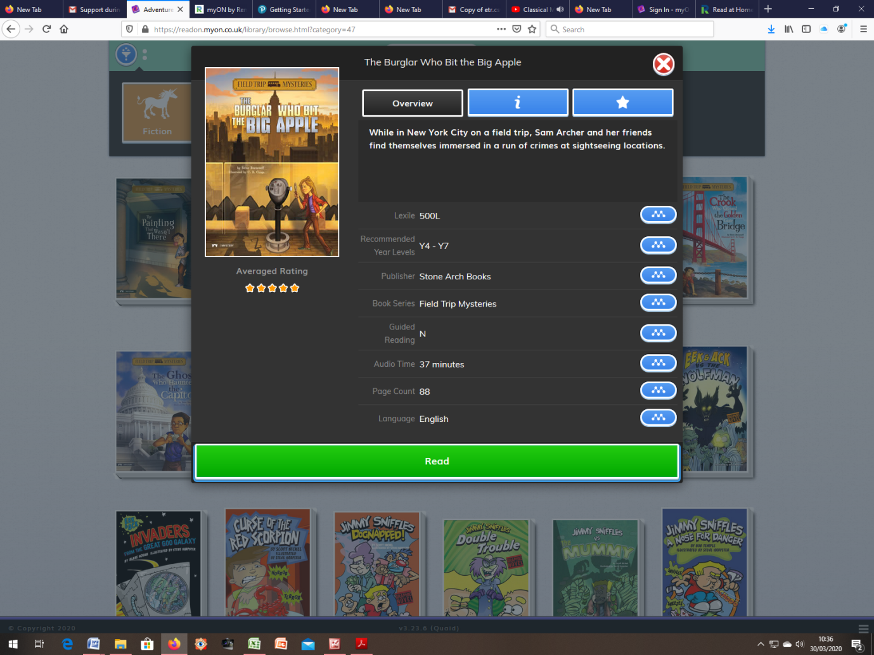
Audible are also providing free access to audio books.
https://stories.audible.com/discovery

