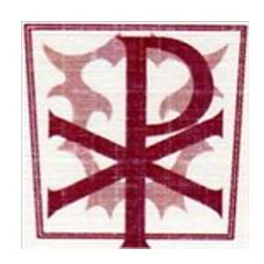
Year 4 Home Learning Tasks - Spring Term 2020
Children should complete at least one task from each box per week.
Design and make  - Draw a Mayan mural painting  - Design Mayan pottery and make it out of plasticine or play-doh  - Design a Mayan headdress and make it out of resources you have at home (think about who you are making your headdress forin the Mayan hierarchy)  - Design and make an instrument  - Design and make your own Mayan hierarchy game  - Weave a Mayan clothing item | Write  - An information booklet on the digestive system and how to look after our bodies  - A letter to S. F. Said about your opinion of Varjak Paw and any questions you would like to ask about the story  - A Poem about food (choose your favourite foods)  - A recipe for a Mexican meal  - Write a travel brochure to advertise a trip to Mexico using all your knowledge from the fact files; include human and physical features to visit. What will you include to persuade people to go?  - Write a newspaper report on a fictional Mayan football game (Pok-ta-Pok)
Find out  - Find out which are the most popular meals in Mexico  - Find out about the different instruments used in South American (Latin American) music  - Find out what currencies are used in South America  - Research the history of South American football  - Find how many languages are spoken in South America  - Find out about different breeds of cats e.g. Bengal , Persian, Siamese | Do  - Visit the local park and make a map of the route from your house to the park. Use the symbols we have learned in our Orienteering lessons  - Listen to a variety of Mexican music  - Listen to Charleston music  - Create your own Charleston dance  - Play your Mayan hierarchy game  - Read for pleasure  - Watch your favourite film and write a play script for your favourite scene

