Department for Education Vision for the Primary PE and Sport Premium
ALL pupils leaving primary school physically literate and with the knowledge, skills and motivation necessary to equip them for a healthy, active lifestyle and lifelong participation in physical activity and sport
The funding has been provided to ensure impact against the following OBJECTIVE:
To achieve self-sustaining improvement in the quality of PE and sport in primary schools. It is important to emphasise that the focus of spending must lead to long lasting impact against the vision (above) that will live on well beyond the Primary PE and Sport Premium funding.
It is expected that schools will see an improvement against the following 5 key indicators:
Evidencing the Impact of Primary PE and Sport Premium

- the engagement of all pupils in regular physical activity – kick-starting healthy active lifestyles
- the profile of PE and sport being raised across the school as a tool for whole school improvement
- increased confidence, knowledge and skills of all staff in teaching PE and sport
- broader experience of a range of sports and activities offered to all pupils
- increased participation in competitive sport
Under the new Inspection Framework, Ofsted inspectors will assess how effectively leaders use the Primary PE and Sport Premium and measure its impact on outcomes for pupils, and how effectively governors hold them to account for this.Improvements should enhance, rather than maintain existing provision. For example, where schools are using their funding to employ specialist coaches, these should be deployed alongside class teachers rather than displacing them, in order for their impact to be sustainable and to enable the upskilling of existing teachers.

You should ensure that information about your use of the premium is available on your school website in order to keep parents and others informed. This should be clear and easily accessible and we recommend that you upload the following template to your website for this purpose.
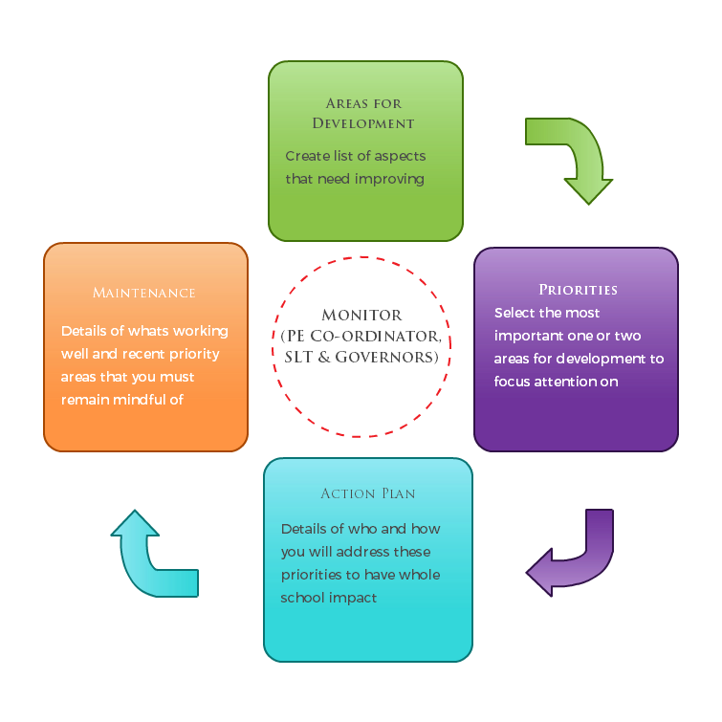
Primary Physical Education and Sport premium planning and actions should show how use of funding contributes to this vision through identified school priorities which can be measured through reference to key outcome indicators. It is important that the main drivers for improvement are those identified by the school through their self-review. Each school should aim to achieve the following objective:
OBJECTIVE:To achieve self-sustaining improvement in the quality of PE and sport in primary schools.

Please see Figure 1 (below): A process model to support your thinking:

HOW TO USE THE PRIMARY PE AND SPORT PREMIUM
Schools must use the funding to make additional and sustainable improvements to the quality of PE and sport they offer. This means that you should use the premium to:
- develop or add to the PE and sport activities that your school already offers
- make improvements now that will benefit pupils joining the school in future years
For example, you can use your funding to:
- hire qualified sports coaches to work with teachers
- provide existing staff with training or resources to help them teach PE and sport more effectively
- introduce new sports or activities and encourage more pupils to take up sport
- support and involve the least active children by running or extending school sports clubs, holiday clubs and Change4Life clubs
- run sport competitions
- increase pupils’ participation in the School Games
- run sports activities with other schools
You should not use your funding to:
- employ coaches or specialist teachers to cover planning preparation and assessment (PPA) arrangements - these should come out of your core staffing budgets
- teach the minimum requirements of the national curriculum – including those specified for swimming.

SECTION 1 – EVALUATION OF IMPACT/LEARNING TO DATE
In previous years, have you completed a self-review of PE, physical activity and school sport? Yes
Have you completed a PE, physical activity and sport action plan/ plan for the Primary PE and Sport Premium spend? Yes
Are your PE and sport premium spend and priorities included on your school website? Yes

Academic Year:  2018/2019 |  | Total fund allocated:  £19,629  Total Spent: 20,600
PE and Sport Premium Key Outcome Indicator | School Focus/ planned Impacton pupils | Actions to Achieve | Planned Funding | Actual Funding  REVIEW  06/19 | Evidence | Actual Impact (following Review)on pupilsREVIEW 06/19 | Sustainability/  Next Steps  REVIEW 09/19
1. the engagement of all pupils in regular physical activity – kick-starting healthy active lifestyles | To provide a broad and balanced curriculum and a related extra curriculum. To inform pupils in all PE and Sport lessons the importance of and how to lead a healthy lifestyle. | To review the curriculum and extra curriculum opportunities and ensure they meet the needs of the pupils to ensure all pupils have the opportunity to be active in and out of school. To give all pupils a questionnaire about what extra- curricular clubs they would like to see at CtK.  New sports provider Full of Beans employed from 1st September | £1,000 for new equipment |  | Numbers in extra curriculum sports clubs will increase by 10%. Knowledge and enjoyment to increase with children taking part in physical activity. This will be done by having a pupil survey – which will be repeated each year.  To increase KS1 clubs on offer  To provide more lunch time clubs |  | Taken on a new provider this year who has offered more clubs to our children. We now have KS1 children participating in clubs.
2. the profile of PE and sport being raised across the school as a tool for whole school improvement | Introduction of numerous clubs some of which to be delivered by Full of Beans and by school staff.  To look at introducing the Daily Mile across school  To ensure that the PE equipment we have in school meets the needs for the children. | Mrs Dennis (PE Specialist) to work with all classes throughout the year- team teaching and observing teaching staff. This is to help raise the standard of teaching within our Teaching Staff and TAs.  To develop use of equipment in hall, playground and field.  To replace active playground equipment | £1,000 |  | To look at impact of children taking part in extracurricular clubs.  To the increase confidence, skill set and enjoyment of PE for both the Teachers and Children. |  | JD has worked with both class teachers and TAs to up skill them in the delivery of the PE curriculum. In house competitions have been a huge part of our curriculum this year.  Active paly equipment has been purchased and new paly leaders have been trained to provide support on the yard during lunchtime.
3. increased confidence, knowledge and skills of all staff in teaching PE and sport | To continue to upskill the identified teachers. Will increase the achievement and attainment in PE | Mrs Dennis to continue to work with teachers in a variety of activities and year groups from Foundation Stage – Year 6  To continue using Ipep on line planning and assessment tool.  Mrs Dennis to team teach and appraise staff this year, during PE lessons. | £3,200 |  | Impact will be seen on the teacher evaluation sheets completed after each period of support.  To further develop the whole school tracking system of assessment for PE. |  | Teacher’s evaluation forms showed that staff now felt confident to teach the PE curriculum without further support from JD.  All staff are using IPep to assess children during PE lessons.
4. broader experience of a range of sports and activities offered to all pupils  To evaluate the use of PE equipment within school and to assess suitability for the curriculum now being taught.  To buy covered bike and scooter shelter for yard. | To provide a wider range of sports in both curriculum and extra curriculum time which will increase activity opportunities for pupils  To encourage pupils to cycle to school- starting the day active.. | Coaches to be used to introduce new activities through Full of beans provider.  To buy play leaders caps so that they are identified on the yard easily.  To purchase trolley for safe storage of PE mats.  To provide safe storage of bikes and scooters encouraging children to cycle to school. | £1,400active coach  £ 4,000  £ 3,300 |  | At least 5 new activities to be introduced to the school which will also increase school-club links  To raise opportunities of activities available in school for our children. |  | Full of beans provider used this year, fencing, dodgeball, gymnastics/dance for KS1has been introduced.  New trolley purchased to re-place broken one.  New bike and scooter shed bought and fitted in yard, the uptake of children coming to school in the summer term tripled to the point where the bike shed could not house the bikes!
5. increased participation in competitive sport | To increase the number of competitive opportunities available for pupils | To introduce some intra school competitions.  To expand entry into inter school competitions within the local cluster for KS1 and KS2 | £300 |  | .  The number of entries into inter school competitions to increase by 10% |  | Intra school competitions took place- gymnastic, dance, hockey, tag rugby, cross country, swimming.
- to repair, sand and safe seal both hall floors to ensure appropriate surface for children’s PE lessons. | To repair broken blocks, to sand and seal floors with sports safe seal. | To improve surface for children to be able to use for PE lessons. | £6,400 |  | To have more children taking part in physical education. |  | Both halls have been repaired and sealed with an anti- slip varnish so they are now safe spaces for PE lessons to take place in.

Completed by Joanne Procter
Date: 01/10/2018
Developedby

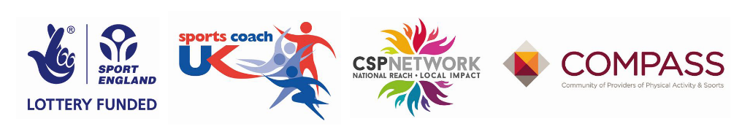
Review Date: 30/09/2019

