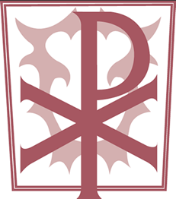
Christ the King Catholic Primary

Winter Uniform
Grey Trousers  White School CTK Polo Shirt  Maroon CTK Sweatshirt  Grey Socks  Black School Shoes(No trainers) | Grey Skirt  White School CTK Polo Shirt  Maroon CTK Sweatshirt/Cardigan  Grey Socks/Tights  Black School Shoes  Plain Hair Bobbles (no bows)

Summer Uniform
Grey Shorts  White School CTK Polo Shirt  Maroon CTK Sweatshirt  Grey Socks  Black School Shoes (No trainers) | Red Checked Summer Dress  Maroon CTK Sweatshirt/Cardigan  White Socks  Black School Shoes  Plain Hair Bobbles (no bows)  Uniform can be purchased from:  Wirral Uniform Centre  2 Princes Pavement  Birkenhead  Wirral  CH41 2XY  0151 647 9588  Design & Stitch Schoolwear  Tarran Way South  Moreton  CH46 4TP  0151 665 0088  https://www.wirralschooluniforms.co.uk/

Maroon CTK Book Bag – no other bags

PE Uniform
Maroon PE Shorts
White T-Shirt
Black Pumps
Maroon CTK Draw-String Pump Bag

