Christ the King Catholic primary School

Child on Child Abuse
Policy

Contents:
Heading | Page Number
Introduction |  | 3
Aims |  | 4
Context -Understanding child-on-child abuse |  | 4
Responding to Alleged Incidents/ Responding to reports of sexual violence and sexual harassment |  | 7
Follow up actions |  | 8
Options to manage the report |  | 8
Support for children affected by sexual assault |  | 10
Prevention |  | 11
Multi-agency working |  | 12
Appendices |  | 13

This policy will be reviewed regularly by the Headteacher and Governing body.
Guidance: Working Together to Safeguard Children ; KCSIE
Linked Policies: Child Protection Policy and Appendix, Positive Behaviour Policy, Anti-bullying Policy, Online Safety Policy

Introduction
Christ the King recognises that children are vulnerable to and capable of abusing other children. It is normal for some children and young people (CYP) to display sexualised behaviour towards other children as they develop. However, sexualised behaviour between children that has become harmful or abusive is unacceptable and must be addressed.
We take such abuse as seriously as abuse perpetrated by an adult. This includes verbal as well as physical abuse. Child-on-child abuse will not be tolerated or passed off as part of “banter” or “growing up”.
Christ the King adopts a ‘zero tolerance’ policy towards child-on-child abuse. These allegations are managed in the same way as any other child protection concern and follow the same procedures, including seeking advice and support from other agencies as appropriate.
This policy is in line with the child protection requirements in KCSIE. Part 5 of the Keeping Children Safe in Education statutory guidance sets out how schools should manage reports of child-on- child sexual violence and harassment.
We are committed to a whole school approach to ensure the prevention, early identification, and appropriate management of child-on-child abuse within our school and beyond.
In cases where child-on-child abuse is identified we will follow our child protection procedures, taking a proportionate, case by case, contextual approach to support all children and young people who have been affected by the situation.
As per KCSIE, we recognise that child-on-child abuse is most likely to include, but may not be limited to:
- Bullying (including cyber-bullying, prejudice-based and discriminatory bullying) • Physical abuse
- Sexual violence
- Sexual harassment
- Causing someone to engage in sexual activity without consent
- Consensual and non-consensual sharing of nude and semi-nude images and/or videos • Upskirting
- Abuse in intimate relationships
- Initiation/hazing type violence and rituals
Some of these behaviours will need to be handled with reference to other policies in school such as the positive behaviour policy, anti- bullying policy, child protection policy and online safety policy.
This policy concentrates on child-on-child abuse in the context of sexual harassment and sexual violence. It is compliant with the statutory guidance on child-on-child abuse as set out in Keeping Children Safe in Education and should be read in conjunction with the school’s Child Protection Policy and Procedures, and relevant Practice Guidance.

Policy Development
The policy has been developed in consultation with the following groups
Mrs Joanne Procter-DSL and Headteacher
Mrs Lindsay Barker-Deputy Headteacher and Deputy DSL
Mrs Jenny Jones- Assistant Headteacher and Deputy DSL
Mrs Karen Head- SBM and Deputy DSL
Mr Jeff Barker- Link Safeguarding Governor

Aims
The policy will: -
- Set out our strategies for preventing, identifying, and managing child-on-child abuse
- Take a contextual approach to safeguarding all children and young people involved. Acknowledging that children who have allegedly abused their children or displayed harmful sexual behaviour are themselves vulnerable and may have been abused by child, parents, or adults in the community.
The Context- Understanding Child-on-child abuse

Physical Abuse
While a clear focus of child-on-child abuse is around sexual abuse and harassment, physical assaults and initiation violence and rituals from pupils to pupils can also be abusive.
These are equally not tolerated and if it is believed that a crime has been committed, will be reported to the police.
The principles from the anti-bullying policy will be applied in these cases, with recognition that any police investigation will need to take priority.
When dealing with other alleged behaviour which involves reports of, for example, emotional and/or physical abuse, staff can draw on aspects of Hackett’s continuum (Appendix 1) to assess where the alleged behaviour falls on a spectrum and to decide how to respond. This could include, for example, whether it:
- is socially acceptable
- involves a single incident or has occurred over a period of time
- is socially acceptable within the child group
- is problematic and concerning
- involves any overt elements of victimisation or discrimination e.g. related to race, gender, sexual orientation, physical, emotional, or intellectual vulnerability • involves an element of coercion or preplanning
- involves a power imbalance between the child/children allegedly responsible for the behaviour • involves a misuse of power

Online Behaviour
Many forms of child-on-child abuse have an element of online behaviour including behaviours such as cyberbullying and sexting.
Policies and procedures concerning this type of behaviour can be found (in Anti- bullying Policy, Online Safety Policy, and Child Protection Policy).

Definition of Sexual Abuse
‘Forcing or enticing a child or young person to take part in sexual activities, not necessarily involving a high level of violence, whether or not the child is aware of what is happening. The activities may involve physical contact, including assault by penetration (for example rape or oral sex) or non- penetrative acts such as masturbation, kissing, rubbing and touching outside of clothing. They may also include non-contact activities, such as involving children in looking at, or in the production of, sexual images, watching sexual activities, encouraging children to behave in sexually inappropriate ways, or grooming a child in preparation for abuse. Sexual abuse can take place online, and technology can be used to facilitate offline abuse.
The sexual abuse of children by other children is a specific safeguarding issue in education’. KCSIE.

Sexual Violence and Sexual Harassment
Sexual violence and sexual harassment can occur between two children of any age and sex or a group of children sexually assaulting or sexually harassing a single child or group of children.
The impact of this behaviour on children can be very distressing and have an impact on academic achievement and emotional health and wellbeing. It is important to consider intra familial harm. It may be necessary to provide support to siblings.
Sexual harassment and sexual violence may also occur online and offline.
All behaviour takes place on a spectrum. Understanding where a child's behaviour falls on a spectrum is essential to being able to respond appropriately to it.

In this policy we recognise the importance of distinguishing between problematic and abusive sexual behaviour (Harmful Sexual Behaviour HSB).
We are adopting the NSPCC definition of HSB as: -
"Sexual behaviours expressed by children...that are developmentally inappropriate, may be harmful towards self or others, or be abusive towards another child...or adult."
We will also use Simon Hackett‘s continuum model to demonstrate the range of sexual behaviours- refer Appendix 1

Vulnerable Groups
We recognise that all children can be at risk however we acknowledge that some groups are more vulnerable. This can include experience of abuse within their family; living with domestic violence; young people in care; children who go missing; children with additional needs (SEN and/or disabilities); children who identify or are perceived as LGBTQ+ and/or have other protected characteristics under the Equalities Act 2010. The Human Rights Act 1998 and the Public Sector Duty are relevant.
Whilst research tells is us girls are more frequently identified as being abused by their children and, girls are more likely to experience unwanted sexual touching in schools this is not confined to girls.
Boys are less likely to report intimate relationship abuse and may display other behaviour such as antisocial behaviour. Boys report high levels of victimisation in areas where they are affected by gangs. We recognise that both boys and girls experience child-on-child abuse, but they do so in gendered ways.

Parents and Carers- Understanding of HSB
It is important that parents and carers understand what is meant by harmful sexual behaviour, and reinforce key messages from school at home. We work in partnership with parents to support our pupils and want to help them keep their child/ren safe. Parents and carers should understand:
- the nature of harmful sexual behaviour;
- the effects of harmful sexual behaviour on CYP;
- the likely indicators that such behaviour may be taking place;
- what to do if it is suspected that child on child sexual abuse has occurred;
Further information to support parents and carers in relation to harmful sexual behaviour is available online, including on the NSPCC and Lucy Faithfull Foundation websites.

Staff
Our staff undertake annual safeguarding training where the different types of abuse and neglect are discussed; this includes information about harmful sexual behaviour and our expectations for staff vigilance about this and other potential types of abuse. Staff also receive updates on safeguarding issues throughout the school year, including about the nature and prevalence of harmful sexual behaviour, where appropriate.
Importantly, the training also ensures that our staff know what to do if they receive a report that harmful sexual behaviour may have occurred, including how to support CYP.
All staff should be aware of indicators, which may signal that child may be at risk from, or is involved with serious violent crime. These may include increased absence from school, a change in friendships or relationships with older individuals or groups, a significant decline in performance, signs of self-harm or a significant change in wellbeing, or signs of assault or unexplained injuries. Unexplained gifts or new possessions could also indicate that children have been approached by, or are involved with, individuals associated with criminal networks or gangs.

Responding to Alleged Incidents /Responding to Reports of Sexual Violence and Sexual Harassment
All reports of child-on-child abuse will be made on a case-by-case basis with the designated safeguarding lead or their deputy taking a leading role using their professional judgement and supported by other agencies such as social care or the police as required. Refer to (Appendix 3 for procedures)

The Immediate Response to a Report
- The school or college will take all reports seriously and will reassure the victim that they will be supported and kept safe.
- All staff will be trained to manage a report.
- Staff will not promise confidentiality as the concern will need to be shared further (for example, with the designated safeguarding lead or social care) staff will however only share the report with those people who are necessary to progress it.
- A written report on CPOMS will be made as soon after the interview as possible recording the facts as presented by the child. These may be used as part of a statutory assessment if the case is escalated later.
- Staff will not view images in order to protect themselves from any legal proceedings.
- The DSL will be informed as soon as possible.

Risk Assessment
When there has been a report of sexual violence, the DSL (or a deputy) will make an immediate risk and needs’ assessment. Where there has been a report of sexual harassment, the need for a risk assessment should be considered on a case-by-case basis. The risk and needs’ assessment should consider:
- The victim, especially their protection and support;
- The alleged perpetrator; and
- All the other children (and, if appropriate, adult students and staff) at the school or college, especially any actions that are appropriate to protect them; additionally consider if support for siblings is necessary.
Risk assessments will be recorded on CPOMS and be kept under review.
The DSL (or a deputy) will ensure they are engaging with the Wirral Children’s Services.

Action Following a Report of Sexual Violence and/or Sexual Harassment
Following an incident, we will consider
- The wishes of the victim in terms of how they want to proceed. This is especially important in the context of sexual violence and sexual harassment;
- The nature of the alleged incident(s), including: whether a crime may have been committed and consideration of harmful sexual behaviour;
- The ages of the children involved;
- The developmental stages of the children involved;
- Any power imbalance between the children. For example, is the alleged perpetrator significantly older, more mature, or more confident? Does the victim have a disability or learning difficulty?
- If the alleged incident is a one-off or a sustained pattern of abuse;
- Are there ongoing risks to the victim, other children, adult students or school or college staff, and other related issues and wider context?

Follow up Actions
Children Sharing a Classroom:
Whilst the school or college establishes the facts of the case and starts the process of liaising with children’s social care and the police:
- The perpetrator will be removed from any classes they share with the victim.
- We will consider how best to keep the victim and alleged perpetrator a reasonable distance apart on school or college premises and on transport to and from the school or college.
These actions are in the best interests of both children and should not be perceived to be a judgment on the guilt of the alleged perpetrator.
Options to Manage the Report

Manage Internally
In some cases of sexual harassment, for example, one-off incidents, we may decide that the children concerned are not in need of early help or statutory intervention and that it would be appropriate to handle the incident internally, perhaps through utilising the behaviour and bullying policies and by providing pastoral support from the school’s DSLs and/or ELSA.
This decision will be made based on the principle that sexual violence and sexual harassment is never acceptable and will not be tolerated. All decisions, and discussions around making these decisions will be recorded and stored by the DSL within the pupil’s safeguarding/child protection file.

Involve Early Help via Integrated Front Door
We may decide that the children involved do not require statutory interventions but may benefit from early help. Early help means providing support as soon as a problem emerges, at any point in a child’s life. Providing early help is more effective in promoting the welfare of children than reacting later. Early help can be particularly useful to address non-violent harmful sexual behaviour and may prevent escalation of sexual violence.

Refer to MASH Team
Where a child has been harmed, is at risk of harm, or is in immediate danger, we will make a referral to the MASH following locally agreed protocols.
Where statutory assessments are appropriate, the designated safeguarding lead or a deputy will be working alongside, and cooperating with, the relevant lead social worker. Collaborative working will help ensure the best possible package of coordinated support is implemented for the victim and, where appropriate, the alleged perpetrator and any other children that require support.

Reporting to the Police
Any report to the police will generally be made through the MASH Team. The DSL (and their deputies) will follow local processes for referrals.
Where a report of rape, assault by penetration or sexual assault is made, the starting point is this will be passed on to the police. Whilst the age of criminal responsibility is ten, if the alleged perpetrator is under ten, the starting principle of reporting to the police remains. The police will take a welfare, rather than a criminal justice, approach.
Where a report has been made to the police, the school or college will consult the police and agree what information can be disclosed to staff and others, the alleged perpetrator and their parents or carers. They will also discuss the best way to protect the victim and their anonymity.
Where there is a criminal investigation, we will work closely with the relevant agencies to support all children involved (especially potential witnesses). Where required, advice from the police will be sought in order to help us.
Whilst protecting children and/or taking any disciplinary measures against the alleged perpetrator, we will work closely with the police (and other agencies as required), to ensure any actions the school or college take do not jeopardise the police investigation.

The End of the Criminal Process
If a child is convicted or receives a caution for a sexual offence, the school will update its risk assessment, ensure relevant protections are in place for all children. We will consider any suitable action following our behaviour policy. If the perpetrator remains in school/academy we will be very clear as to our expectations regarding the perpetrator now they have been convicted or cautioned. This could include expectations regarding their behaviour and any restrictions we think are reasonable and proportionate about the perpetrator’s timetable.
Any conviction (even with legal anonymity reporting restrictions) is potentially going to generate interest among other pupils in the school or college.
We will ensure all children involved are protected, especially from any bullying or harassment (including online).
Where cases are classified as “no further action” (NFA’d) by the police or Crown Prosecution Service, or where there is a not guilty verdict, we will continue to offer support to the victim and the alleged perpetrator for as long as is necessary. A not guilty verdict or a decision not to progress with their case will likely be traumatic for the victim. The fact that an allegation cannot be substantiated does not necessarily mean that it was unfounded. We will continue to support all parties in this instance.

Support for Children Affected by Sexual-Assault
Support for victims of sexual assault is available from a variety of agencies (see Appendix 4).
We will support the victim of sexual assault to remain in school but if they are unable to do so we will enable them to continue their education elsewhere. This decision will be made only at the request of the child and their family.
If they are moved, we will ensure the new school is aware of the ongoing support they may need. The DSL will support this move.
Where there is a criminal investigation, the alleged perpetrator will be removed from any shared classes with the victim, and we will also consider how best to keep them a reasonable distance apart on the school premises or on school transport. This is in the best interest of the children concerned and should not be perceived to be a judgement of guilt before any legal proceedings. We will work closely with the police.
Where a criminal investigation into a rape or assault by penetration leads to a conviction or caution, we may take suitable action, if we have not already done so. In all but the most exceptional of circumstances, the rape or assault is likely to constitute a serious breach of discipline and lead to the view that allowing the perpetrator to remain in the same school or college would seriously harm the education or welfare of the victim (and potentially other pupils).
Where a criminal investigation into sexual assault leads to a conviction or caution, we may, if we have not already done so, consider any suitable sanctions using our behaviour policy, including consideration of permanent exclusion.
Where the perpetrator is going to remain at the school or college, the principle would be to continue keeping the victim and perpetrator in separate classes and continue to consider the most appropriate way to manage potential contact on school and college premises and transport. The nature of the conviction or caution and wishes of the victim will be especially important in determining how to proceed in such cases.
Reports of sexual assault and sexual harassment will, in some cases, not lead to a report to the police (for a variety of reasons). In some cases, rape, assault by penetration, sexual assault or sexual harassment are reported to the police and the case is not progressed or are reported to the police and ultimately result in a not guilty verdict. None of this means the offence did not happen or that the victim lied. The process will have affected both victim and alleged perpetrator. Appropriate support will be provided to both as required and consideration given to sharing classes and potential contact as required on a case-by-case basis.
All the above will be considered with the needs and wishes of the victim at the heart of the process (supported by parents and carers as required). Any arrangements should be kept under review.

Prevention
Christ the King actively seeks to raise awareness of and prevent all forms of child-on-child abuse by:
- Responding to cases of child-on-child abuse promptly and appropriately.
- Creating a safeguarding culture in which our pupils feel able to share their concerns openly, in a non- judgmental environment, and
- Educating all Governors, Senior Leadership Team, staff and volunteers and volunteers on the nature, prevalence, and effect of child-on-child abuse, and how to prevent, identify and respond to it. This includes:
  - Contextual Safeguarding
  - The identification and classification of specific behaviours; and
  - The importance of taking seriously all forms of child-on-child abuse (no matter how low level they may appear) and ensuring that no form of child-on-child abuse is ever dismissed as horseplay or teasing.
  - Educating children about the nature and prevalence of child-on-child abuse via age related PSHE and the wider curriculum. An age-appropriate Child-friendly child-on-child abuse policy has been created.
  - Pupils are frequently told what to do if they witness or experience such abuse, the effect that it can have on those who experience it and the possible reasons for it, including vulnerability of those who inflict such abuse.
  - They are regularly informed about the school's approach to such issues, including its zero-tolerance policy towards all forms of child-on-child abuse.
  - Engaging parents on this issue by:
(a)Talking about it with parents, both in groups and one to one;
    - Asking parents what they perceive to be the risks facing their child and how they would like to see the school address those risks;
    - Involving parents in the review of School policies and lesson plans;
    - Encouraging parents to hold the school to account on this issue.
  - Ensuring that all child-on-child abuse issues are fed back to the school's safeguarding lead or deputy so that they can spot and address any concerning trends and identify pupils who maybe in need of additional support. This is done by way of a weekly staff meeting at which all concerns about pupils are discussed.
  - Challenging the attitudes that underlie such abuse (both inside and outside the classroom)
  - Working with Governors, Senior Leadership Team, all staff, and volunteers, pupils and parents to address equality issues, to promote positive values, and to encourage a culture of tolerance and respect amongst all members of the school community; have them listened to; and can aspire to and realise safe and healthy relationships

Multi-Agency Working
Christ the King actively engages with its local partners in relation to child-on-child abuse, and works closely with the MASH team, the Early Help Team, children’s social care, the Police and/or other relevant agencies, and other schools.
The relationships the school has built with these partners are essential to ensuring that the school is able to prevent, identify early and appropriately handle cases of child-on-child abuse. They help the school:
- To develop a good awareness and understanding of the different referral pathways that operate in its local area, as well as the preventative and support services which exist;
- To ensure that our pupils can access the range of services and support they need quickly;
- To support and help inform our local community's response to child-on-child;
- To increase our awareness and understanding of any concerning trends and emerging risks in our local area to enable us to take preventative action to minimise the risk of these being experienced by our pupils.
The school actively refers concerns/allegations of child-on-child abuse where necessary to Wirral Integrated Front Door Team, the Police, children's social care, and/or other relevant agencies.
Children resident out of county but attending a Christ the King will be reported to their home MASH or equivalent Social Care.
In cases involving children who are subject to risk, harm, and abuse and who have LAC status, the children’s social worker must be informed and a coordinated approach to address any incidents or concerns will be required.

Appendix 1

Harmful Sexual Behaviours Toolkit
Simon Hackett (2010) has proposed a continuum model to demonstrate the range of sexual behaviours presented by children and young people, from those that are normal, to those that are highly deviant:
https://www.nspcc.org.uk/globalassets/documents/publications/harmful-sexual-behaviour- framework.pdf
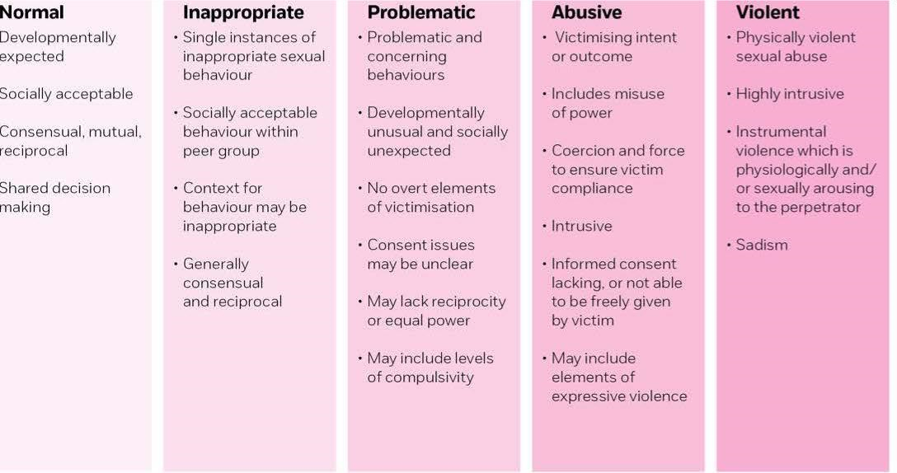

Appendix 2
Brook Traffic Light Tool
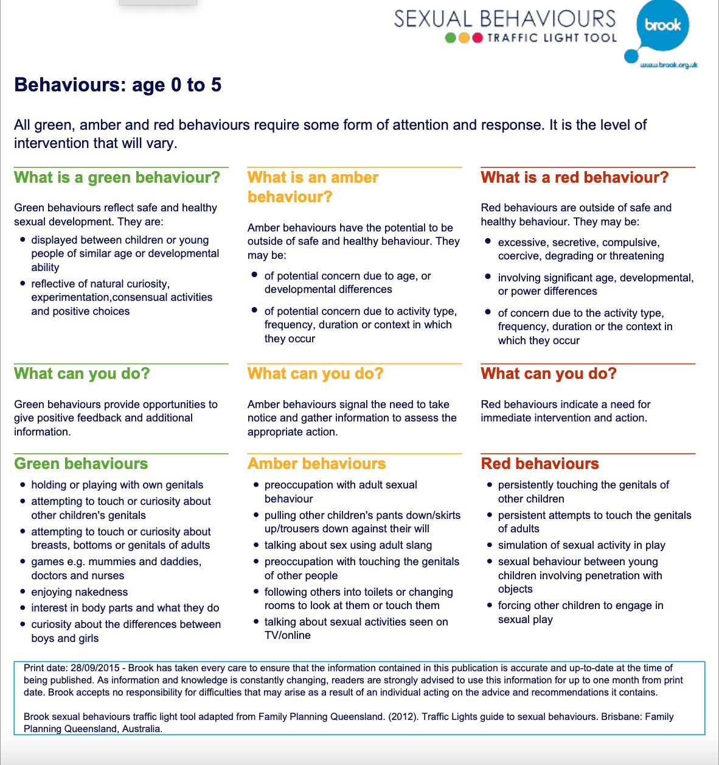

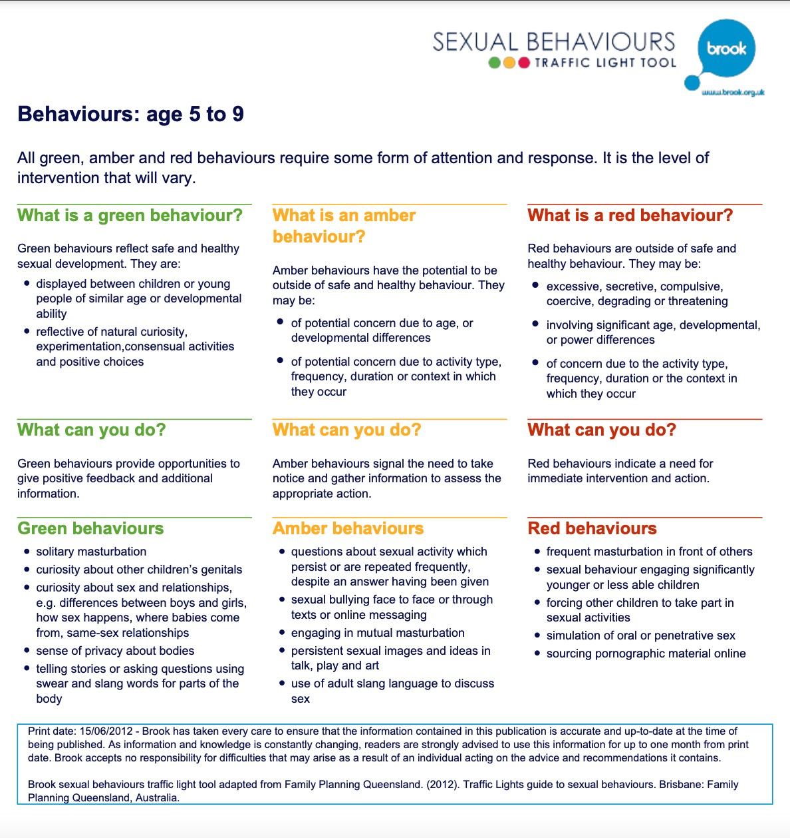

Appendix 3- Child-on-Child Abuse Procedure
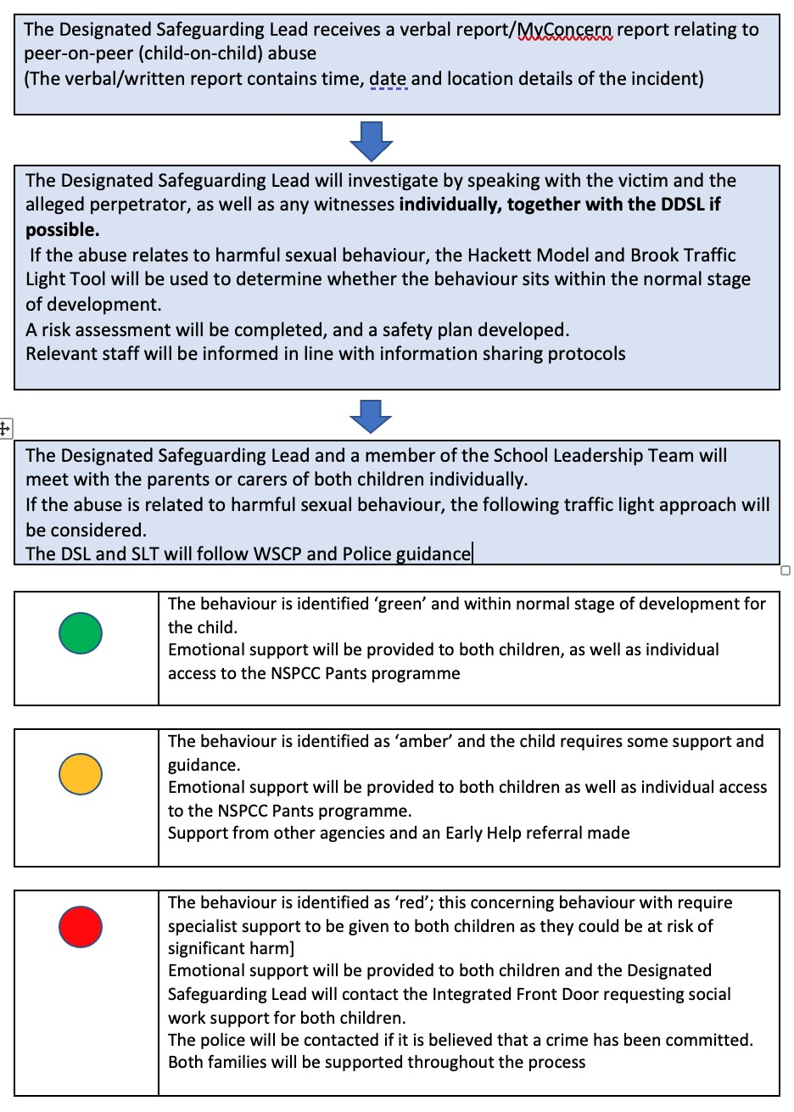

Appendix 4

Resources and Support
Child and adolescent mental health services (CAMHS)
Internet Watch Foundation (to potentially remove illegal images) www.iwf.org.uk

Useful Publications and Websites
Government Publications
Sexual harassment and sexual violence in schools
www.gov.uk/government/publications/sexual-violence-and-sexual-harassment-between- children-inschools-and-colleges
Keeping Children safe in Education - www.gov.uk/government/publications/keeping- children-safe-ineducation
Preventing youth violence and gang involvement www.gov.uk/government/publications/advice-to-schools-and-colleges-on-gangs-and-youth- violence Preventing and tackling bullying in schools www.gov.uk/government/publications/preventing-and-tackling-bullying
Other Useful Documents
Sexting
Sexting in schools and colleges-Responding to incidents and safeguarding young people
https://assets.publishing.service.gov.uk/government/uploads/system/uploads/attachment_ data/file/609874/6_2939_SP_NCA_Sexting_In_Schools_FINAL_Update_Jan17.pdf
Child-on-child abuse
Farrer &Co - Child-on-child abuse toolkit, guidance on child-on child abuse policy and template child-onchild abuse policy www.farrer.co.uk/Global/Child-on-child%20abuse%20toolkit%2014.pdf
Anti-bullying alliance
There are some useful links on the section on sexual bullying:-
Sexual bullying: developing effective anti-bullying practice- A guide for school staff and other professional
www.antibullyingalliance.org.uk/sites/default/files/field/attachment/Sexual%20bullying%20-%20anti- bullying%20guidance%20for%20teachers%20and%20other%20professionals%20- %20Feb17_1.pdf Preventing abuse among children and young people-guidance from Stop it Now, NCB and NSPCC
www.stopitnow.org.uk/files/stop_booklets_children_play_preventing_abuse_among_children
_and_young_people01_14.pdf https://www.lucyfaithfull.org.uk/services.htm
What is Age appropriate? http://www.stopitnow.org/ohc-content/what-is-age-appropriate NSPCC-Harmful sexual behaviour https://www.nspcc.org.uk/preventing-abuse/child-abuse-and-neglect/harmful-sexual- behaviour/
https://www.nspcc.org.uk/globalassets/documents/advice-and-info/pants/pants-2018/pants-parentsguide-online.pdf
NCB Harmful sexual behaviour
https://www.ncb.org.uk/resources-publications/resources/workforce-perspectives-harmful- sexualbehaviour
NSPCC –Is this sexual abuse?
https://www.nspcc.org.uk/globalassets/documents/research-reports/nspcc-helplines- report-child-sexualabuse.pdf
Online sexual harassment
Project deSHAME- Digital Exploitation and Sexual Harassment Amongst Minors in Europe Understanding,
Preventing, Responding https://www.childnet.com/our-projects/project-deshame Relationship Education, Relationship and Sex Education HMSO www.gov.uk/government/news/relationships-education-relationships-and-sex

