Thursday 1st July TA / I
LO: I can write a sequences of sentences to form a short narrative.
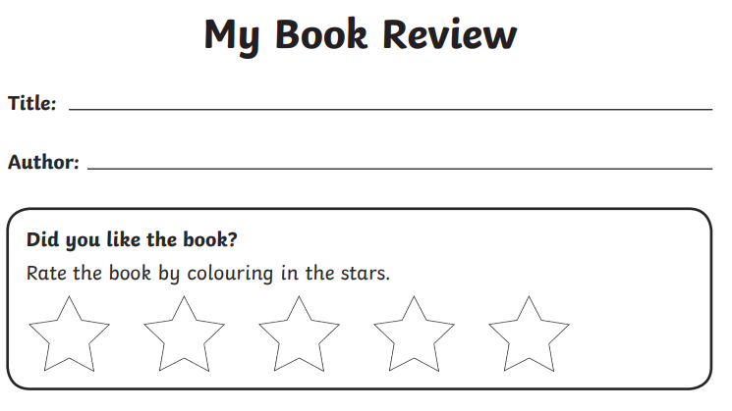
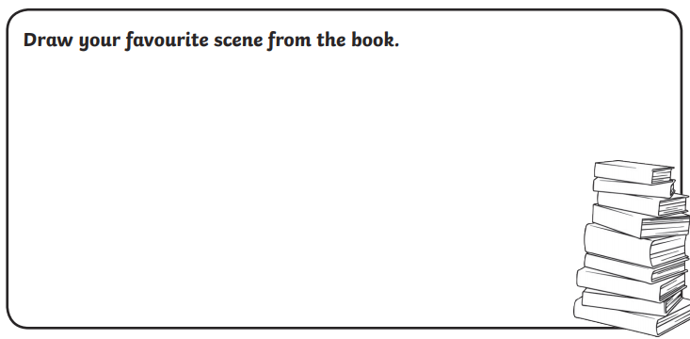
Use the next page to write about your favourite part in the story. Add some detail and description. Explain why you liked it.

