30.06.21
Counting coins
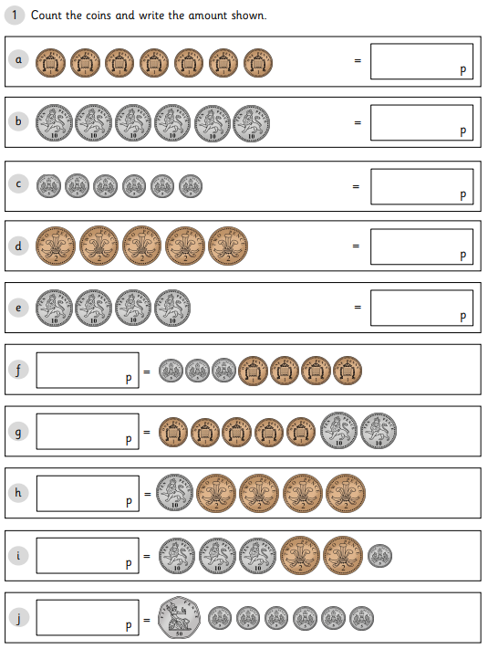

2) Draw money in the piggy banks to show the amounts
