YEAR 2 LONG TERM ENGLISH PLAN (2022-2023)

 | Autumn 1 | Autumn 2 | Spring 1 | Spring 2 | Summer 1 | Summer 2
Texts | Perfectly Norman (settling in)  Jack and the Beanstalk  Little Red  Little Red Riding Hood  Rapunzel  Hansel and Gretel  Literacy Shed film: Marshmallow | 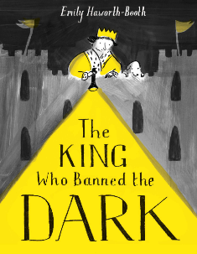  The Dark | 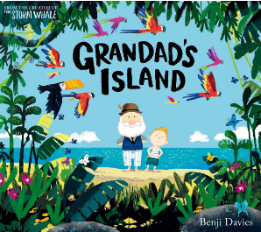  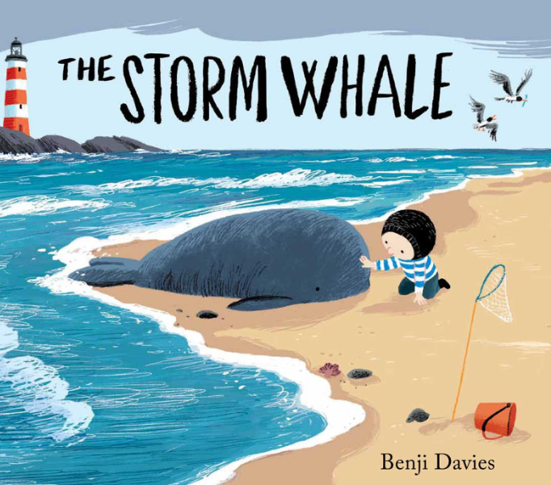  Leaf | Literacy Shed: Something Fishy | 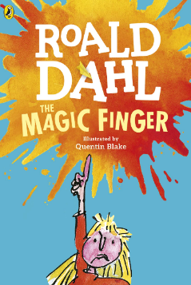 | 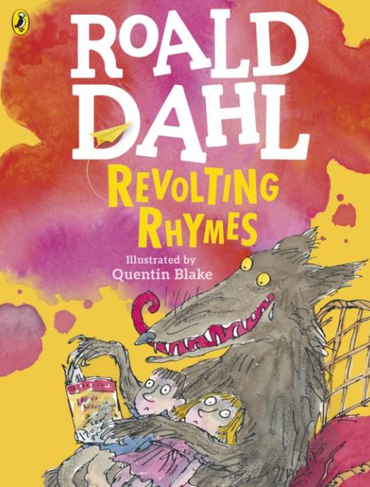  Michael Rosen Poetry  - Feel the rhythm (Performance Piece)  - Down behind the dustbin (Michael Rosen)  - Revolting Rhymes  (Roald Dahl)  Rhyming  Instructions
Poetry Focus |  |  |  |  | Michael Rosen Poetry  •Feel the rhythm (Performance Piece)  •Down behind the dustbin (Michael Rosen)  •Revolting Rhymes (Roald Dahl)
Writing Purpose | Traditional tales  Main outcome: NARRATIVE – write an introduction to a traditional tale  - Compare different versions of a traditional tale  - Character / setting descriptions  - Write an introduction to a traditional tale | The Dark  Main outcome: NARRATIVE – write a letter  - Setting description in first person  - Describing ‘dark’ using senses  The King who banned the dark  Main outcome: PERSUASIVE TEXT– write a persuasive letter  - Story prediction  - Write a story ending  - Compare two texts | Grandad’s Island  Main outcome: NARRATIVE – write a story  - Describe your grandad  - Setting description – Grandad’s Jungle Shack  - Comparing two texts  Leaf  Main outcome: NARRATIVE –  - Story prediction  - Character’s emotions | Something fishy  Main outcome: NARRATIVE –write a setting description  - Story sequence/events  - Character description  Recount of trip  Main outcome: RECOUNT – recount of Barnstondale trip  - Planning recount | The Magic Finger  Main outcome: NARRATIVE - write a story  - Ask questions in a letter to a character  - Coordinating conjunctions sentences about text  - Plan a diary  - diary from Mrs Gregg  - Plan a story | Michael Rosen Poetry  Main outcome: POETRY -  Instruction writing  Main outcome: INSTRUCTIONS – write a set of instructions  - Sequencing instructions  - Use of verbs and adverbs
Grammar Focus  Alan Peat Sentence Type | Coordinating and subordinating conjunctions: because, if, that, when, that, and, or, but, so  2A sentences | Past tense - Suffix – ed verbs  Suffix - -ly  Sentence types: statement, question, exclamation, command  2A sentences | Apostrophes for contraction and possession  2A sentences  Expanded noun phrases | Expanded noun phrases  Verbs – simple past and present  Coordinating and subordinating conjunctions: because, if, that, when, that, and, or, but, so | Expanded noun phrases  Coordinating and subordinating conjunctions: because, if, that, when, that, and, or, but, so | Expanded noun phrases  Coordinating and subordinating conjunctions: because, if, that, when, that, and, or, but, so  Suffix -ly  Verbs – imperative present form
Reading  Focus |  | Inferences  Link what I read to my own experiences  Meanings of words  Comparing texts
Punctuation Focus | Commas to separate items in a list | !?. | Commas to separate items in a list
Spoken Language | Debate about the dark |  |  |  | Debate about foxes / sea pollution?
Cross-Curricular writing links* | Information about Great Fire of London |  | Titanic - persuasive advert
* Worked into Geography/History lessons

