There is very little education and/or training available in Margarita’s village in the rainforest. | The city slums of Rio de Janeiro are dirty, often with no sewerage systems and disease is a big problem.
The weather in the rainforest is extremely hot, with extensive rainy periods. | Margarita lives with her grandparents, parents and three daughters in a village in the rainforest. Her life is built around her family.
Rio de Janeiro is a big wealthy city. There are so many rich people living there. The night-life is amazing. | The government do not seem interested in helping the people of the rainforest.
The government offer the people living in the city-slums of Rio de Janeiro the opportunity to improve their own living conditions. | Margarita’s husband moved to the slums of Rio de Janeiro to look for more reliable work. He sends the extra money he earns home to Margarita and their children, though he hopes they will join him in the city soon.
Poor, thin soils make farming extremely difficult in the rainforest. | Margarita would receive higher wages if she moved to Rio de Janeiro and was able to get a job.
Malaria is a problem in the rainforest. Margarita’s brother died as a result of it only two years ago. | Margarita has heard that drugs and crime are often a big problem in the city-slums of Rio de Janeiro.
Margarita enjoys the relaxing atmosphere of the countryside and the slow pace of life. | There are big hospitals and schools in the city.
Land around her village has been taken away recently by logging companies and cattle ranches. | All of Margarita’s friends are in the village, in the rainforest.


............................................................................................................................................................................................................................................................................................................................................................................................................................................................................................................................................................................................................................................................................................................................................................................................................................................................................................................................................................................................................................................................................................................................................................................................................................................................................................................................................................................................................................................................................................................................................................ .......................................................................................................................................................................................................................................................................................................................................................................................Overall I have seen that............................................................................... ..............................................................................................................................................................................................................................................................................................................................................................................................................................................................................................................................................................................................................................................................

Sort the cards into three piles:
- Push factors from the rainforest
- Pull factors to the city
- Reasons why she might want to stay in the rainforest

Rank the 3 piles from the least to the most convincing arguments.
Now it is time to make your decision. Should Margarita stay in the rainforest or move to Rio de Janeiro? You must have reasons for the answer that you give.
I think Margarita should................................................................................. I think this because.......................................................................................... ................................................................................................................................................................................................................................................................................................................................................................................................................................................................................................................................................................................................................................................................................................................................................................................................................................................................................................................................................................................................................................................................................................................................................................................................................................................................................................................................................................................................................................................................................................................................................................................................................................................................................................................................................................................................................................................................................................................................................................................. On the other hand............................................................................................. ........................................................................................................................................................................................................................................................................................................

Bonus Questions:
Can you think what problems might be caused if lots of people from rural areas in Brazil decided to move to cities, such as Rio de Janeiro? How would this affect both the cities and the rural areas that the people are moving from? Answer in full sentences.

Key words you could use: Rural-to-urban migration, push factor, pull factor, LEDC, adult literacy, employment rate, death rate, shifting cultivation, people per doctor, population levels
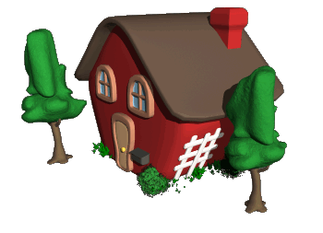
Key term | Definition | Pictionary
Rural-to-
urban migration
Push factors
Pull factors

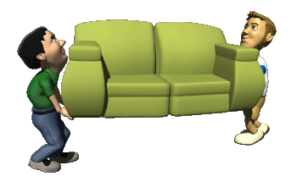
Bonus Question:
What would make you move away from the Wirral?.................. ............................................................................................................................................................................................................................................................................................................

