Area of Learning | Monday | Tuesday | Wednesday | Thursday | Friday
Phonics | Play a game of the winning word is…  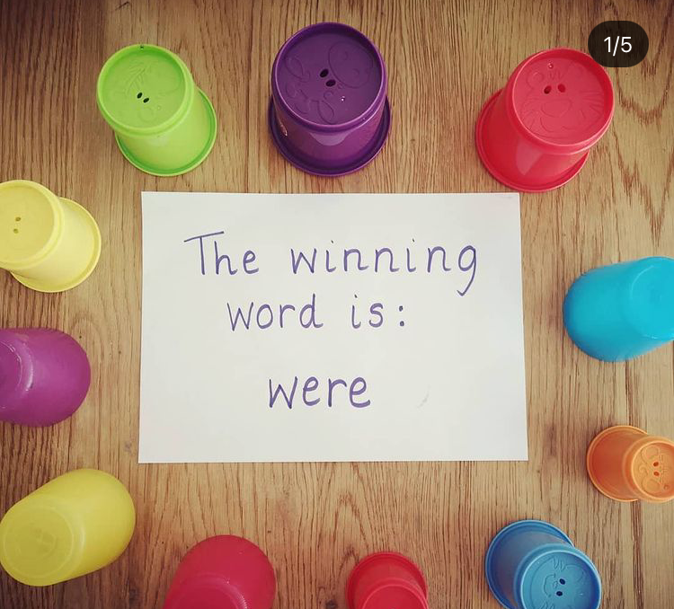  Write a selection of words using our phonics sounds from last week and hide them under cups. Use a sign like the above to tell your child the winning word.  The children have to read all of the words under the cups until they find a match!  Example words:  HFW - went / from / help / Mr / Mrs / asked / very / I’m / called / they / are/ all / was / you / her / my / said / have / like | Flash card sounds previously learnt - ‘ai, ee, igh, oa, oo, ar, or, ur, ow, oi’  Read HFW - went / from / help / Mr / Mrs / asked / very / I’m / called  Flashcard tricky words with silly voices- they / are/ all / was / you / her / my / said / have / like  Today's sound is the trigraph ‘ear’. Can you think of a word with ‘ear’ in it? ear, hear, gear.  Model writing ‘ear’. Then model writing a word with ‘ear’ like dear, tear, year, beard. Where is the ‘ear’ digraph in my word?  Sound talk the rest of the words and the children write them. Can they use one or more in a sentence? | Flash card sounds previously learnt - ‘ai, ee, igh, oa, oo, ar, or, ur, ow, oi’  Read HFW - went / from / help / Mr / Mrs / asked / very / I’m / called  Flashcard tricky words with silly voices- they / are/ all / was / you / her / my / said / have / like  Today's sound is the trigraph ‘air’. Can you think of a word with ‘air’ in it?  Model writing ‘air’. Then model writing a word with ‘air’ like air / hair / chair / fair / lair / pair.  Where is the ‘air’ digraph in my word?  Sound talk the rest of the words and the children write them. Can they use one or more in a sentence? | Flash card sounds previously learnt - ‘ai, ee, igh, oa, oo, ar, or, ur, ow, oi’  Read HFW - went / from / help / Mr / Mrs / asked / very / I’m / called  Flashcard tricky words with silly voices- they / are/ all / was / you / her / my / said / have / like  Today's sound is the trigraph ‘ure’. Can you think of a word with ‘ure’ in it?  Model writing ‘ure’. Then model writing a word with ‘ure’ like sure, pure, cure, insure, manure, mature, secure, assure.  Where is the ‘ure’ digraph in my word?  Sound talk the rest of the words and the children write them. Can they use one or more in a sentence? | Flash card sounds previously learnt - ai, ee, igh, qu, ur, ow, oi, ear.  Read HFW - just / down / now / for / went / from / help / when  Flashcard tricky words with silly voices- they / are/ all / was / you / my / her  Today's sound is the digraph ‘er’. Can you think of a word with ‘er’ in it?  Model writing ‘er’. Then model writing a word with ‘er’ like hammer, rocker, dinner, letter, rocker, ladder, better, summer, supper, boxer.  Where is the ‘er’ digraph in my word?  Sound talk the rest of the words and the children write them. Can they use one or more in a sentence?
Maths | Today we are following White Rose Maths- Lesson 1  https://whiterosemaths.com/homelearning/early-years/find-my-pattern-week-1/  Activity: Maths lesson 1  See home learning page for uploaded activity sheet | Today we are following White Rose Maths- Lesson 2  https://whiterosemaths.com/homelearning/early-years/find-my-pattern-week-1/  Activity: Maths lesson 2  See home learning page for uploaded activity sheet | Today we are following White Rose Maths- Lesson 3  https://whiterosemaths.com/homelearning/early-years/find-my-pattern-week-1/  Activity: Maths lesson 3  See home learning page for uploaded activity sheet | Today we are following White Rose Maths- Lesson 4  https://whiterosemaths.com/homelearning/early-years/find-my-pattern-week-1/  Activity: Maths lesson 4  See home learning page for uploaded activity sheet | Today we are following White Rose Maths- Lesson 5  https://whiterosemaths.com/homelearning/early-years/find-my-pattern-week-1/  Activity: Maths lesson 5  See home learning page for uploaded activity sheet
Reading | Share your reading book together discussing the character, settings and what happens next. | Share your reading book together discussing the character, settings and what happens next. | Share your reading book together discussing the character, settings and what happens next. | Share your reading book together discussing the character, settings and what happens next. | Share your reading book together discussing the character, settings and what happens next.
Other | RE - Prayer beads  Resources needed: Colourful beads/piper cleaner or string.  Provide children with colourful beads and string to make their own prayer beads.  Children could thread beads onto a pipe cleaner for a prayer bracelet.  Use your prayer beads to say a prayer to Mary.  An example of a little prayer to say could be: ‘Mary, I love you’ or ‘Mary, please help me or mummy etc. | PE - Bear gymnastics  This week you are practising jumping, rolling, balancing and travelling  Warm up: Goldilock sequence- see PowerPoint attached. Game to make your heart beat faster.  Activity:  See PowerPoint attached | UTW- Science Experiment-Volcano eruption  Watch the video- Nina and Neurons- erupting volcano.  https://www.youtube.com/watch?v=rkCol2aJZmY  Talk: What do you notice?  Activity: Make your own volcano eruption with adult supervision- see sheet attached.  Upload photos on Tapestry for your friends to see. | Outdoor classroom Day  Nature inspired activities :)  Nature Art: Children cut leaves and flowers to create a picture.  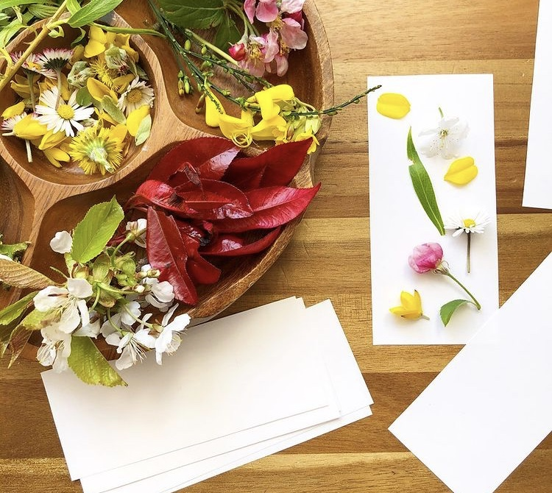  Dinosaurs Tears: See uploaded sheet for this rainy day activity.  Go on a garden colour hunt:  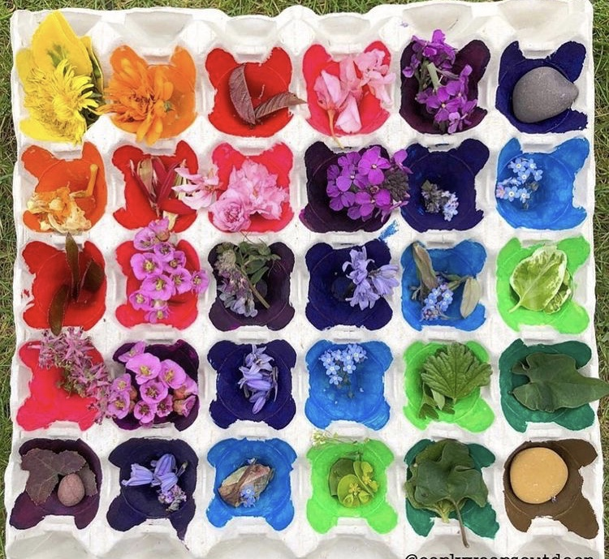 | UTW/LIT - Dinosaur facts- Stegosaurus  Watch: https://www.bbc.co.uk/cbeebies/curations/dinosaur-facts  Activity: Create a fact file about a Stegosaurus. Draw a picture of a stegosaurus and write 3 facts.  Example: It has 7 plates on his back.  It eats plants.
Extra | Cosmic Kids Yoga  https://www.youtube.com/user/CosmicKidsYoga | Finger Gym  https://youtu.be/3VpARNgbb8c | Boot Camp  https://www.youtube.com/channel/UC1uISIOKNnnGALw17v9naPg | Art & Design-  Follow the video to draw a dinosaur- Brontosaurus  https://www.youtube.com/watch?v=EcyVlP37LOo | Music - Listen and play- Minibeasts  Listen:  https://www.bbc.co.uk/teach/school-radio/listen-and-play-minibeasts/zhh6jhv  Sing: https://www.bbc.co.uk/teach/school-radio/listen-and-play-minibeasts/zhh6jhv

