Area of Learning | Monday | Tuesday | Wednesday | Thursday | Friday
Phonics | Play a game of the winning word is…  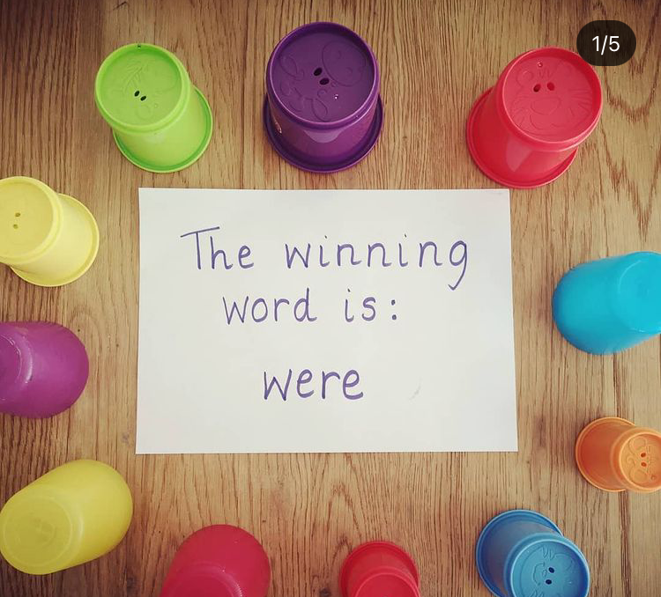  Write a selection of words using our phonics sounds from last week and hide them under cups. Use a sign like the above to tell your child the winning word.  The children have to read all of the words under the cups until they find a match!  Example words:  ee- bee / feel / deep / keep / sheep  qu - queen, quit, quiz, quack  igh - tight, sight, high, tonight  oa - coat, toad, goal, oak, boatman  HFW - they / are/ all / was / you / my / her / see / too / look / children / it’s / just. | Flash card sounds previously learnt - j, v, x, y, z, zz, ch, sh, th, ng, ee, qu, igh, ai, ur, ow, oi, ear.  Read HFW - see / too / look / just / down / now / for  Flashcard tricky words with silly voices- they / are/ all / was / you / my / her  Today's sound is the digraph ‘oo (said like u the short sound)’. Can you think of a word with ‘oo’ in it? (look, book, foot)  Model writing ‘oo’. Then model writing a word with ‘oo’ like book / wood / shook / hood. Where is the ‘oo’ digraph in my word?  Sound talk the rest of the words and the children write them. Can they use one or more in a sentence? | Flash card sounds previously learnt - j, v, x, y, z, zz, ch, sh, th, ng, ee, qu, igh, ai, ur, ow, oi, ear.  Read HFW - see / too / look / just / down / now / for  Flashcard tricky words with silly voices- they / are/ all / was / you / my / her  Today's sound is the digraph ‘oo’ (long sound like in moon). Can you think of a word with ‘oo’ in it?  Model writing ‘oo’. Then model writing a word with ‘oo’ like cool / hoof / root / food. Where is the ‘oo’ digraph in my word?  Sound talk the rest of the words and the children write them. Can they use one or more in a sentence? | Flash card sounds previously learnt - j, v, x, y, z, zz, ch, sh, th, ng, ee, qu, igh, ai, ur, ow, oi, ear.  Read HFW - see / too / look / just / down / now / for  Flashcard tricky words with silly voices- they / are/ all / was / you / my / her  Today's sound is the digraph ‘ar’. Can you think of a word with ‘igh’ in it?  Model writing ‘ar’. Then model writing a word with ‘ar’ like car / bar/ star / market. Where is the ‘ar’ digraph in my word?  Sound talk the rest of the words and the children write them. Can they use one or more in a sentence? | Flash card sounds previously learnt - j, v, x, y, z, zz, ch, sh, th, ng, ee, qu, igh, ai, ur, ow, oi, ear.  Read HFW - see / too / look / just / down / now / for  Flashcard tricky words with silly voices- they / are/ all / was / you / my / her  Today's sound is the digraph ‘or’. Can you think of a word with ‘or’ in it?  Model writing ‘or’. Then model writing a word with ‘or’ like torn / born / sort / fork. Where is the ‘or’ digraph in my word?  Sound talk the rest of the words and the children write them. Can they use one or more in a sentence?
Maths | Today we are following White Rose Maths- Lesson 1  https://whiterosemaths.com/homelearning/early-years/first-then-now-week-1/  Activity: Maths lesson 1  See home learning page for uploaded activity sheet | Today we are following White Rose Maths- Lesson 2  https://whiterosemaths.com/homelearning/early-years/first-then-now-week-1/  Activity: Maths lesson 2  See home learning page for uploaded activity sheet | Today we are following White Rose Maths- Lesson 3  https://whiterosemaths.com/homelearning/early-years/first-then-now-week-1/  Activity: Maths lesson 3  See home learning page for uploaded activity sheet | Today we are following White Rose Maths- Lesson 4  https://whiterosemaths.com/homelearning/early-years/first-then-now-week-1/  Activity: Maths lesson 4  See home learning page for uploaded activity sheet | Today we are following White Rose Maths- Lesson 5  https://whiterosemaths.com/homelearning/early-years/first-then-now-week-1/  Activity: Maths lesson 5  See home learning page for uploaded activity sheet
Reading | Share your reading book together discussing the character, settings and what happens next. | Share your reading book together discussing the character, settings and what happens next. | Share your reading book together discussing the character, settings and what happens next. | Share your reading book together discussing the character, settings and what happens next. | Share your reading book together discussing the character, settings and what happens next.
Other | RE - May the month of Mary  Listen and sing:  https://youtu.be/7OxeUAtiuHk Or join in with actions:  https://youtu.be/VZQjVI-P55w  Show your child a picture of Mary  Talk: Who was Jesus’ Mother? Can you remember a story Mary was in from the bible?  The bible has lots of stories about Mary and tells us that Mary was united with Jesus on earth and in heaven. Which month do we celebrate Mary in?  We think of Mary as our mother too because Christ the Lord gave her to us as a mother and she is the queen of heaven. What do Queens often wear?  Our Mary doesn’t have a crown to show that she is so special to us. What do you think we should do to show our love to Mary?  Activity: Make a flower crown for Mary. Put the crown of beautiful flowers on top of a statue of Mary or on a picture of Mary.  Think of a prayer to take to her or the name of someone you would like her to look after like a mother would but from heaven. | PE - Goldilocks and the Three Bears - Learning to Roll.  See PPT in attachments.  Children warm up by travelling through the forest in different ways.  Learn to rock back and forth up to standing.  Learn to barrel roll with knees tucked up and on their side.  Learn to straight roll with arms / legs stretched out and on side. | UTW/LIT - Jaspers Beanstalk  Can you remember what happened in Jasper's beanstalk?  Listen to the story together: https://youtu.be/t_y79wIX6do  What do plants need to grow? Discuss water / sunlight / soil.  Activity- Complete the first page of your bean diary- see attached.  Draw and label your pictures. | UTW/LIT - Jaspers Beanstalk  Can you remember what Jasper used to plant his beanstalk? spade/soil/bean  Tell your child that you are going to plant a bean together using different equipment-see sheet attached ‘Bean in a Bag’,  Activity- complete the second page of your bean diary- equipment. Draw and label the equipment you need to plant your bean. | UTW/LIT - Jaspers Beanstalk  Plant your bean following the instructions- see sheet attached.  Complete the instructions page of your bean diary. Draw a picture and write a simple sentence.  Example:  1. First wet the paper towel  2. Put towel inside the bag.  3. Put the bean on the paper towel  4. Seal the bag and tape to a sunny window
Extra | Cosmic Kids Yoga  https://www.youtube.com/user/CosmicKidsYoga | Finger Gym  https://youtu.be/3VpARNgbb8c | Boot Camp  https://www.youtube.com/channel/UC1uISIOKNnnGALw17v9naPg | Art & Design-  Paint a picture of Mary. | Music -  Learn the fourth song for the story:  https://www.bbc.co.uk/teach/school-radio/music-jack-and-the-beanstalk-song4/zksk47h

