Area of Learning | Monday | Tuesday | Wednesday | Thursday | Friday
Phonics | Play a game of Tricky / HFW towers!  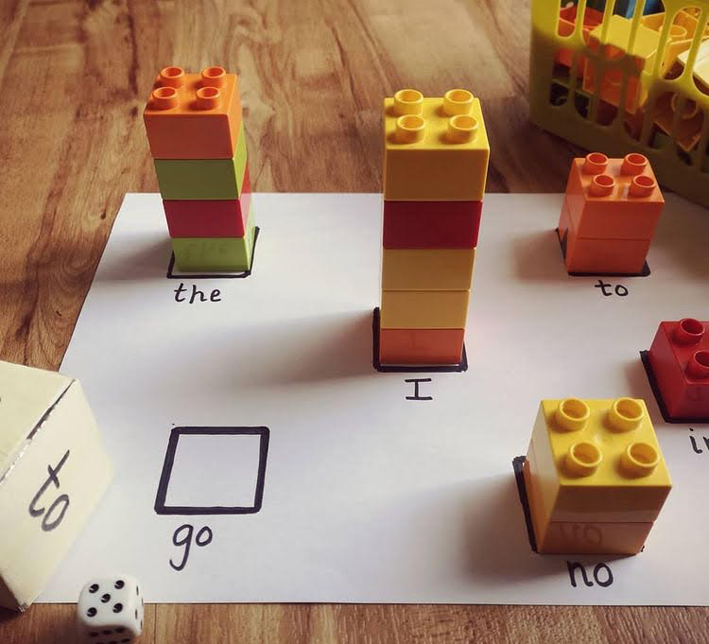  Make a large dice or cover a dice with phase 3 tricky or HFW words from this list: they / are/ all / was / you / my / her / see / too / look / children / it’s / just.  Make game squares as above on a piece of paper.  Roll the word dice and the number dice - children read the word and add the correct amount of bricks to that words tower. | Flash card sounds previously learnt - j, v, x, y, z, zz, ch, oo (short), oo (long), ar and or.  Read HFW - see / too / look / children / it’s / just  Flashcard tricky words with silly voices- they / are/ all / was / you / my / her  Today's sound is the digraph ‘ee’. Can you think of a word with ‘ee’ in it?  Model writing ‘ee’. Then model writing a word with ‘ee’ like bee / feel / deep / keep / sheep. Where is the ‘ee’ digraph in my word?  Sound talk the rest of the words and the children write them. Can they use one or more in a sentence? | Flash card sounds previously learnt - j, v, x, y, z, zz, ch, oo (short), oo (long), ar and or.  Read HFW - see / too / look / children / it’s / just  Flashcard tricky words with silly voices- they / are/ all / was / you / my / her  Today's sound is the digraph ‘qu’. Can you think of a word with ‘qu’ in it?  Model writing ‘qu’. Then model writing a word with ‘qu’ like queen, quit, quiz, quack. Where is the ‘qu’ digraph in my word?  Sound talk the rest of the words and the children write them. Can they use one or more in a sentence? | Flash card sounds previously learnt - j, v, x, y, z, zz, ch, oo (short), oo (long), ar and or.  Read HFW - see / too / look / children / it’s / just  Flashcard tricky words with silly voices- they / are/ all / was / you / my / her  Today's sound is the trigraph ‘igh’. Can you think of a word with ‘igh’ in it?  Model writing ‘igh’. Then model writing a word with ‘igh’ like tight, sight, high, tonight. Where is the ‘igh’ trigraph in my word?  Sound talk the rest of the words and the children write them. Can they use one or more in a sentence? | Flash card sounds previously learnt - j, v, x, y, z, zz, ch, oo (short), oo (long), ar and or.  Read HFW - see / too / look / children / it’s / just  Flashcard tricky words with silly voices- they / are/ all / was / you / my / her  Today's sound is the digraph ‘oa’. Can you think of a word with ‘oa’ in it?  Model writing ‘oa’. Then model writing a word with ‘oa’ like coat, toad, goal, oak, boatman’. Where is the ‘oa’ digraph in my word?  Sound talk the rest of the words and the children write them. Can they use one or more in a sentence?
Maths | Today we are following White Rose Maths- Lesson 1  https://whiterosemaths.com/homelearning/early-years/to-20-beyond-week-3/  Activity: Maths lesson 1  See home learning page for uploaded activity sheet | Today we are following White Rose Maths- Lesson 2  https://whiterosemaths.com/homelearning/early-years/to-20-beyond-week-3/  Activity: Maths lesson 2  See home learning page for uploaded activity sheet | Today we are following White Rose Maths- Lesson 3  https://whiterosemaths.com/homelearning/early-years/to-20-beyond-week-3/  Activity: Maths lesson 3  See home learning page for uploaded activity sheet | Today we are following White Rose Maths- Lesson 4  https://whiterosemaths.com/homelearning/early-years/to-20-beyond-week-3/  Activity: Maths lesson 4  See home learning page for uploaded activity sheet | Today we are following White Rose Maths- Lesson 5  https://whiterosemaths.com/homelearning/early-years/to-20-beyond-week-3/  Activity: Maths lesson 5  See home learning page for uploaded activity sheet
Reading | Share your reading book together discussing the character, settings and what happens next. | Share your reading book together discussing the character, settings and what happens next. | Share your reading book together discussing the character, settings and what happens next. | Share your reading book together discussing the character, settings and what happens next. | Share your reading book together discussing the character, settings and what happens next.
Other | RE - May the month of Mary  Listen and sing:  https://youtu.be/7OxeUAtiuHk  Or join in with actions:  https://youtu.be/VZQjVI-P55w  Talk:  Talk about the Hail Mary being a prayer we say to Our Mother and Jesus’ Mother too, we can say it any time and we say it at Mass.  Activity:  Learn the ‘Hail Mary’ together and decorate the prayer either writing it out for your child or using the print out. | PE - Goldilocks and the Three Bears - Learning to Roll.  See PPT in attachments.  Children warm up by travelling through the forest in different ways.  Learn to rock back and forth up to standing.  Learn to barrel roll with knees tucked up and on their side.  Learn to straight roll with arms / legs stretched out and on side. | UTW/LIT - Jaspers Beanstalk  Listen to the story together: https://youtu.be/t_y79wIX6do  As you are listening, stop and draw a picture of what Jasper is doing beside each day of the week.  Ask your child to think of labels to add OR can they think of a caption… On Monday he... | UTW/LIT - Jaspers Beanstalk  How did Jasper plant his bean? recall the story together.  Watch the timelapse of the beanstalk growing.  Ask your child what they think the beanstalk needs to grow? Discuss water / sunlight / soil.  Write a list of the things the beanstalk needs to grow. | UTW/LIT - Jaspers Beanstalk  Grow and then plant a bean together!  See instructions in documents attached.
Extra | Cosmic Kids Yoga  https://www.youtube.com/user/CosmicKidsYoga | Finger Gym  https://youtu.be/3VpARNgbb8c | Boot Camp  https://www.youtube.com/channel/UC1uISIOKNnnGALw17v9naPg | Art & Design-  Paint or draw a picture of a bean being planted. | Music -  Learn the third song for the story:  https://www.bbc.co.uk/teach/school-radio/music-jack-and-the-beanstalk-song3/z6ydkmn

