Area of Learning | Monday | Tuesday | Wednesday | Thursday | Friday
Phonics | Watch the Phase 3 Flashcards / HFW / Tricky Troll words video on Tapestry.  Play Giggling Graphemes (oo ar or): https://www.phonicsplay.co.uk/resources/phase/2/grab-a-giggling-grapheme  Challenge: Can you write a sentence about your weekend.  Example: I went to the park with my mum and dad. | Watch the Phase 3 Flashcards / HFW / Tricky Troll words video on Tapestry.  Play Alien Escape: https://www.phonicsbloom.com/uk/game/alien-escape?phase=3  Challenge: Can you write the words from Alien escape on your whiteboard or on paper. | Watch the Phase 3 Flashcards / HFW / Tricky Troll words video on Tapestry.  Play Phonics Frog ( select oa words):  https://www.phonicsbloom.com/uk/game/phonics-frog?phase=3  Challenge: Can you write as many oa words as you can in one minute.  Examples: goat/coat/float | Watch the Phase 3 Flashcards / HFW / Tricky Troll words video on Tapestry.  Play Help a Hedgehog (phase 3 cvcc and ccvc):  https://www.ictgames.com/mobilePage/helpAHedgehog/index.html  Challenge: Can you write the words from the game on your whiteboard or paper. | Watch the Phase 3 Flashcards / HFW / Tricky Troll words video on Tapestry.  Play Blending Bingo (oi and or):  https://www.ictgames.com/mobilePage/bingoOriginal/index.html  Challenge: Can you write the words on your whiteboard or paper
Maths | Today we are following White Rose Maths- Lesson 1  https://whiterosemaths.com/homelearning/early-years/spring-consolidation-week-3/  Activity: Maths lesson 1  See home learning page for uploaded activity sheet | Today we are following White Rose Maths- Lesson 2  https://whiterosemaths.com/homelearning/early-years/spring-consolidation-week-3/  Activity: Maths lesson 2  See home learning page for uploaded activity sheet | Today we are following White Rose Maths- Lesson 3  https://whiterosemaths.com/homelearning/early-years/spring-consolidation-week-3/  Activity: Maths lesson 3  See home learning page for uploaded activity sheet | Today we are following White Rose Maths- Lesson 4  https://whiterosemaths.com/homelearning/early-years/spring-consolidation-week-3/  Activity- Maths lesson 4  See home learning page for uploaded activity sheet  Activity: Maths lesson 4  See home learning page for uploaded activity sheet | Today we are following White Rose Maths- Lesson 5  https://whiterosemaths.com/homelearning/early-years/spring-consolidation-week-3/  Activity: Maths lesson 5  See home learning page for uploaded activity sheet
Reading | Share your reading book together discussing the character, settings and what happens next. | Share your reading book together discussing the character, settings and what happens next. | Share your reading book together discussing the character, settings and what happens next. | Share your reading book together discussing the character, settings and what happens next. | Share your reading book together discussing the character, settings and what happens next.
Other | RE - Easter Story  Palm Sunday-Today we are thinking all about Palm Sunday which the gospel tells us is the story of Jesus' triumphant ride into Jerusalem on the back of a donkey.  Sing: Sing Hosanna  https://youtu.be/8t8zA1N6mCY  Watch: Palm Sunday-  https://www.youtube.com/watch?v=lTmbTuutBgg  Talk: Where had Jesus been? Where did he want to go? What animal did he ask the disciples to find? What did they do with their cloaks? (sign of respect as Jesus is our King) What did the people do? (Palm leaves are a sign of victory - remember Jesus beat the temptations of the devil) What did the people cheer? why? (Hosanna - because they loved Jesus and believed in his message).  Activity: Complete Palm Sunday page of Easter Book.  Colour the picture and write a sentence about Palm Sunday.  OR  Make a paper palm leaf- see sheet attached | RE-Easter Story  The Last Supper-Today we are thinking all about The Last Supper which the gospel tells us is the story of Jesus' last meal with his very best friends the disciples when he told them he had been betrayed  Sensory Story- Read and act out the story together- see sheet attached  Resources needed: bread/juice/water/bowl  Talk: What can you remember about the beginning of the story? The middle? The end? What did Jesus share with the disciples? What did he do to it before? Why did Jesus wash the disciples feet? What did it show? What does Jesus want us to do?  Activity: Complete The Last Supper page of Easter Book.  Colour the picture and write a sentence about The Last Supper. | RE- Easter Story  Jesus in the Garden  Listen- Make me a channel of your peace-https://www.youtube.com/watch?v=ihhvm6eLWZI  Watch: Jesus in the Garden https://www.youtube.com/watch?v=TzFatYi-Z0U  Pray: Adult - Dear Jesus, for the times we have not been good friends  Children - Jesus, we are sorry.  Adult - For the times we have been unkind.  Children - Jesus we are sorry.  Adult - For the times we have not shared.  Children - Jesus we are sorry.  Activity: Complete Jesus in the Garden page of Easter Book.  Colour the picture and write a sentence about Jesus in the Garden  OR  Decorate a number three to represent the amount of times Peter denied Jesus but was forgiven. Can they decorate their number three with three’s eg three flowers? Can the children add the key words eg. forgive, make friends, be kind? | RE- Easter Story-  Good Friday- Today we are thinking all about Good Friday which the gospel tells us is the story of how Jesus died as God had planned.  Listen- Everything I have I give it to you lord  -https://www.youtube.com/watch?v=n3iG1gkW9R0  Sensory Story- Read and act out the story together- see sheet attached  Resources needed:  cross/feather/pebble/torch  Talk: What can you remember from the beginning/middle/end of the story?  Activity: Complete Good Friday page of Easter Book.  Colour the picture and write a sentence about Good Friday. | Art- -Easter crafts  Create and decorate an Easter Card for your family.  Write: To my Family  Happy Easter  From xxxx  OR  Draw the Easter Cross using the tea light candles and then use watercolors to paint the background  Example: 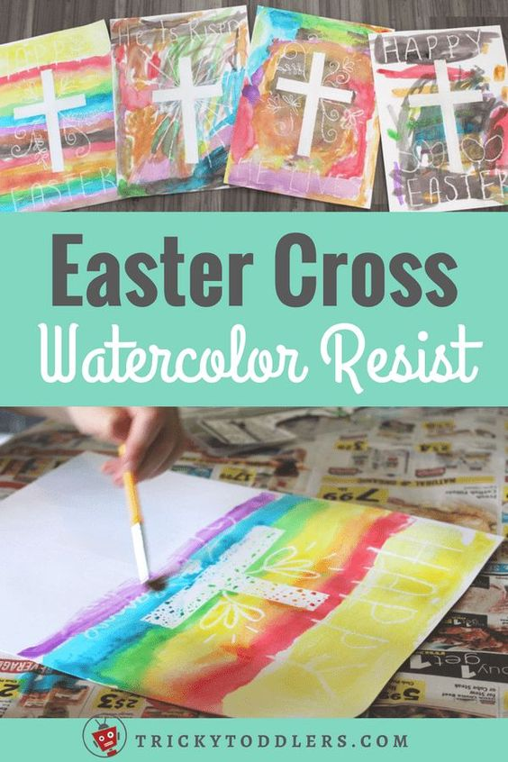
Extra | Cosmic Kids Yoga  https://www.youtube.com/user/CosmicKidsYoga | Finger Gym  https://youtu.be/3VpARNgbb8c | Boot Camp  https://www.youtube.com/channel/UC1uISIOKNnnGALw17v9naPg | Music -  https://www.bbc.co.uk/teach/bring-the-noise/primary-music-yolanda-brown-meet-the-band/zmj4y9q

