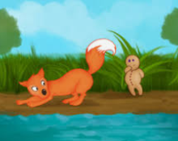
The problem

The Gingerbread Man sees the fox in the lake, but he can’t swim! Build him a bridge to get to the other side.

