Area of Learning | Monday | Tuesday | Wednesday | Thursday | Friday
Phonics | Watch the Phase 3 Flashcards / HFW / Tricky Troll words video on Tapestry.  Play Giggling Graphemes (ai, ee, igh, oa): https://www.phonicsplay.co.uk/resources/phase/2/grab-a-giggling-grapheme  OR  Challenge: Can you write all of the sounds in the alphabet? | Watch the Phase 3 Flashcards / HFW / Tricky Troll words video on Tapestry.  Play Alien Escape: https://www.phonicsbloom.com/uk/game/alien-escape?phase=3  OR  Challenge: Can you think of 5 ‘ur’ words? Can you write one in a sentence? | Watch the Phase 3 Flashcards / HFW / Tricky Troll words video on Tapestry.  Play Phonics Frog ( select ow words):  https://www.phonicsbloom.com/uk/game/phonics-frog?phase=3  OR  Challenge: Read this sentence and draw a picture to match - ‘The brown cow and a duck’ | Watch the Phase 3 Flashcards / HFW / Tricky Troll words video on Tapestry.  Play Help a Hedgehog (ch, sh, th, ng):  https://www.ictgames.com/mobilePage/helpAHedgehog/index.html  OR  Challenge: Go on an ‘oi’ word hunt around your house! How many will you collect? Do all of the words have the ‘oi’ digraph? | Watch the Phase 3 Flashcards / HFW / Tricky Troll words video on Tapestry.  Play Blending Bingo (oi and ear):  https://www.ictgames.com/mobilePage/bingoOriginal/index.html  OR  Challenge: Play match the digraph. Children read a word and say if it has the sound - ur / ow / oi / ear - then put them in a pile together. Example words:  turn / burp / cow / brown / owl / oil / boil / soil / dear / year / ear
Maths | Today we are following White Rose Maths- Lesson 1  Click on the link below to watch the video- lesson 1.  https://whiterosemaths.com/homelearning/early-years/building-9-10-week-3/  Activity: WB: 1.03.21- Maths lesson 1  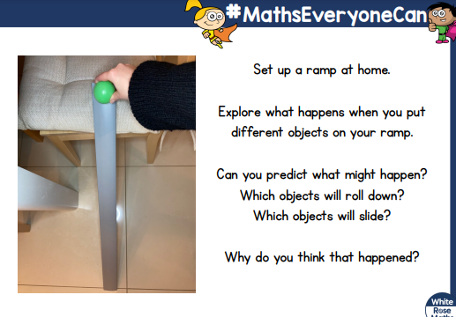 | Today we are following White Rose Maths- Lesson 2  Click on the link below to watch the video- lesson 2  https://whiterosemaths.com/homelearning/early-years/building-9-10-week-3/  Activity: WB: 2.03.21-Maths lesson 2  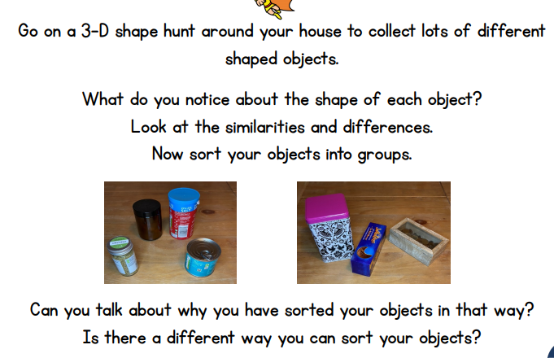 | Today we are following White Rose Maths- Lesson 3  Click on the link below to watch the video- lesson 3  https://whiterosemaths.com/homelearning/early-years/building-9-10-week-3/  Activity: WB: 3.02.21- Maths lesson 3  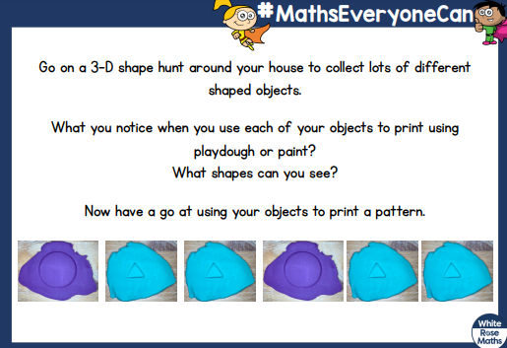 | Today we are following White Rose Maths- Lesson 4  Click on the link below to watch the video- lesson 4  https://whiterosemaths.com/homelearning/early-years/building-9-10-week-3/  Activity: WB: 4.03.21- Maths lesson 4  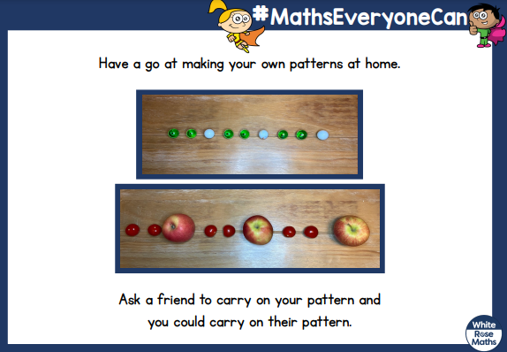 | Today we are following White Rose Maths- Lesson 5  Click on the link below to watch the video- lesson 5  https://whiterosemaths.com/homelearning/early-years/building-9-10-week-3/  Activity: WB: 5.03.21- Maths lesson 5  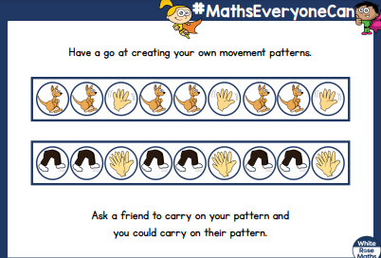
Reading | Share your reading book together discussing the character, settings and what happens next. | Share your reading book together discussing the character, settings and what happens next. | Share your reading book together discussing the character, settings and what happens next. | Share your reading book together discussing the character, settings and what happens next. | Share your reading book together discussing the character, settings and what happens next.
Other | RE  Listen and sing: https://youtu.be/KKSUsS-NoRY  Talk time:  Jesus wants us to forgive others. This is easy to understand but sometimes hard to do. Matthew tells us the story of the unforgiving servant.  Watch the story of the unforgiving servant: https://youtu.be/ED3fzkS-bhA  Let us pray: Dear Jesus,  We are sorry for the times when we forgot to be kind to each other. Please  help us to put things right and try again. Amen.  Activity: Draw a picture of a time you have been kind or forgiven someone. Write a sentence ‘I was kind and helpful because…’ | Literacy - Gingerbread Man  Watch The Gingerbread Man https://youtu.be/H0uV6nWxO-w  Make a Story Map! Draw the beginning, middle and the end of the story round in a circle (see example - Gingerbreadman story map).  Can you use your story map to retell the story to your family? | NON SCREEN TIME IDEAS  PE  Skipping Challenges - This is a core skill we were developing with the children in school so we will leave this one on for the next few weeks.  Cards Fitness Fun  Sardines  Find Three Things that are... | NON SCREEN TIME IDEAS  Science experiment  Swimming Gingerbread Man-see sheet attached  Key Questions: What do you think will happen to the Gingerbread Man in the water?  What words can you use to describe what happened the Gingerbread Man  You will need:  Small Gingerbread Men/bowl or cup/jug/water | Literacy- Gingerbread Man  Make your own Gingerbread Man story book.  Use your story map to help you remember the parts of the story to fill in your book. Draw a picture and write a story sentence to match it.  Page 1 - front cover - title and picture of the Gingerbread Man  Page 2 - The beginning - Ran from the oven.  Page 3 - The middle - Gingerbread man being chased saying ‘run run fast as you can you can’t catch me I’m the Gingerbread man’  Page 4 - The End - Gingerbread man jumps on the fox and is snip snap gobbled up!
Extra | Cosmic Kids Yoga  https://www.youtube.com/user/CosmicKidsYoga | Finger Gym  https://youtu.be/3VpARNgbb8c | Boot Camp  https://www.youtube.com/channel/UC1uISIOKNnnGALw17v9naPg | Art- Building a bridge for the Gingerbread Man  The Gingerbread Man sees the fox in the lake, but he can’t swim! Build him a bridge to get to the other side.  You could build your bridge from lego, blocks or boxes. | Music -  https://www.bbc.co.uk/teach/bring-the-noise/primary-music-yolanda-brown-meet-the-band/zmj4y9q

