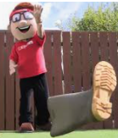
How far can you throw?
How many footsteps?
1st
throw
2nd throw
3rd throw

