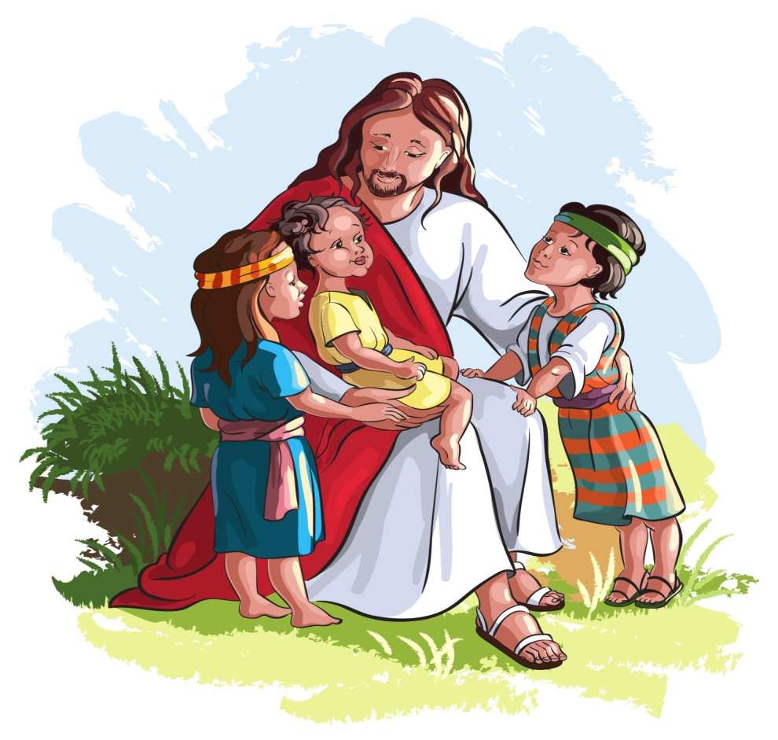
Today, we are going to listen to a story about the time Jesus showed his friends how to welcome little children.

One day, while Jesus was teaching his friends, come mums and dads came with their children to see him. They were looking forward to meeting Jesus because they wanted him to bless their children.

The friends of Jesus were very annoyed because they did not want anyone to disturb him while he was teaching. “Please go away. Do not disturb Jesus”, they said.

When Jesus saw what was happening, he called the children to him and said, “Let the little children come to me, and do not stop them. I love children very much and I want to have them near me.”

Jesus explained to the grown-ups that children are very special. The grown-ups should learn to love and trust like children.

