Area of Learning | Monday | Tuesday | Wednesday | Thursday | Friday
Phonics | HFW challenge!  Watch the video together blending the words using the right amount of phoneme fingers:  https://youtu.be/Ao0hohDWsVM  Can you say them all on your own?  EXTRA CHALLENGE!  Write as many of the words as you can remember on your whiteboard… how many did you think of? | Today’s sound - sh  Short clip on Tapestry  Jolly Phonics song:  https://youtu.be/3uyqR3u4jtg  Model the digraph ‘sh’  Send your child on a ‘sh’ word hunt around the house to collect the words and blend them: ship, shop, shell, shed, fish, shock, cash, bash, hush, rush.  AND/OR  Complete ‘sh’ page in the phase 3 phonics booklet together.  and maybe if you have a chance play the ‘sh’ game online:  https://www.kizphonics.com/phonics/digraph-sh-phonics-game/ | Today’s sound - th  Recording on tapestry  Jolly phonics song:  https://youtu.be/7bOOI3JIqs0  ‘th’ page in the phase 3 phonics booklet. | Today’s sound - ng  Short clip on tapestry.  Today’s story is The Wishing Dish. Can you make the ‘ng’ sound?  Watch story on tapestry.  Sing the jolly phonics song:  https://youtu.be/xqPMJR2cLwI  Model the digraph ‘ng’ on the line.  Children blend and write the ‘ng’ words. Adults explaining their meaning and putting them in sentences: ring / king / spring / swing / wings / sting / fang / bang / string / rang / lungs  OR ‘ng’ page in phase 3 phonics booklet. | Today’s sound - ai  Recording on tapestry.  Jolly Phonics song:  https://youtu.be/5PrHpmxQeyw  ‘ai’ page in phase 3 phonics booklet.
Maths  This week’s we will be learning about the Number of the week- 7 | Lesson 1- Number of the week- Meet 7!  WB: 25.1.21 maths lessons PowerPoint.  You will find a choice of two activities for this lesson. Choose one.  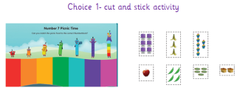  WB 25.1.21 Maths Lesson 1- activity sheet 1/2  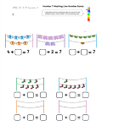 | Lesson 2- Different ways to make 7.  WB: 25.1.21 maths lessons PowerPoint.  You will find a choice of two activities for this lesson. Choose one.  WB 25.1.21 Maths Lesson 2- activity sheet 1/2  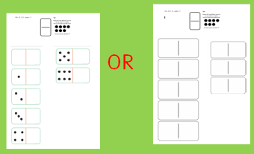 | Lesson 3- Memory game  White Rose Home Learning – Phase 5, Growing 6,7,8- lesson 4  White Rose teaching video linked below:  https://whiterosemaths.com/homelearning/early-years/growing-6-7-8/  WB: 25.1.21 maths lessons PowerPoint.  WB 25.1.21 Maths Lesson 3- activity sheet.  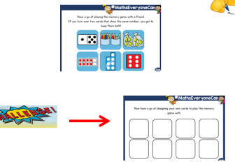  ! – Week 3 | Lesson 4- What’s missing from Kipper’s Toy Box.  Recording on tapestry  WB: 25.1.21 maths lessons PowerPoint.  WB 25.1.21 Maths Lesson 4- activity sheet.  Resources: toys and a box | Lesson 5- Number formation numbers 0-10  Recording on tapestry  WB: 25.1.21 maths lessons PowerPoint.  WB 25.1.21 Maths Lesson 5- activity sheet 5
Reading | Share your reading book together discussing the character, settings and what happens next. | Share your reading book together discussing the character, settings and what happens next. | Share your reading book together discussing the character, settings and what happens next. | Share your reading book together discussing the character, settings and what happens next. | Share your reading book together discussing the character, settings and what happens next.
Other | RE  Listen to ‘Yes Jesus Loves Me’  https://youtu.be/U-ryg9plBM4  Talk time – How do we take care of a baby? What do they need? How do we keep them and you safe? (food / milk / clothes / toys / help from adults). Talk about how much babies and children need affection and love. Babies need special care.  In today’s story we are going to learn what Jesus said about babies and children.  See ‘Jesus loves the little children’ document OR watch  https://youtu.be/QPDL_xFCqhw  KEY QUESTIONS: • Why did the children want to see Jesus? • How do you think the children felt when they were told to go away? • What did Jesus say? How do you think we can show Jesus that we love him?  Activity - draw and colour a heart to show Jesus’ love OR draw a picture of the story and write a sentence about what happened. | NON SCREEN TIME IDEAS  The topic for the next two weeks is ‘People who help us’.  In school we will be making a junk model town with all of the buildings for the people who help us everyday.  Can you build your own People who help us town? or an emergency vehicle?  Ideas in document ‘People who help us – creation ideas’ | NON SCREEN TIME IDEAS  Getting creative and active together - try one or all of the PE Active Family games together (documents uploaded) and definitely upload your pictures!  Blindfold Obstacle course  Hamster Wheel  Paper Dance  Mouse Trap  Balloon Volleyball | Ten Ten  Please see document ‘Ten Ten - Head, Shoulders, Knees and Toes’ for activity and login details.  https://www.tentenresources.co.uk/online-parent-portal-primary/home-learning/8595095082-2/  Worksheet - ‘’Ten Ten - Head, Shoulders, Knees and Toes - Activity’ | Literacy - People who help us  What job would you like to do when you grow up? Would you like to be a real life superhero?  Intro - Document called ‘People who help us’  OR straight to link if unable to open: https://classroom.thenational.academy/lessons/to-understand-what-it-means-to-have-a-job-c5hpad?activity=vid  Activity - Draw a picture of you doing the job that you would like to do.  Write a sentence to tell us what it is: ‘I want to be a xxx  Challenge: I can help by xxx OR tell us something you would do in that job.  Post to tapestry to share with all of our friends in FS2 - will will collate them and post on Monday for everyone to see :)
Extra | Cosmic Kids Yoga  https://www.youtube.com/user/CosmicKidsYoga | Finger Gym  https://youtu.be/3VpARNgbb8c | Boot Camp  https://www.youtube.com/channel/UC1uISIOKNnnGALw17v9naPg | Music  Please follow the link for the Oak Academy:  https://classroom.thenational.academy/lessons/lets-go-shopping-part-1-68wkje

