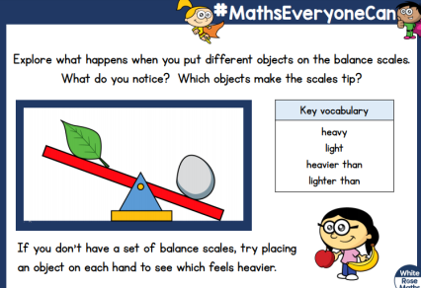
WB: 18. 1.21 Lesson 3 Can you draw pictures of your scale and objects?
Challenge - Can you label each side of you scale using heavy or light

