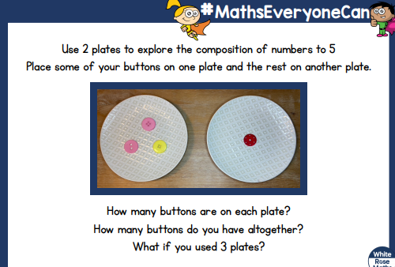
Can you drawn how many objects on each plate

