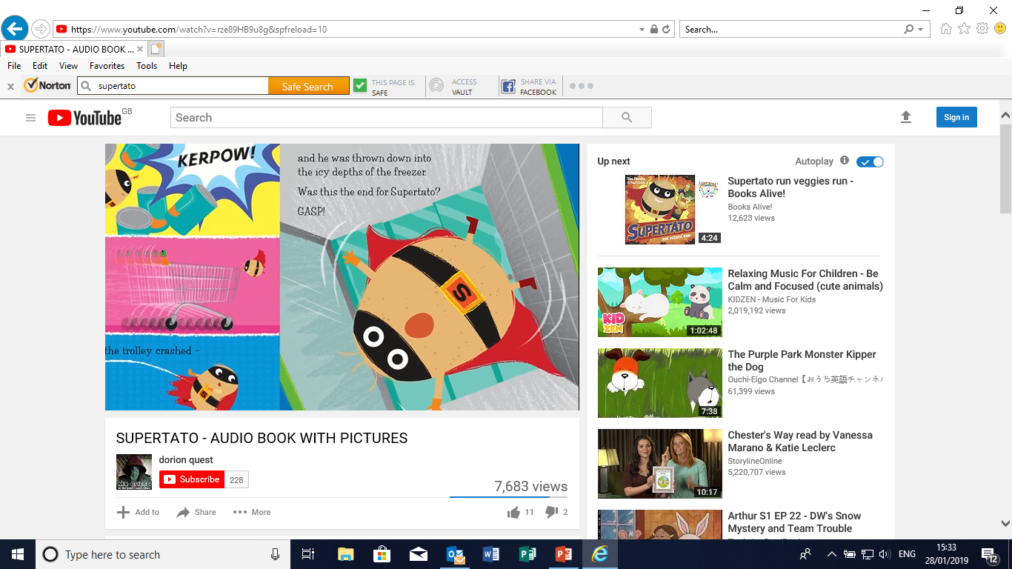

WB: 4.1.21 I D W- CL-

**To make a prediction for next part of the story “Supertato”.**