YEAR 4 LONG TERM ENGLISH PLAN (2023-2024)

 | Autumn 1 | Autumn 2 | Spring 1 | Spring 2 | Summer 1 | Summer 2
Texts | 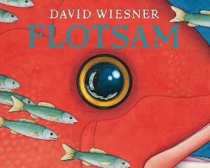 | 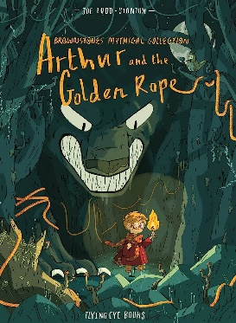  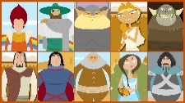  https://www.bbc.co.uk/teach/school-radio/english-ks1-english-viking-sagas/zkyqd6f  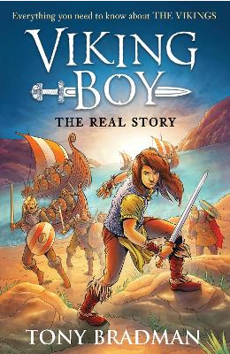 | 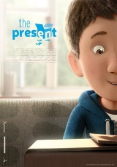  Present film unit  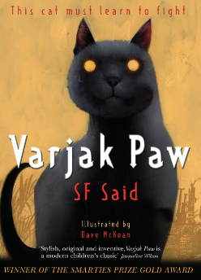 |  | 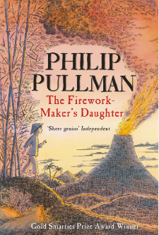 | 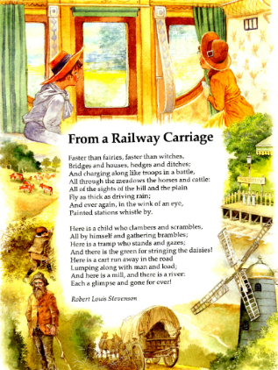  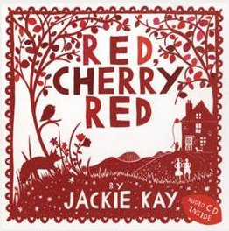
Poetry Focus |  |  |  |  | From a Railway carriage  Bush Fire
Written  Outcome | Main Outcome 1: Writing to persuade  Short bursts of writing:  Main outcome 2:  Writing a newspaper article: Recount of events  Short bursts of writing | Main Outcome 1:  To Entertain: Narrative: 100 words or less  Mini saga Norse Gods  Short Burst Writing:  Character Description  Setting description  Main Outcome 2: 1st person narrative  Short bursts of writing:  Character description  Story openers using verbs+ | Main outcome 1:  To show a change of heart: Narrative:  Short burst:  Build description of setting | Main outcome 1: Dairy  Recount: Diary  Main outcome 2:  Letter  Short burst: | Main outcome 1:  Suspense narrative describing the cave/volcano  Short burst: Description | Main outcome  Geography  To inform – non-chronological on natural disasters  Main outcome  Performance poetry
Grammar Focus and Alan Peat Sentence Type | Expanded noun phrases with adventurous adjectives  Sensational language  Facts and opinions  Direct speech  Fronted adverbials  2A | Speech punctuation  Subordinate clause  Simile  Alliteration  Fronted adverbial  Verbs  Verb, person  Emotion, comma | Coordinating conjunctions (avoiding run-on sentences)  Subordinate conjunctions  Adverbs and prepositions to help with chronology | Imperative verbs  Fronted adverbials, (commas)  Plural possessive  Verb, person  Emotion, comma | Verb, person  If, if then???? | Recap determiners  With a (n) action more action
Punctuation Focus | Adverbs of frequency  Comma  Inverted commas | speech punctuation  subordinate clause  comma | coordinating conjunctions and subordinating conjunctions | apostrophe | Personal possessive pronouns, verb inflections, recap speech, conjunctions | Fixing run ons, Recap determiners, apostrophes, conjunctions
Reading  Focus | Predictions  Character descriptions  inference |  | inference
Cross-Curricular writing links* |  |  | History  To inform: Maya decline  Instructional text: What to do after a hurricane. |  | Main outcome 1: Explanation text on natural disasters.

