YEAR 6 LONG TERM ENGLISH PLAN (2022-2023)

 | Autumn 1 | Autumn 2 | Spring 1 | Spring 2 | Summer 1 | Summer 2
Texts | 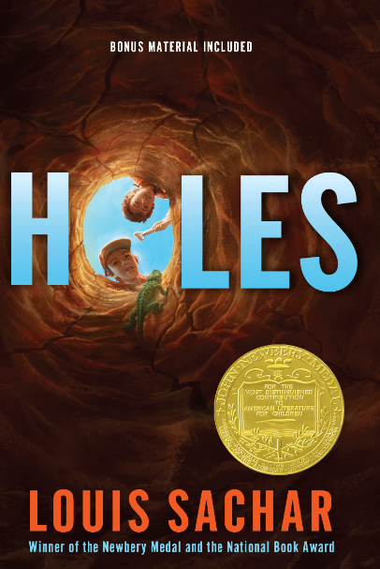  Highwayman | Holes  Dulce and Decorum | 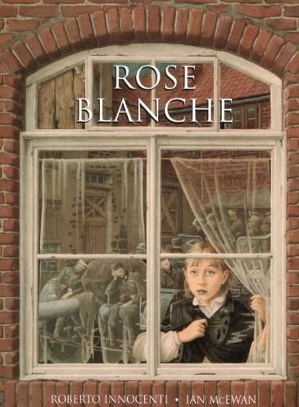  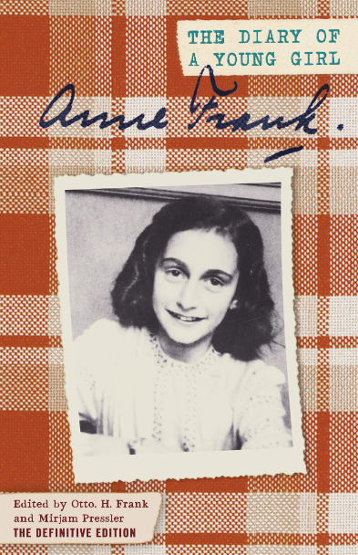 | 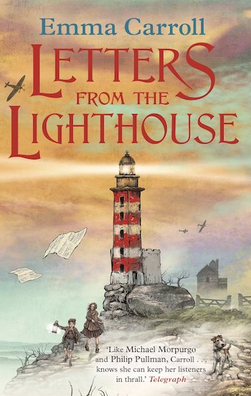 | 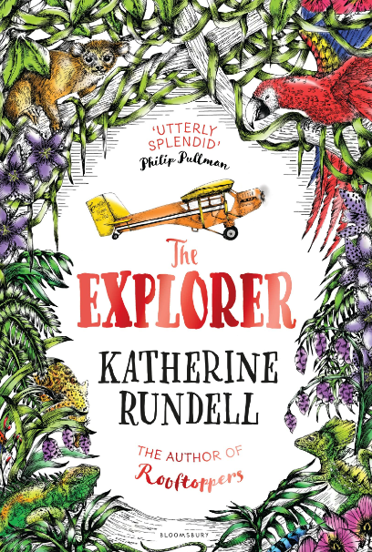  The Explorer  Rooftoppers | Lit shed films: Alma and Francis
Poetry Focus | Highwayman and  Dulce et Decorum Est  Poetic Devices
Written  Outcome | Highwayman poem  Main outcome 2: Narrative - Turn Highwayman into a narrative – story in role (could be told from alternative POV)  Short writing opportunities:  Setting descriptions – moor  Character descriptions  Alternative endings  Holes  Main Outcome 1: Narrative - Recount (diary) - Stanley’s Diary entry  Short writing opportunities:  Wreck room setting description  Yellow Spotted Lizard encounter | Holes  Main outcome 1 - Newspaper report on Stanley  Short writing opportunities:  Brief bulletin about arrest | Rose Blanche  Main outcome: 1  Descriptive & emotive poem based on Rose Blanche concentration camp  Anne Frank (History link)  Main outcome:1 Biography of Anne Frank  Main Outcome 2  Bravery Speech (Read to Write)  Children to write examples of formal  words/phrases and sentences that could be used later in  their own speeches | Letters from the Lighthouse  Main outcome: Narrative – third person (set in Air Raid Shelter)  Short writing opportunities:  - Character description  - Setting description  - Building tension (air raid paragraph)  History link  Main Outcome- To discuss  Balanced argument on Dunkirk (See template) | The Explorer  Main outcome: Narrative - Flashback and forwards  Short writing opportunities:  setting description  Plane crash  Create convincing characters and gradually reveal more as the story unfolds, through the way that they talk, act and interact with others  Geography Link  Main outcome: to persuade(formal) - climate change | Lit Shed Films:  Main outcome: Narrative  Short writing opportunities:  Descriptive paragraph –setting  Dialogue to advance action  Geography link  Main outcome: Non chronological report – rivers ,linked
Grammar Focus and Alan Peat Sentence Type | Informal language for a diary  Expanded noun phrases expanded by the addition of modifying adjectives, nouns and prepositional phrases  Fronted adverbials  Cohesion through pronouns, fronted adverbials and prepositions  Subordinate clauses  Alan Peat Sentence  Some; some  The more, the more  Irony sentences ‘The ‘camp’ at Green lake was not..  Edingly  Imagine | Compound and complex sentences  Formal language  Direct and reported speech  Alan Peat Sentence  Some others  De:de | Poem  Poetic devices – alliteration, simile, metaphor  Formal Speech  Formal language  Subjunctive  Passive  Modals  Adverbs of possibility  Flashback narrative  Amplification  Most important in short | Air Raid Narrative  Noun phrases expanded by the addition of modifying adjectives, nouns and prepositional phrases.  Dialogue to reveal characters and move story along  Balanced Argument  Cohesion  Connecting adverbials  Writers need to make formal and informal vocabulary choices to suit the form of the writing and audience by making generic statements followed by specific examples  The passive voice can sometimes be used to present points of view e.g. It could be claimed that…it is possible that…some could claim that…  Because arguments include hypothetical ideas, conditional language, such as the subjunctive form can sometimes be used e.g. If people were to  In discussions, complex ideas need developing over a sentence. Colons and semi-colons can be useful for separating and linking these ideas.  DE:de  I was exhausted: I hadn’t slept for more than two days.  Some; others  If, If, if | Cohesion within and across paragraphs and focus on using adverbials and prepositions to enhance flashback  Noun phrases expanded by the addition of modifying adjectives, nouns and prepositional phrases.  Dialogue to reveal characters and move story along  Tell: show 3  The rainforest was a cocoon of flora and fauna: creeping vibes; howling monkeys; birds with long, bright tail feathers. | Dramatic heightening  ( the more.. the more_)  Passive voice  Subjunctive  (If people were to stop cutting down the rainforest)  - Requires the writer to make formal and informal vocabulary choices by moving from generic statements to specific examples when key points are being presented.  - Repetition can be used to strengthen your point of view. This also acts as a cohesive device.  - Because arguments include hypothetical ideas, conditional language, such as the subjunctive form can sometimes be used e.g. If people were to stop hunting whales  First Last
Punctuation Focus | Diary: use of brackets for parenthesis  Dashes for parenthesis  Semi colons between clauses  Use and punctuate direct speech (using dialogue to show the relationship between characters), | place apostrophe correctly for regular plurals,  Use commas after fronted adverbials.  Semi-colon | Use of commas after fronted adverbials and subordinate clauses.  Use of colons in clauses | Place the possessive apostrophe accurately in words with regular plurals and in words with irregular plurals.  Colon  Semi colon  Bullet points | Secure use of apostrophes for possession, including for plural nouns  Begin to use dashes for emphasis | .
Reading  Focus | Inferring feelings from actions and words  Authorial intent  Word choice for tension  Infer about a character - what impression do you get of Tim the Ostler, The Highwayman?  (Highwayman)  Identifying themes | Understanding impact of poetic devices in Dulce et decorum est  Dulce and Decorum  Poetry  Short writing opportunities  PEE- dulce  Identifying themes | Author’s use of show not tell |  | Language choices to create a picture in reader’s mind
 | Ongoing work with VIPERS
Cross-Curricular writing links* |  |  | Balanced argument on Dunkirk
* Worked into Topic books/lessons

