YEAR 3 LONG TERM ENGLISH PLAN (2022-2023)

 | Autumn 1 | Autumn 2 | Spring 1 | Spring 2 | Summer 1 | Summer 2
Texts | 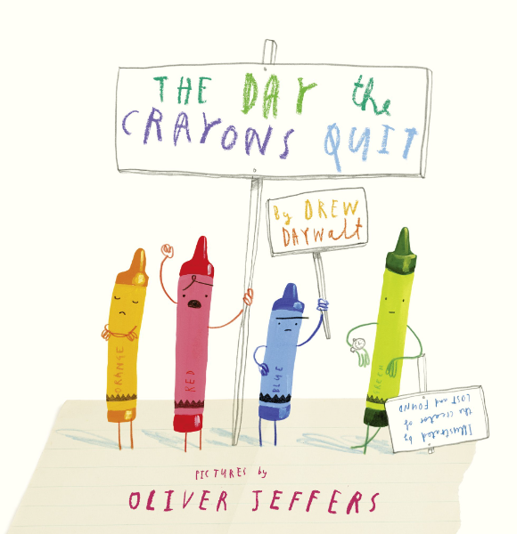 | 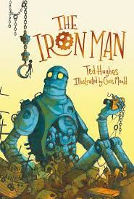 | 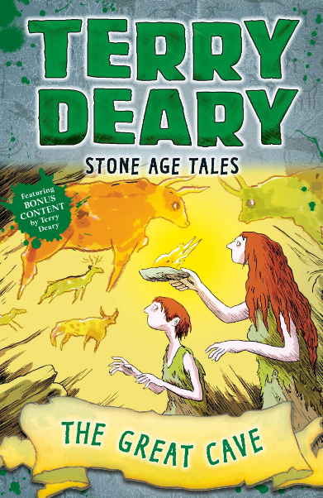  Gilgamesh | 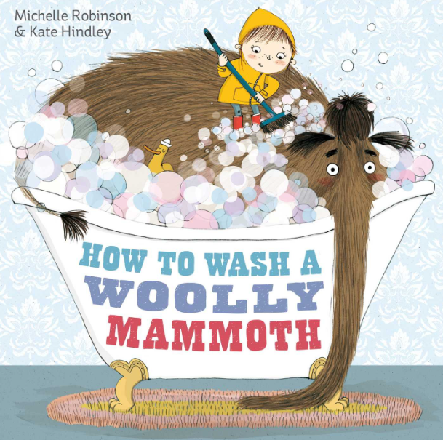 | 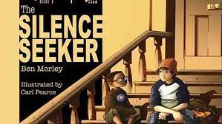 | 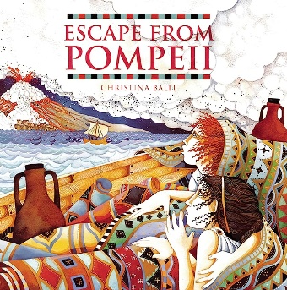
Writing purpose | The Day the Crayons Quit:  Main outcome: Letter to inform  Short writing opportunities:  - Letter  - sentences for feelings and emotions of character | The Iron Man  Main outcome 1: Narrative  Short writing opportunities:  -character description  -setting description  -Story map  -sentence openers | Stone Age Tales The Great Cave  Main outcome 1: Recount  Short writing opportunities:  -Alternative recount  Main outcome 2: Non-chronological report  Short writing opportunities:  -Sentences in present to past tense  -Sentences using 1st and 3rd person  -structure of paragraphs and subheadings | How to Wash a Woolly Mammoth  Main outcome : Instructions  Short writing opportunities:  -Instructions for How to Wash a Woolly Mammoth | The Silence Seeker  Main outcome: Narrative  Short writing opportunities  - Setting descriptions (Expanded noun phrases for key parts in the text).  - Shared writing for middle section of story. | Escape to Pompeii  Main outcome 1:  Narrative  Short writing opportunities  - Dialogue for a scene in narrative  - Setting description  Main outcome 2: Persuasive letter  Short writing opportunities:  - AFOREST sentences to persuade  - Letter to Goldilocks to persuade.  - invade against romans (history links)
Grammar Focus  Alan Peat sentence type | Use conjunctions and, but, so, or, because. | 2A sentences (adjectives)  Similes | Expressing the time, place and cause using conjunctions (e.g. when, so, before,after, while, because), adverbs (e.g. then, next, soon, therefore), or prepositions(e.g. before, after, during,in, because)  Conjunctions | Prepositions  Imperative verbs  Time connectives | Expanded noun phrases  Subordinating clauses | Alliteration  Exaggeration  Repetition  Rhetorical questions  -ly words
Punctuation Focus | Capital letters and full stops. | Capital letters and full stops.  Use and punctuate direct speech (using dialogue to show the relationship between characters), place apostrophe correctly for regular plurals,  Use commas after fronted adverbials. | Capital letters for proper nouns. |  | Use inverted commas to indicate direct speech | Use inverted commas to indicate direct speech
Reading Focus | Prediction  Inferring characters feelings at different points in the text. | Retrieval  PEE  Inferring characters feelings at different points in the text.  Explain | Sequence  Inferring characters feelings at different points in the text. | Retrieve  Sequence and summarise  Vocabulary - Effect of vocabulary on a reader Prediction
Spoken Language
Cross-Curricular writing links*

