YEAR 1 LONG TERM ENGLISH PLAN (2022-2023)

 | Autumn 1 | Autumn 2 | Spring 1 | Spring 2 | Summer 1 | Summer 2
Texts | 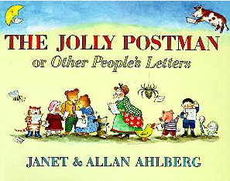  With Traditional Tales | 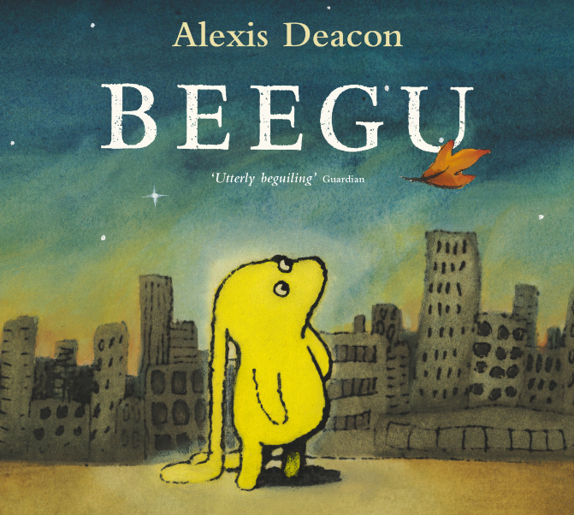 | 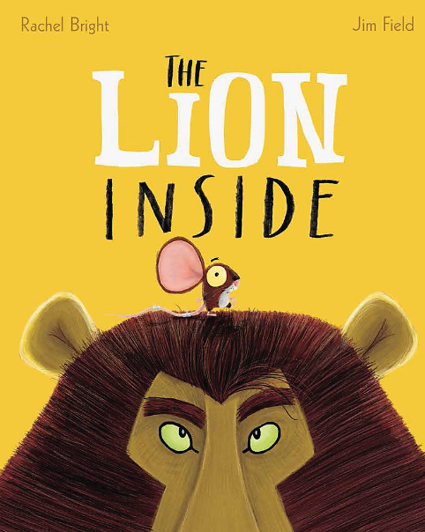  Books about penguins | 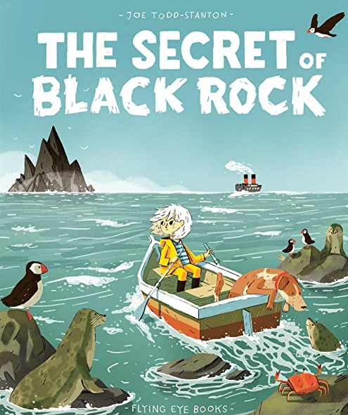 | 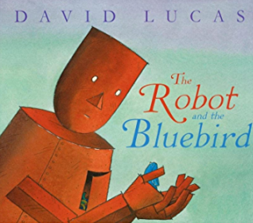 | 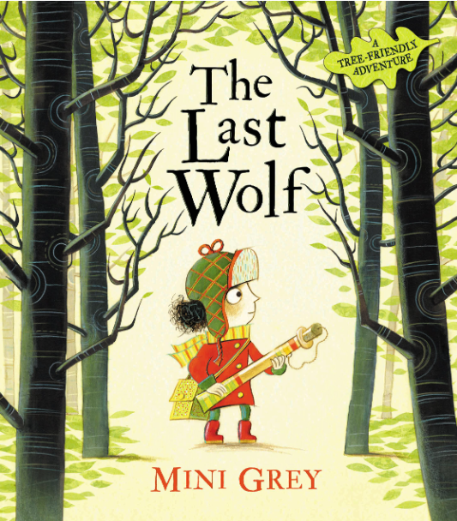  The Ugly Sharkling
Poetry Focus | Nursery rhymes |  | Performance poetry / Poems about the sea and sea creatures
Writing Purpose | Baseline writing – Holiday news recount  Jolly Postman  Main outcome 1: WRITING TO INFORM – RECOUNT – holiday postcard  - Simple sentences  - Story prediction  Main outcome 2: WRITING TO ENTERTAIN – NARRATIVE – retell Little Red Riding Hood  Short writing opportunities:  - Character description  - Sequencing traditional tales and nursery rhymes  - Speech / thought bubbles  - letter from characters | Beegu  Main outcome 2 : WRTING TO ENTERTAIN - RECOUNT (imaginative) – recount Beegu’s day at school from children’s point of view  Short writing opportunities:  - Setting description  - Character description  - Story sequencing  - Speech/Thought bubbles  - Lost poster for Beegu  - Accident report | Lion Inside  Main outcome: WRITING TO ENTERTAIN - NARRATIVE – retell story  Short writing opportunities:  - Story prediction  - Character descriptions  - Setting description  - Story sequencing  - speech bubbles  Books about penguins  Main outcome: WRITING TO INFORM – NON-CHRONOLOGICAL REPORT – report about penguins  Short writing opportunities:  - Fact finding about penguins  - Labels and captions  - Introductory paragraph. | The Secret of Black Rock  Main outcome 1: WRITING TO ENTERTAIN – RECOUNT (imaginative) – Diary recount of Erin  Short writing opportunities:  - Story prediction  - Character descriptions  - Setting description  - Speech bubbles  - Sequencing story  Main outcome 2: WRITING TO INFORM – RECOUNT– Trip to Greenacres  Short writing opportunities:  - Asking questions  - Write sentences about the farm picture.  - Facts about animals  - Sequencing main events | The Robot and the Bluebird  Main outcome 1: WRITING TO ENTERTAIN – NARRATIVE – retell story  Short writing opportunities:  - Story prediction  - Character descriptions  - Setting description using senses  - Sequencing story  Main outcome 2: WRITING TO INFORM –  INSTRUCTIONS – instructions for a bird feeder  Short writing opportunities:  - Sequencing instructions | The Last Wolf  Main outcome: WRITING TO ENTERTAIN – NARRATIVE – adapt the ending  Short writing opportunities:  - Wanted poster Big Bad Wolf  - Questions about story  - Character descriptions  - Write diary of Red’s journey  - Speech bubbles  - Sequencing story  - Editing text  - Write a letter in role as Little Red  The Ugly Sharkling  Main outcome: WRITING TO ENTERTAIN – NARRATIVE – write a postcard/letter in role as Little Phil  Short writing opportunities:  -Character description  - Sequencing story
Grammar Focus  Alan Peat Sentence Type | Simple sentences –make sense  Time sequencing words | Suffixes: Plurals – e, es  Suffixes: ed – no change to root  Conjunctions: and | Suffixes: Plurals – e, es  Suffixes: ed, - no change to root  Suffixes for comparative words: -er –est  Conjunctions: and but so | Suffixes: Plurals – e, es  Suffixes: ed, -ing - no change to root  Suffixes for comparative words: -er –est  Conjunctions: and but so because  1A sentence - Adjectives for description | Prefix: un  Suffixes: Plurals – e, es  Suffixes: ed, -ing - no change to root  Suffixes for comparative words: -er –est  Conjunctions: and but so because  1A sentence - Adjectives for description | Prefix: un  Suffixes: Plurals – e, es  Suffixes: ed, -ing - no change to root  Suffixes for comparative words: -er –est  Conjunctions: and but so because  1A sentence - Adjectives for description
Reading  Focus | becoming very familiar with key stories, fairy stories and traditional tales, retelling them and considering their particular characteristics  learning to appreciate rhymes and poems, and to recite some by heart | predicting what might happen on the basis of what has been read so far  discussing the significance of the title and events | discussing word meanings, linking new meanings to those already known  recognising and joining in with predictable phrases  being encouraged to link what they read or hear read to their own experiences | checking that the text makes sense to them as they read and correcting inaccurate reading  making inferences on the basis of what is being said and done | read words with contractions [for example, I’m, I’ll, we’ll], and understand that the apostrophe represents the omitted letter(s)  participate in discussion about what is read to them, taking turns and listening to what others say | explain clearly their understanding of what is read to them.  re-reading what they have written to check that it makes sense  read aloud their writing clearly enough to be heard by their peers and the teacher.
Punctuation Focus | Finger spaces, Capital letter, full stops to demarcate sentences  Capital letters for the personal pronoun I. | Finger spaces, Capital letter, full stop, question marks to demarcate sentences | Finger spaces, Capital letter, full stop, question marks, exclamation marks to demarcate sentences | Capital letters for names  Finger spaces, Capital letter, full stop, question marks, exclamation marks to demarcate sentences | Capital letters for names  Finger spaces, Capital letter, full stop, question marks, exclamation marks to demarcate sentences | Capital letters for names  Finger spaces, Capital letter, full stop, question marks, exclamation marks to demarcate sentences
Spoken Language
Cross-Curricular writing links* | Moon landings information  Neil Armstrong facts |  | Lifeboats fact sheet  Grace Darling report  Facts about penguins |  | Eastham Country Park leaflet/info  Weather report
* Worked into Geography/History lessons

