Area of Learning | Monday | Tuesday | Wednesday | Thursday | Friday
Phonics | Play a game of the winning word is…  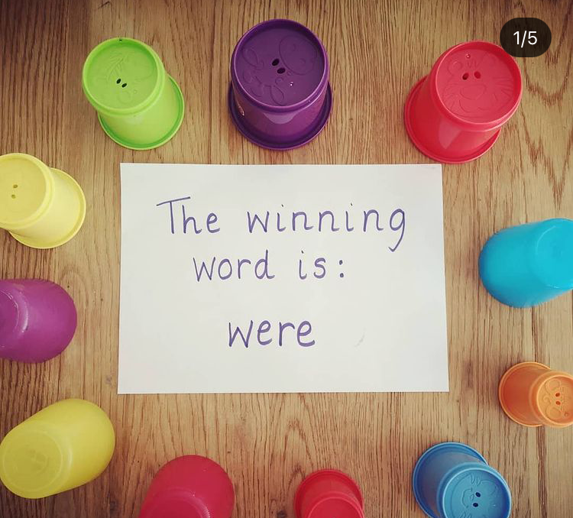  Write a selection of words using our phonics sounds from last week and hide them under cups. Use a sign like the above to tell your child the winning word.  The children have to read all of the words under the cups until they find a match!  Example words:  HFW - they / are/ all / was / you / my / her / just / down / now / for / went / from / help / when | Flash card sounds previously learnt - ai, ee, igh, qu, ur, ow, oi, ear.  Read HFW - just / down / now / for / went / from / help / when  Flashcard tricky words with silly voices- they / are/ all / was / you / my / her  Today's sound is the digraph ‘ur’. Can you think of a word with ‘ur’ in it? (fur, burn, surf, turnip)  Model writing ‘ur’. Then model writing a word with ‘ur’ like burp, hurt, turn, burnt. Where is the ‘ur’ digraph in my word?  Sound talk the rest of the words and the children write them. Can they use one or more in a sentence? | Flash card sounds previously learnt - ai, ee, igh, qu, ur, ow, oi, ear.  Read HFW - just / down / now / for / went / from / help / when  Flashcard tricky words with silly voices- they / are/ all / was / you / my / her  Today's sound is the digraph ‘ow’. Can you think of a word with ‘ow’ in it? now, pow, owl, towel, clown.  Model writing ‘ow’. Then model writing a word with ‘ow’ like cow, down, growl. Where is the ‘ow’ digraph in my word?  Sound talk the rest of the words and the children write them. Can they use one or more in a sentence? | Flash card sounds previously learnt - ai, ee, igh, qu, ur, ow, oi, ear.  Read HFW - just / down / now / for / went / from / help / when  Flashcard tricky words with silly voices- they / are/ all / was / you / my / her  Today's sound is the digraph ‘oi’. Can you think of a word with ‘oi’ in it? oil, boil, soil.  Model writing ‘oi’. Then model writing a word with ‘oi’ like coin, join, poison, tinfoil, toilet. Where is the ‘oi’ digraph in my word?  Sound talk the rest of the words and the children write them. Can they use one or more in a sentence? | Flash card sounds previously learnt - ai, ee, igh, qu, ur, ow, oi, ear.  Read HFW - just / down / now / for / went / from / help / when  Flashcard tricky words with silly voices- they / are/ all / was / you / my / her  Today's sound is the trigraph ‘ear’. Can you think of a word with ‘ear’ in it? ear, hear, gear.  Model writing ‘ear’. Then model writing a word with ‘ear’ like dear, tear, year, beard. Where is the ‘ear’ digraph in my word?  Sound talk the rest of the words and the children write them. Can they use one or more in a sentence?
Maths | Today we are following White Rose Maths- Lesson 1  https://whiterosemaths.com/homelearning/early-years/first-then-now-week-2/  Activity: Maths lesson 1  See home learning page for uploaded activity sheet | Today we are following White Rose Maths- Lesson 2  https://whiterosemaths.com/homelearning/early-years/first-then-now-week-2/  Activity: Maths lesson 2  See home learning page for uploaded activity sheet | Today we are following White Rose Maths- Lesson 3  https://whiterosemaths.com/homelearning/early-years/first-then-now-week-2/  Activity: Maths lesson 3  See home learning page for uploaded activity sheet | Today we are following White Rose Maths- Lesson 4  https://whiterosemaths.com/homelearning/early-years/first-then-now-week-2/  Activity: Maths lesson 4  See home learning page for uploaded activity sheet | Today we are following White Rose Maths- Lesson 5  https://whiterosemaths.com/homelearning/early-years/first-then-now-week-2/  Activity: Maths lesson 5  See home learning page for uploaded activity sheet
Reading | Share your reading book together discussing the character, settings and what happens next. | Share your reading book together discussing the character, settings and what happens next. | Share your reading book together discussing the character, settings and what happens next. | Share your reading book together discussing the character, settings and what happens next. | Share your reading book together discussing the character, settings and what happens next.
Other | RE - May the month of Mary  Listen and sing:  https://youtu.be/7OxeUAtiuHk Or join in with actions:  https://youtu.be/VZQjVI-P55w  Talk: Use the document ‘St. Francis’ School crowning Mary Queen of Heaven’.  Look at each page and talk about the following things -  What is happening?  Who do you see in the photo?  Why do you think the children are looking at Mary?  What is special about Mary?  Activity:  Write captions together or support your child to write captions or sentences about each of the pictures. | PE - Rocking Rolling Bears  Practising our rolls again this week!  Warm up: Who ate my porridge? Game to make your heart beat faster.  Activity: Practising rocking bears up to standing / Barrel Roll / Straight Roll  See Goldilocks document. | UTW/LIT - Dinosaurs  Listen to the story of the Dinosaurumpus!  https://youtu.be/tSBbh6TYECc  Can you join in with the repeated words?! and be a very loud dinosaur!  Choose your favourite dinosaur from the book. Draw or paint your dinosaur and label all of the different parts. | OUTDOOR LEARNING DAY  Nature inspired activities :)  Nature Art: Children cut leaves and flowers to create a picture.  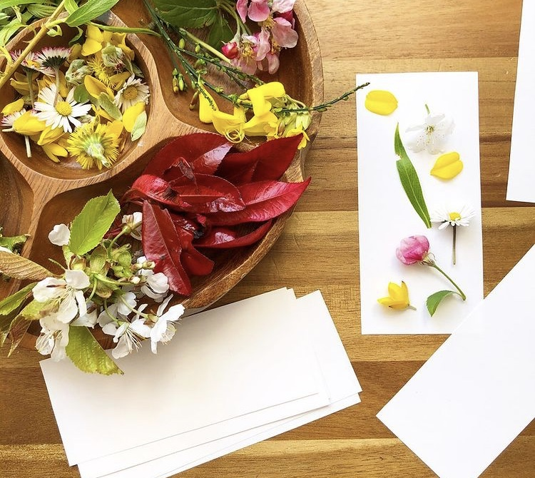  Dinosaurs Tears: See uploaded sheet for this rainy day activity.  Go on a garden colour hunt:  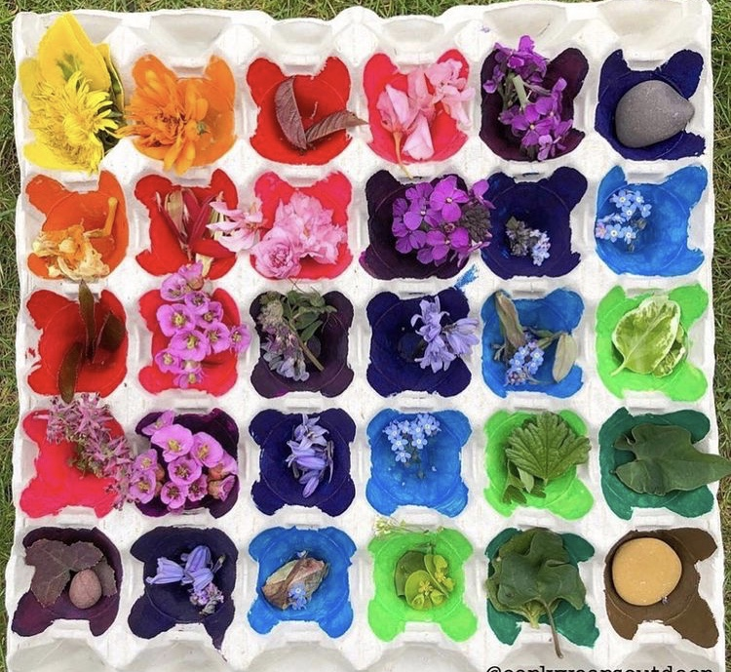 | UTW/LIT - Dinosaurs  Listen to the story of the Dinosaurumpus!  https://youtu.be/tSBbh6TYECc  Can you join in with the repeated words?! and be a very loud dinosaur!  Find your favourite dinosaur again - can you remember their rhyme?  Write their rhyming words or their whole rhyme and add it to your picture.  For example:  clatter, clatter, clatter!  or more challenge:  Stegosaurus stomps along with lots of her mates, clatter clatter clatter! go their bony back plates.
Extra | Cosmic Kids Yoga  https://www.youtube.com/user/CosmicKidsYoga | Finger Gym  https://youtu.be/3VpARNgbb8c | Boot Camp  https://www.youtube.com/channel/UC1uISIOKNnnGALw17v9naPg | Art & Design-  Follow the video to draw a dinosaur:  https://youtu.be/EZ2h6W4YVz0 | Music - Listen and play dinosaurs:  https://www.bbc.co.uk/teach/school-radio/nursery-rhymes-dinosaurs/z6snmfr  Listen:  https://www.bbc.co.uk/cbeebies/radio/nick-cope-song-dinosaurs

